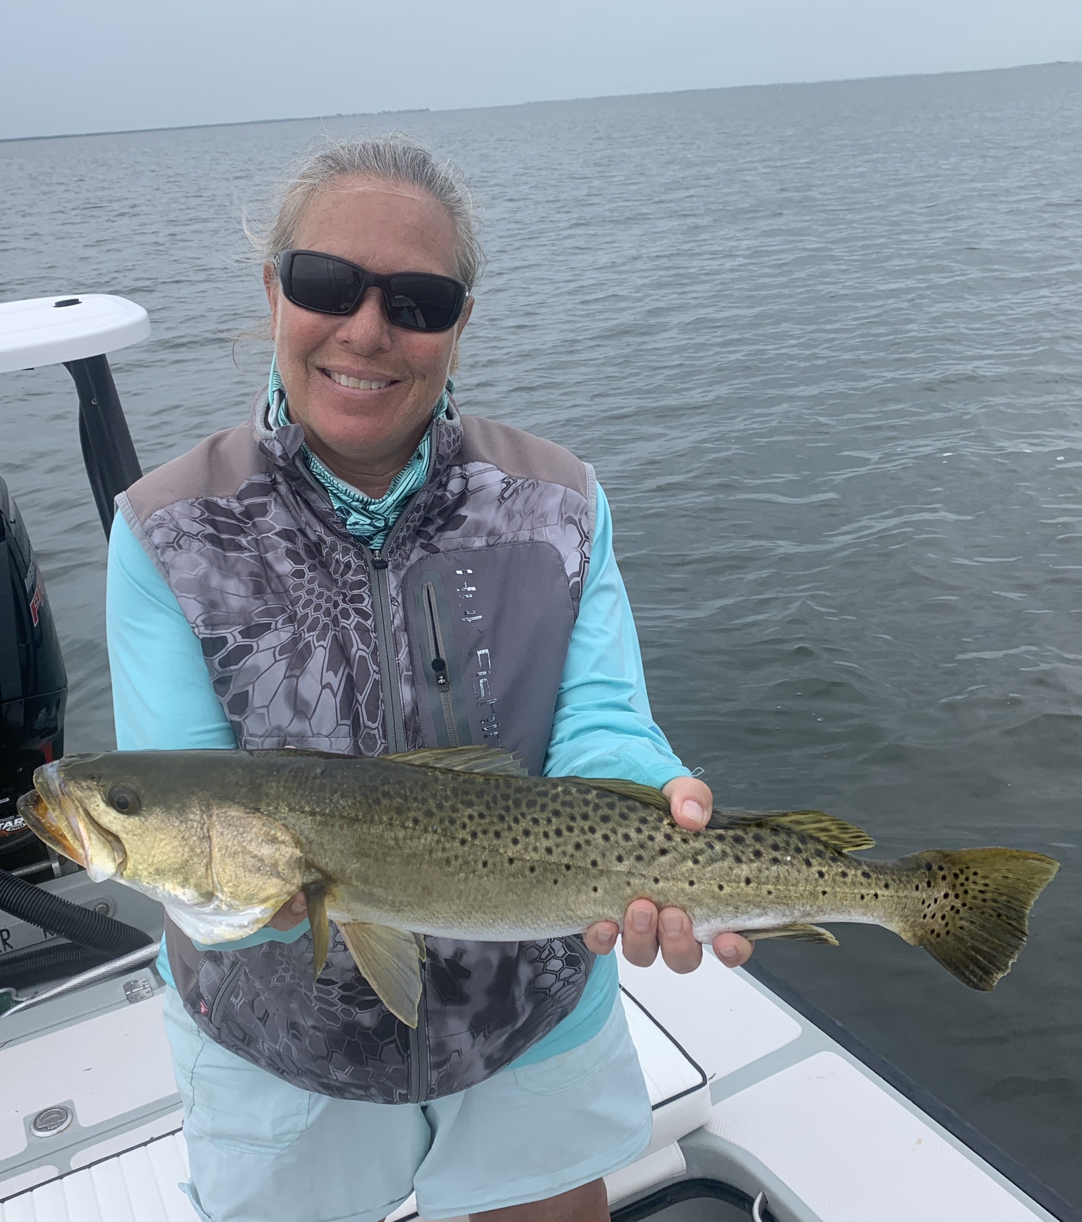

Summertime trout fishing

Pic: Mary Laser with a 26 inch “Gator Trout” she caught while tarpon fishing this week.

With a passing tropical disturbance we got a break from the sizzling summer heat with overcast conditions all week. Even though we saw very little rain the cloud cover did wonders for keeping temperatures lower than normal. Slower tides did make fishing a little tougher at times with little to no water movement even in the passes for hours. Moving out to the many grass flats was one option as the snook and redfish bite simply quit at times.

When tides are not right sometimes you just have to switch gears and target a species that seems to feed no matter what. Trout are one of the most popular species in Florida and can be caught a variety of ways with both live bait and artificial. Finding the small fry bait and feeding birds out on the open water flats is a sure sign to locate trout. Look for clean clear water and the trout will be there.

The tried and true method to catch these fish is a live shrimp under a popping cork. Make long casts and snap the rod tip making the cork pop. This sound imitates a shrimp or bait skipping on the surface and draws the trout in. There are lots of ways to switch this rig up with either a soft plastic or DOA like shrimp or a live pinfish or grunt. Big trout love grunts aka pig fish more than anything else that swims.

Top water plugs maybe the most fun way to catch trout. Watching them chase and miss the plug is great entertainment. Low light conditions are the best time for this. Some really big trout are caught in super shallow water around both oyster bars and shoals. Look for the transition area’s where grass and sand meet. Soft plastic’s bounced across the bottom on a jig head is another way to catch trout. We often drift and fan cast the flats in 3-5ft to catch these fish.

Some of the biggest trout we catch all year we pick up as by catch while tarpon fishing. Large pinfish under a float catch some giant 24 inch plus trout on almost every tarpon trip I run this time of year. Although they are not the target species catching a 26 inch trout is a great sign about the amazing recovery we have seen to our waters. Trout are a very delicate fish and gentle handling is the key to a good release. Wetting your hands or using a hook out tool and not even touching the fish gives them the best chance at swimming away unhurt.

Although trout has been reopened to harvest in our region as of June 1st the recreational limits have been lowered to six fish max per vessel. The slot limit has also changed to 15-19 inches with only one per vessel over 19 inches in that bag limit. The regulations for the entire state changed Febuary 1st 2020.

