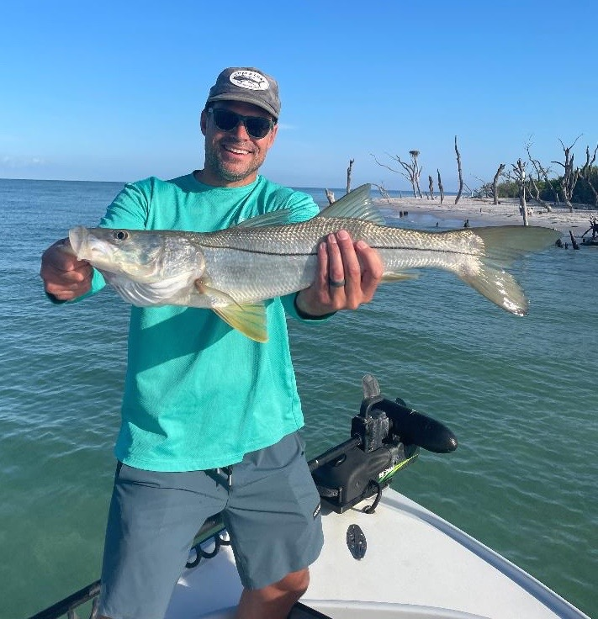

Summer Snookin

Pic: Brad from Maryland with a pass snook caught while fishing with Capt Matt Mitchell this week

Summer always means some of the best catch and release snook fishing of the year. Although these fish are all through our area the most consistent fishing will be found close to the passes and around out on the beaches.

During strong tides fishing in and around the passes can be some of the widest open snook fishing of the year. Every pass has its own rips and eddy’s where these fish will stack up by the hundreds. Deeper passes like Captiva and Redfish can be drifted very effectively while at times anchoring on a specific rip or downed tree can be the better way to go.

Shiners, pinfish and grunts will all catch these fish while the most effective technique will be dependent on if you choose to fish deeper or shallow areas. For drift fishing a small sinker or split shot on or above the leader will keep the bait close to and bouncing on the bottom. While pitching to downed structure and snags free line is the way to go as bait will move more naturally.

Out along our beaches snook fishing is a little different with these fish gravitating to any kind of structure. Even just a few downed tree limbs or areas of flat rock will hold lots of snook. Although our beaches don’t offer very much structure anymore its worth searching it out. Jetties on the inside or outside of the passes make great ambush points too.

One of my favourite ways to fish our summer snook is to sight fish them on the beaches. With our water being so clear its often possible during light wind periods and high sun to slowly trolling motor right down the beach and sight cast either jigs or live baits to these fish. The beaches of Cayo Costa are amazing for this. Anglers without a boat can walk the beaches and still enjoy this amazing sight fishing opportunity. Look for these fish right up close to the sand as they slowly cruise.

We are so fortunate to live in a place that offers anglers some of the best snook fishing anywhere on the planet. The rebound we have seen in this fishery since the Red Tide closure in 2017 has to be witnessed to be believed. This amazing resource should be guarded by all. Anglers need to keep doing everything possible to safely release these fish unharmed. After taking this world class snook fishing for granted for so many years mismanaged water almost wiped it out. Its great that things are improving and slowly getting back on the right track. We can thank the many grass roots movements that have exposed much of a crooked government scheme that controlled Florida’s water for so many years.

