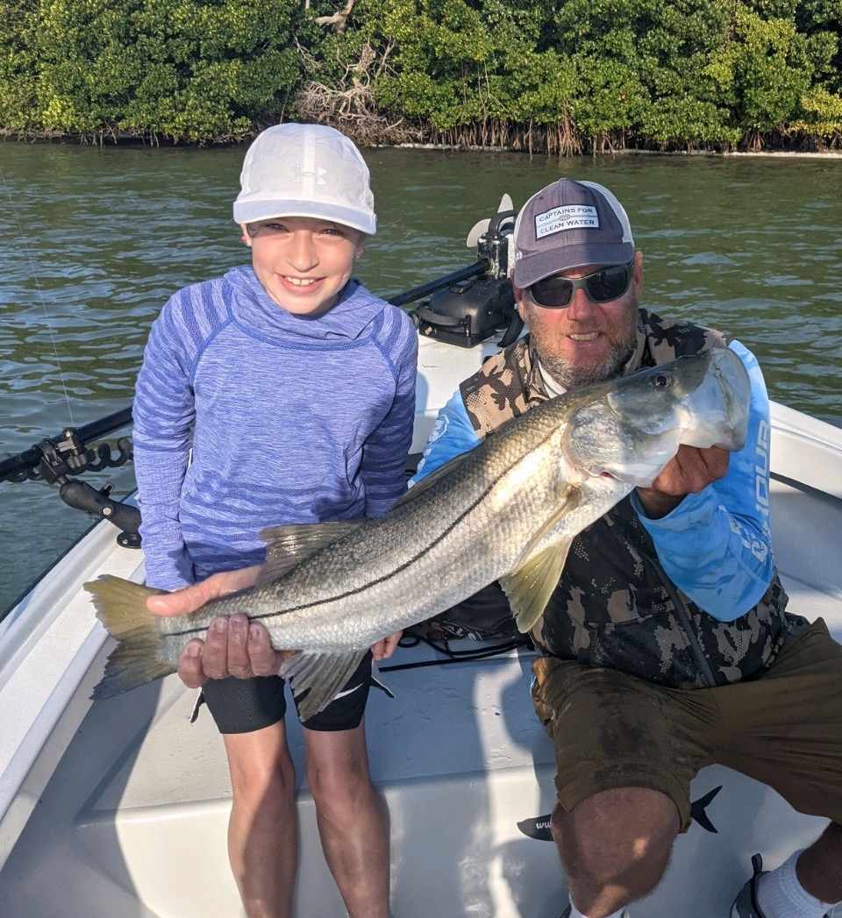

Pic: 10yr old Aubree caught this 31 inch snook while fishing with Capt Matt Mitchell this week.

Spring in full swing

With our season now in full swing visitors and locals alike could not ask for better weather to be out fishing. Water temperatures have crept back into that magical mid 70’s which fires everything up. The variety and amount of life found throughout our waters is what Spring is all about.

Over the past week mornings have started off calm and then south winds have gradually picked up all day. If its going to be windy a warm south wind is my favorite for snook fishing. Incoming tide and southerly winds had the snook bite going off all week. Once I located these snook it was just a matter of I returning again and again to both shorelines and oyster bars to catch these fish depending on the stage of the tide.

During lower periods of the incoming tide the bite was best in deeper natural channels and shorelines. Find one of these channels that the wind is blowing into and you can wear these snook out. Free lined live shiners caught snook, jacks, and even a few redfish.

Once the tide gets up higher I’ve been switching gears and moving to the many oyster bars in both the sound and Matlacha pass. Certain bars set up better on a south wind. Depending on the bar some had super clear water while others were stirred up. Firing shiners up to the edges of these bars and slowly retrieving them had these fish going off. Seemed the better action came on the bars with the dirty stirred up water most days.

Almost over night as water temperatures reached the mid 70’s tarpon started to show up in the sound. Although we did not hook any the first few hours after sunrise these fish could be seen rolling in all the usual places. Once the winds picked up they became much harder to locate. These same places have become overrun with black tip sharks. Trying to soak a bait for a tarpon became almost impossible.

With these tarpon now a fixture for the next few months it makes it a little tough to go fishing for anything else. Last year with all the shut downs due to COVID I got to enjoy chasing these fish a few days a week just for fun. This year our season is as busy as we have ever seen it with all my boats running daily and no time for me to play. Even after chasing these tarpon for so many years the excitement of casting a bait and watching one of these giants eat never gets old. Guess thats why they call it tarpon fever.

