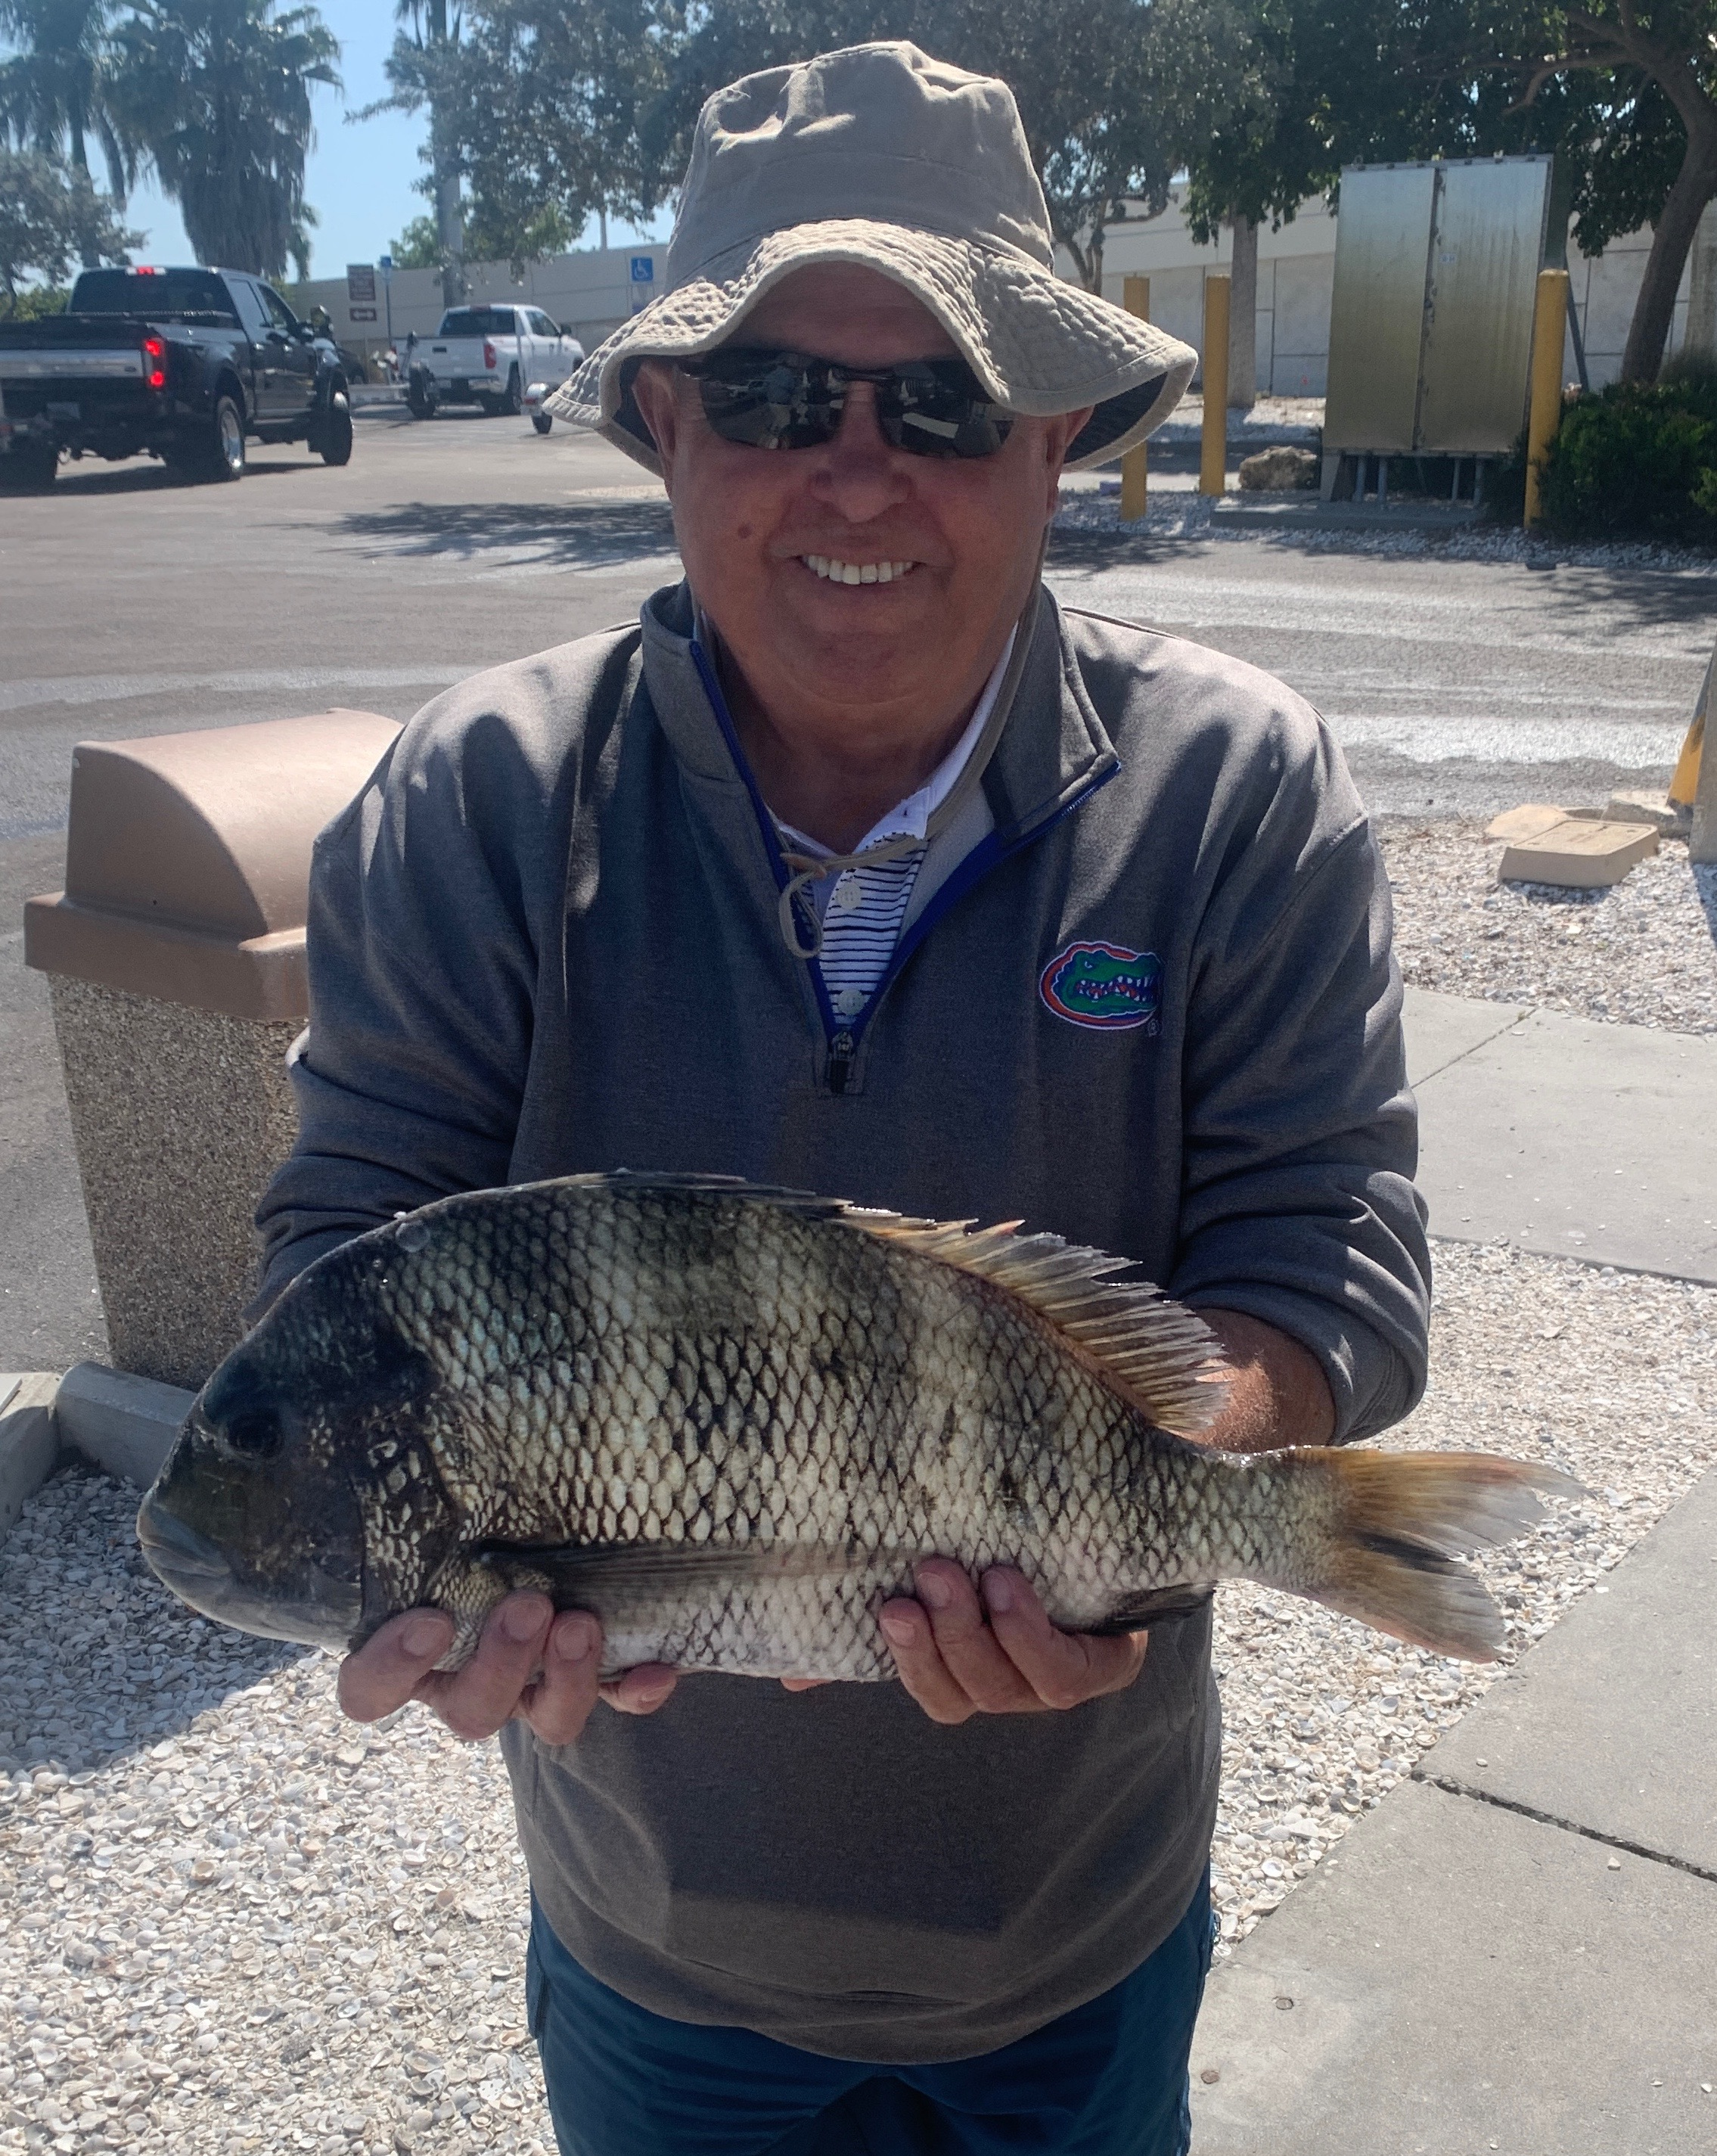

Spring break fishing

Pic: This monster sheep measured 21 1/2 inches and was caught while fishing with Capt Matt Mitchell this week.

With Spring officially starting this week we are finally on a warming trend with no cold fronts in sight. Now our water has crept back into the mid 70’s the sound has come to life with both bait and fish. All the Spring visitors have arrived. Watching the increase in life reappear is amazing and brings some of the best fishing of the year.

Throughout the entire sound Spanish Mackerel have invaded our waters. Catching these mackerel is non stop action on both artificial and bait. Drifting the passes with live shrimp on a jig head resulted in double and triple hook ups. How ever be careful when handling these fish as there ultra sharp teeth can cut you extremely quickly. Using a de hooker is the safest way.

Getting in a few last sheepshead trips this week we managed to catch the largest one on my boat this season. This Sheepzilla measured 21-1/2 inches and came at the first stop of the trip. When catching these sheepshead multiple other fish would follow up the hooked fish a we reeled them in. While filleting these fish at the end of the day the majority have already spawned and are void of eggs.

Catch and release snook fishing around the passes remained a strong bite. All our local passes have these snook and in the clear water its often as easy as seeing them and setting up to present them a bait.
The problem arises when the dolphins move in and start eating these snook as you release them. When this happens its time to move on.

The Spring pompano bite is also in full swing. The best way to locate these fish is often to idle around and watch for them to skip in your wake. Small jigs tipped with shrimp along with pompano jigs in bright colors caught em. Watch for these fish on sandy channel edges both off the toll booth flat and inside of Captiva and Redfish pass.

Shark fishing has heated up too with lots of blacktop of all sizes around. The Rocky Channel area and inside of Captiva pass remain some of the most productive places I catch these hard pulling sharks.
Its a simple rig consisting of 6-8ft of 200# mono leader with a swivel on one end and a 12/0 cut bait circle hook on the other. Bait up with a large chunk of mullet or ladyfish. In these same area’s we have also been seeing a few rolling tarpon.

The Corona virus has caused lots of cancellations for all our local businesses. Usually March is totally sold out and our busiest month of the year. This was the case until this week when the phone calls began with people changing there travel plans. With spring break now in full swing I can’t think of a safer place any further away from the Virus than being out on a boat in the open water with family and friends.

