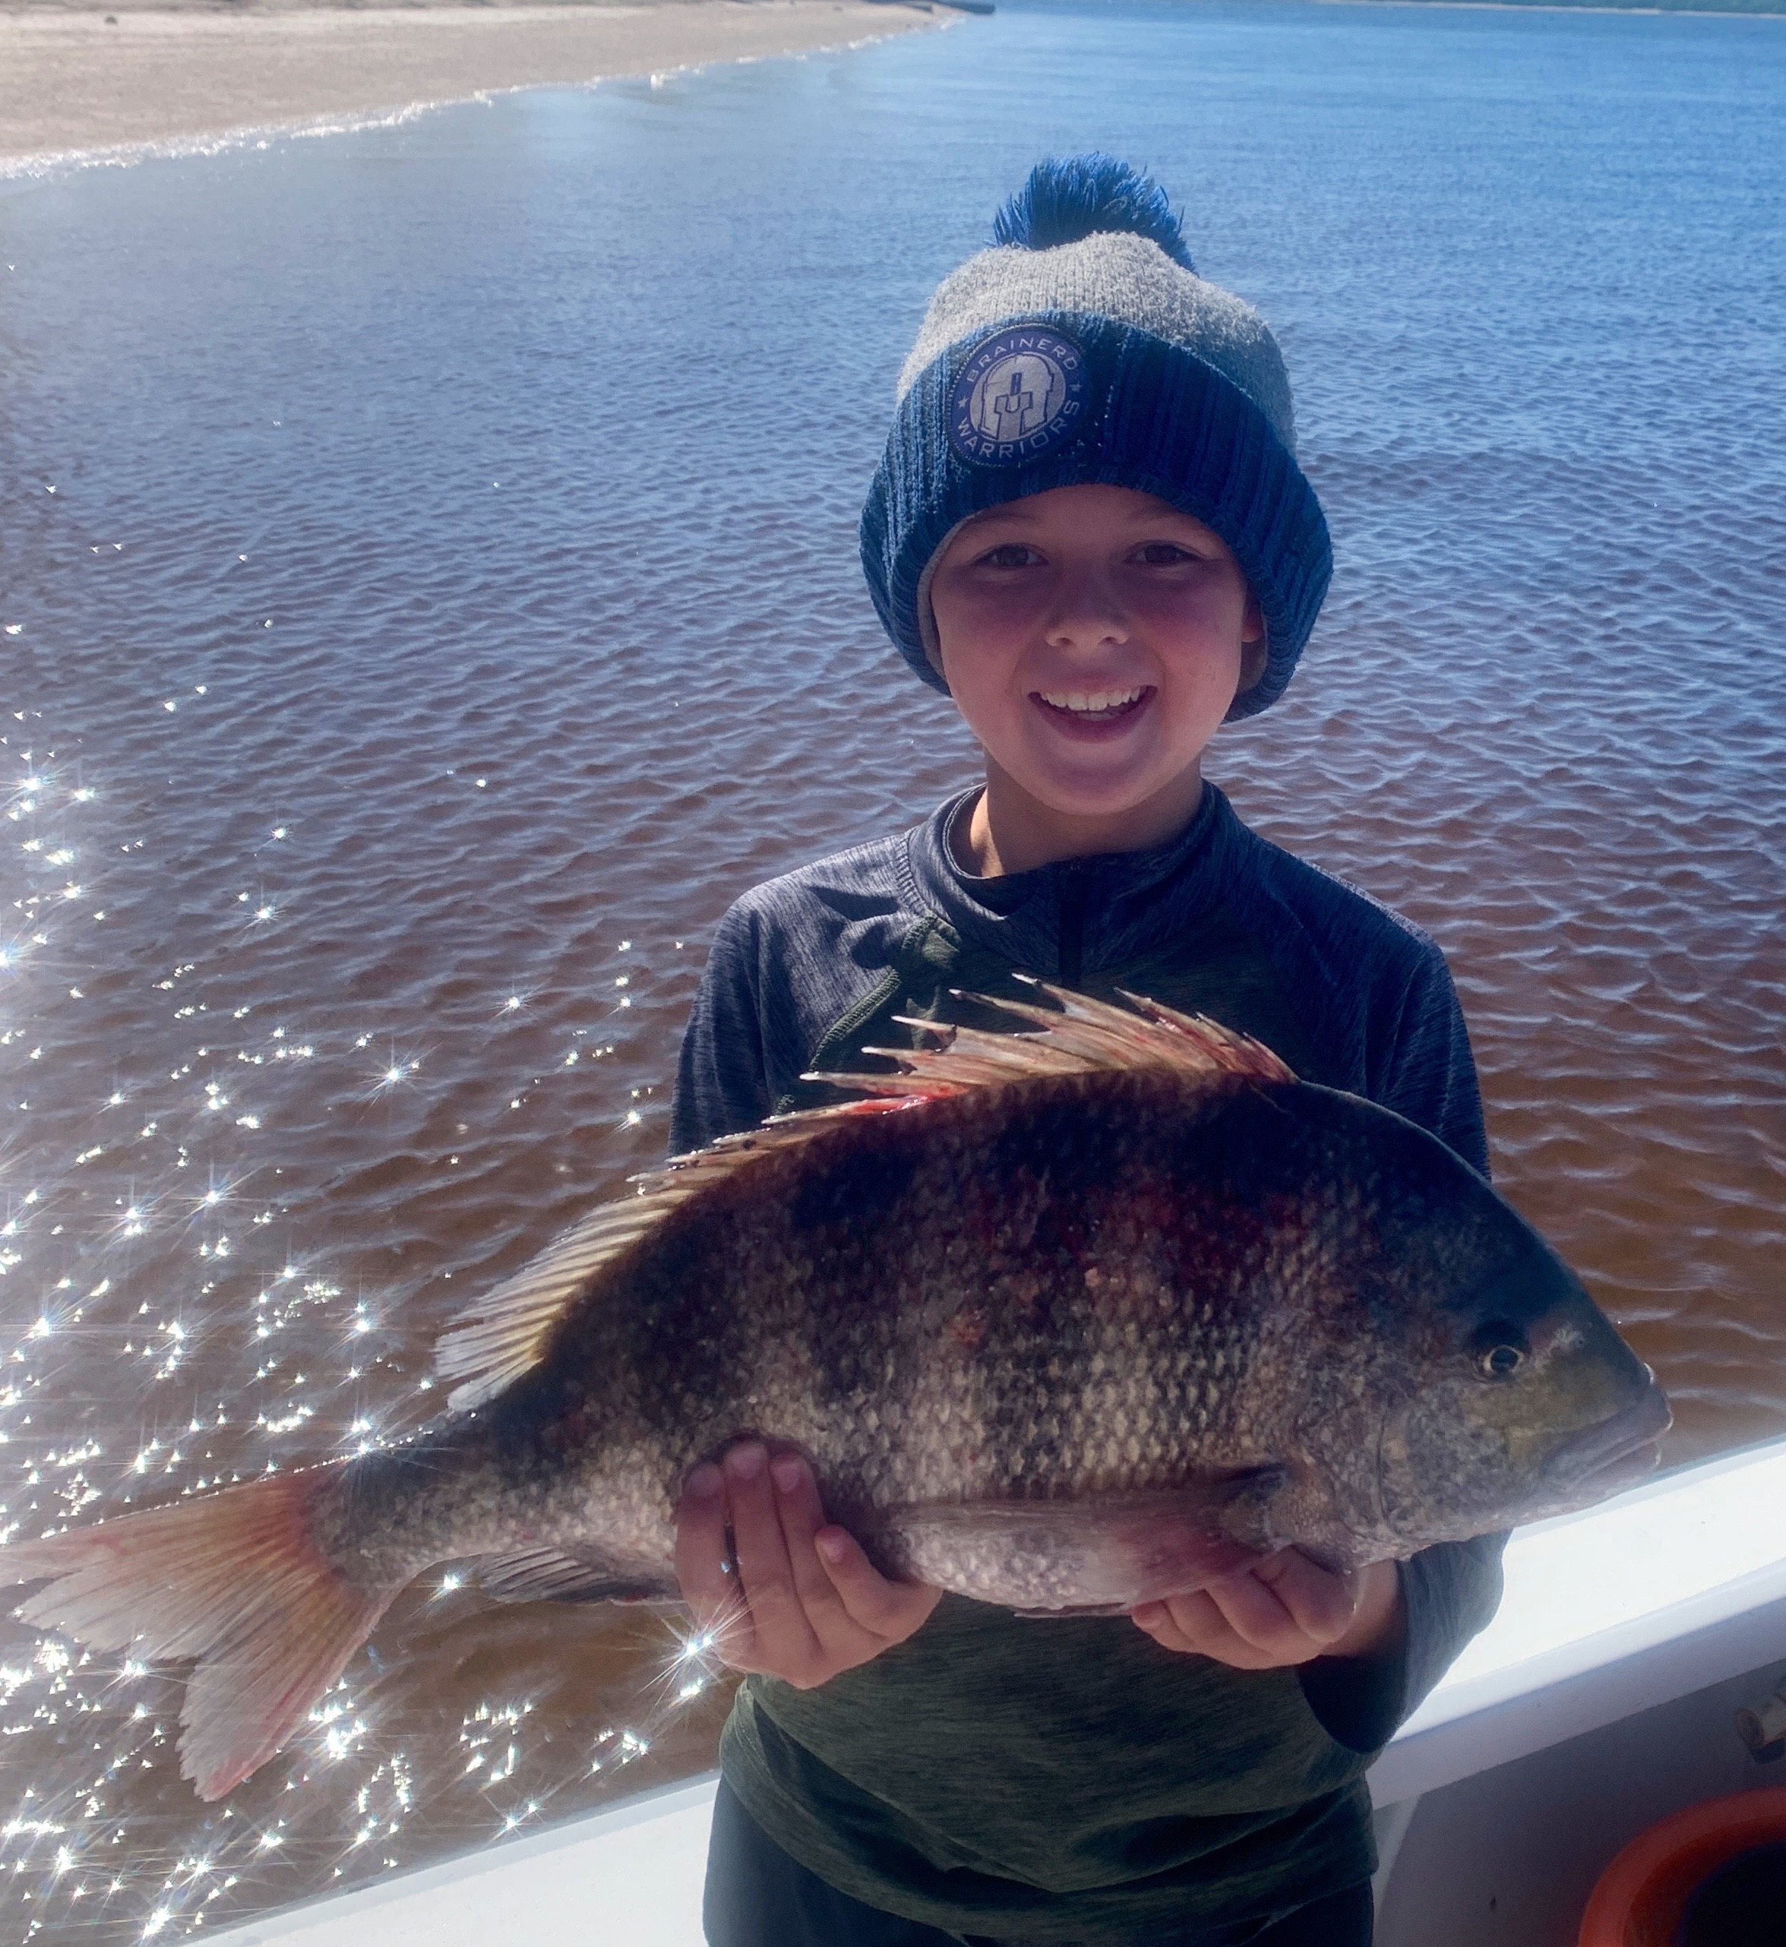

Spectacular sheepshead fishing

Pic: A sheepshead dinner makes everyone happy

March traditionally marks the best Sheepshead fishing we get to see all year, Cooler water temperatures from the last cold front made this a reality. We got to offer our clients some of the most wide open action on these striped porgies we have seen all winter. This big annual spawning push has them stacked up by the hundreds in places where I have just never seen so many of them.

Clear water channels inside the passes made spotting huge schools of these Sheepshead easy. Groups of a hundred fish sat in the fast moving current hunkered down to the bottom. Once located it was as simple as anchoring up and feeding them a chunk of shrimp on a jig head to get a bite every cast. At times when we were sat in a big school I started breaking up shrimp into little pieces. This little bit of chumming had these fish fired up and even coming up to the surface to eat. All I can compare this crazy sheepshead action to is catching snapper offshore.

With many of our Spring clients wanting to go home with a fresh fish dinner this has been the perfect set up. These crustacean eating fish have mild, firm, white meat and can be prepared countless ways all delicious. Within the first hour of most charters we have caught enough keeper sheepshead to cover a quality meal before moving on to target our usual snook, redfish and trout on live shiners.

Although it is quite possible to fill a cooler full of sheepshead practicing moderation is so very important. These fish are spawning and the future of their population is at stake. No matter how great this sheepshead bite is its not about killing every legal fish caught. Although Florida regulations allow for 8 fish per person of 12 inches minimum a better rule of thumb is to take only what you plan on eating for one meal. With very little meat on a 12 inch sheepshead a 14 inch minimum is a better call with 2 fish per person yielding a quality meal.

