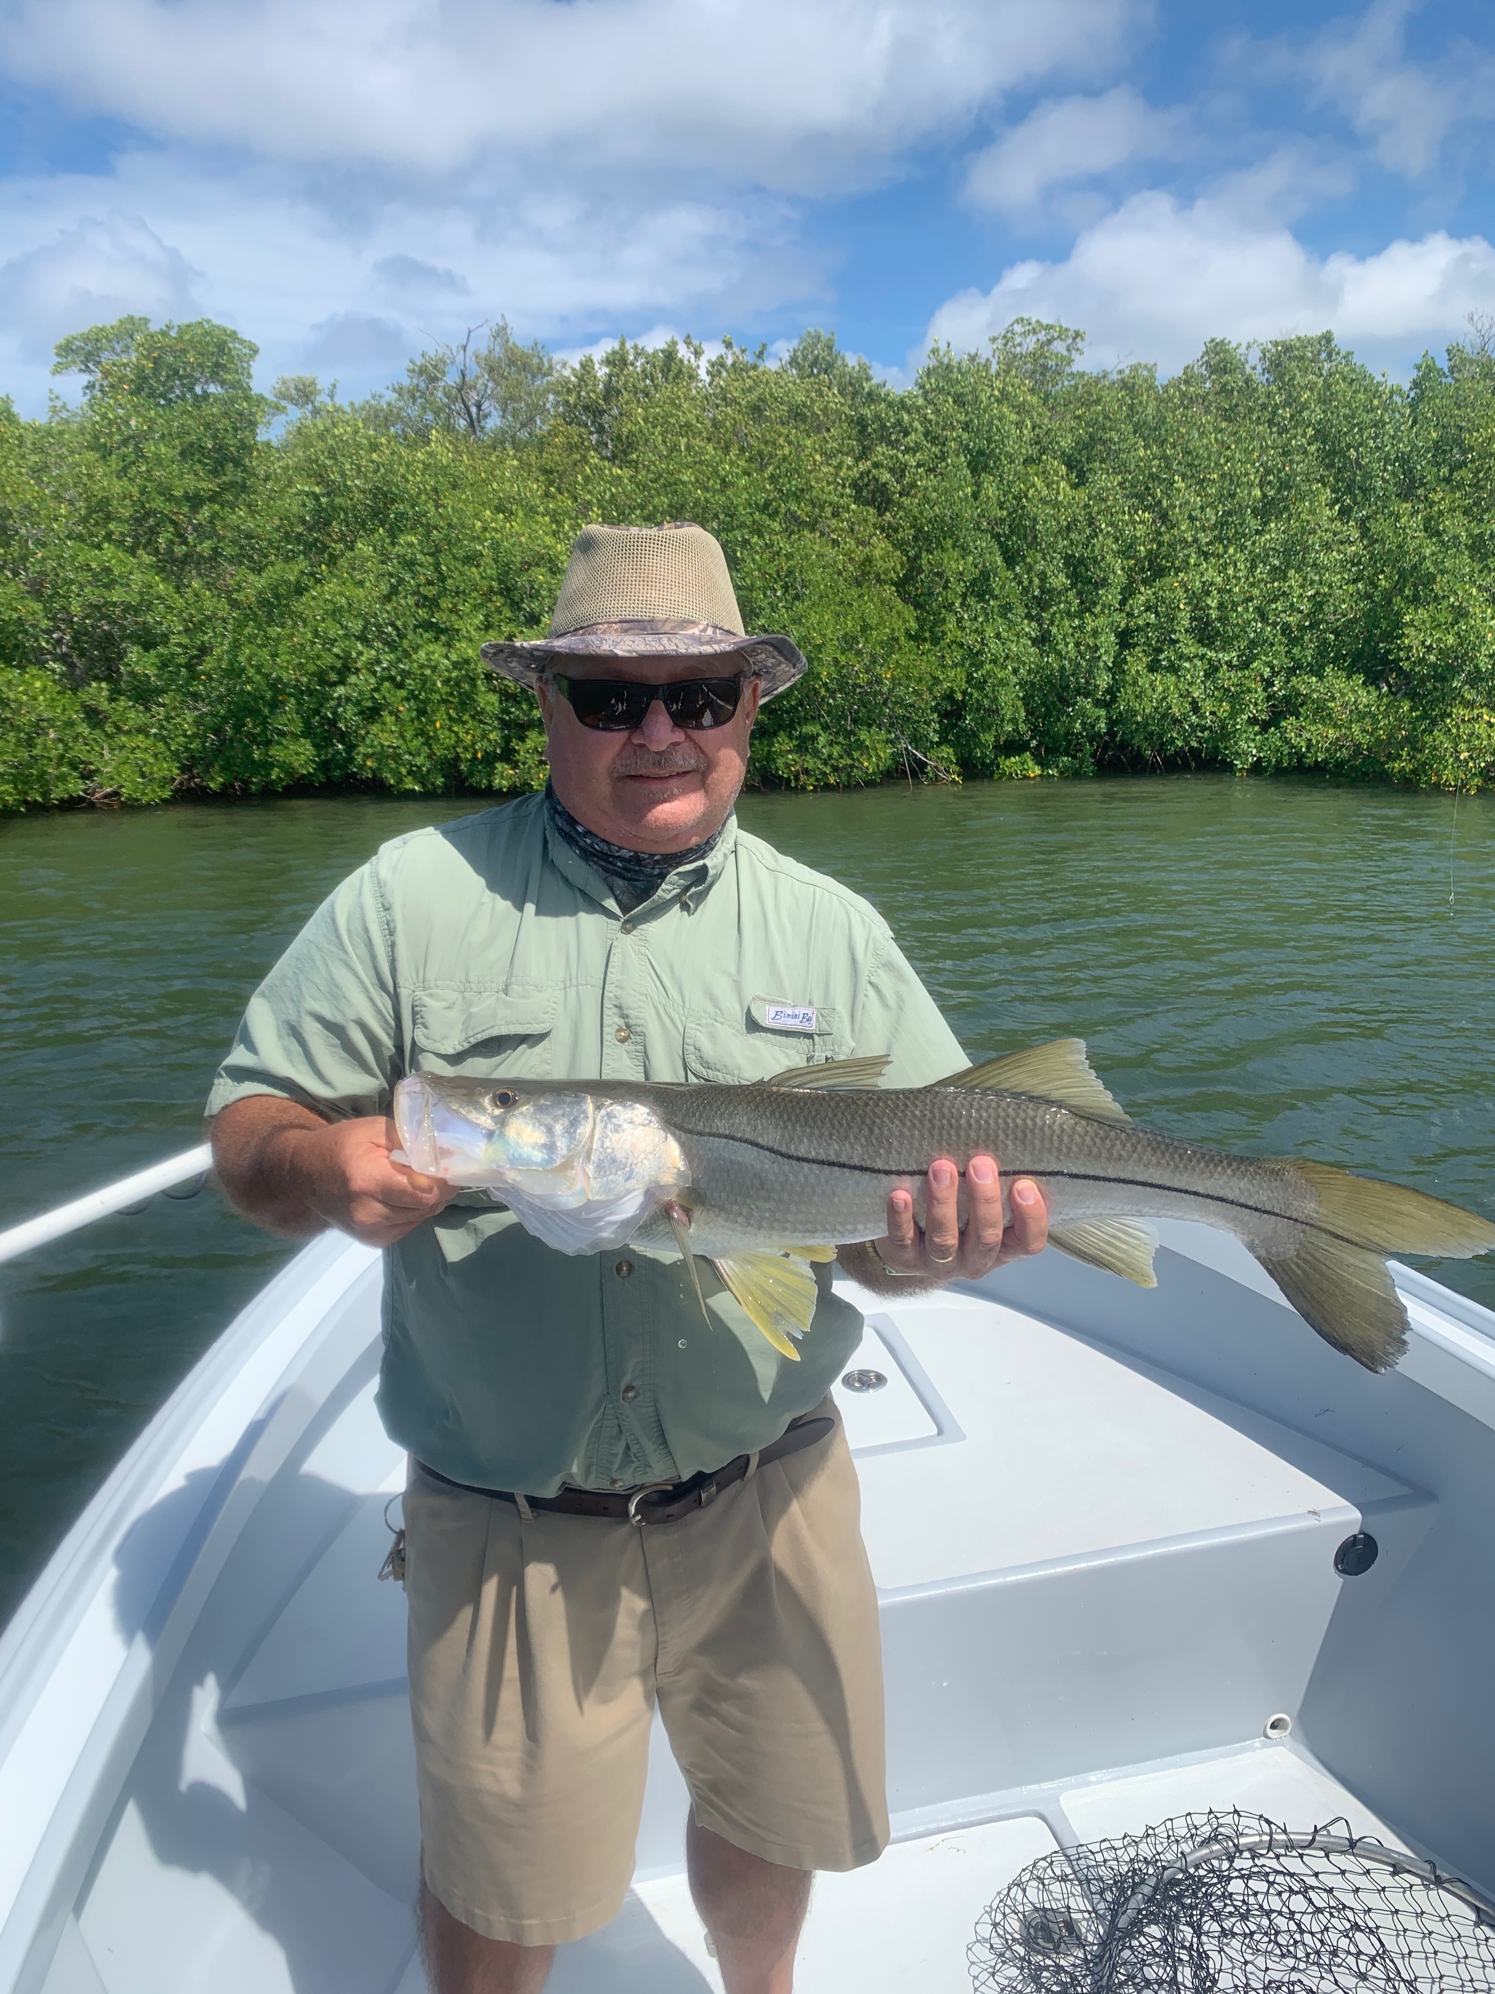

Sizzling Snook bite.

Pic: Barry from Ft Myers with a 31 inch Snook caught while fishing with Capt Matt Mitchell this week.

Warm water and summer heat turns the Snook bite on and this proved true this week with our action only getting better and better. Throw in some south wind and this bite only got better and better. Higher than normal tides brought on by these southerly winds gave anglers the opportunities to fish some shorelines I have not fished in months,

Most Snook trips this week we managed a solid 20 fish caught and released with most days bringing chances at a few big ones that we at least hooked if not landed. Fishing with newly retired local Lee county bus driver Barry we caught Snook all morning until he tied into a much much bigger fish fishing oyster bars. This crazed giant headed around the bar which was too shallow for it to cross then turned 180 degree’s right down the back side. Starting up the boat I gave chase and just about got it to the boat when the hook pulled loose.

Fishing one last shoreline before wrapping up the morning charter Barry caught a few more mid twenty inch fish before hooking and landing a 31 incher. This was Barry’s biggest ever and took away a little bit of the pain from loosing the larger model at the last stop. Most Snook trips this week brought fast paced action along with landing a couple over that 30 inch mark.

This week also brought the best trout fishing I have seen since last June. Targeting area’s from Demere key north we caught lots of trout up to 18 inches. We caught these fish lots of different ways including popping corks, jigs and free lined live shiners. The key seemed to be working the sandy potholes in 4-6ft of water. If I did not catch a fish within a few minutes I’d pick up the powerpoles and drift down another 20 yards or so. Mixed in with these trout we caught a variety of species: mackerel, bluefish, jacks and ladyfish. Its been a long time since I caught trout with any regularity so this felt good.

Windy days have made it a little tough on the early season tarpon anglers. I did see lots of fish one day behind Cayo costa and another good amount by Bird key basin. These fish are very hard to get a pattern on as they seem to be there one day then gone the next. April is always a windy month which makes tarpon fishing a little tough. Once you do get a nice slick calm day we will realize there are tarpon everywhere.

