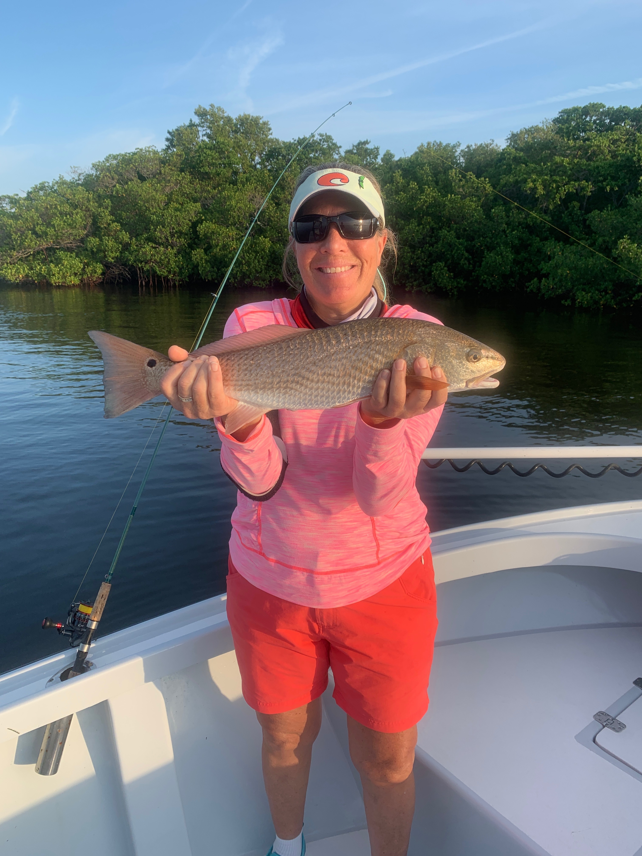

Pic: Mary Laser with a Fun-day redfish.

September fishing is as good as it gets.

After what was almost a full week of not getting out on the water due to Hurricane Dorian effects winds finally laid down and it was go time. With all the reports of red drift algae on the beaches I expected to find a mess out there. The bay remained clean and loaded with birds, bait and fish. Snook, Redfish, Trout and Mangrove Snapper kept the rods bent during the few charters I did take this week. Most days there where very few boats out and almost zero angler pressure which is normal for this time of year.

As we move into mid September business has slowed and its the time of year most of us local fishing guides get to enjoy some time on the water along with taking our annual vacations. Being able to get out and go fish without clients on board is something I still cherish. September offers some of our best fishing all year with what can be endless options. From now through October generally most weeks we do work though its just a handful of trips. Being on the water 300 plus days a year after a couple of days without a trip I start to twitch and get stir crazy.

During these next few months I get to explore and do what I like to call research looking for new places to fish. When fishing without a client on board its very different as there is no pressure to catch fish. My favorite fish to target for the next few months are tarpon which are now just starting to show up off our beaches mixed in with the huge bait schools. These tarpon feed much better than the the ones we all make a living fishing for in the Spring. Where and when they decide to show up is not quite as predictable as in the Spring though once located I often stay on them for weeks as long as the weathers stays consistent. Getting out for a few hours first thing in a morning and locating these fish you will generally have them all to yourself. This is as good as our tarpon fishing gets.

The Redfish bite has also been strong with lots of mid to over slot sized fish being caught close to home. Getting out on the right tide phase has been the key to catching these fish. This redfish bite will only get better through October with big schools starting to pop up around the passes and out on the flats. When looking for food fish our mangrove snapper bite has been on fire out on the flats with limits coming in and around the bait schools. Catch and release snook fishing has started to move from the beaches and passes to the transition areas these fish use as they work there way back into the sound.

When ever anyone asks what’s your favorite month to fish my answer never changes: September.

