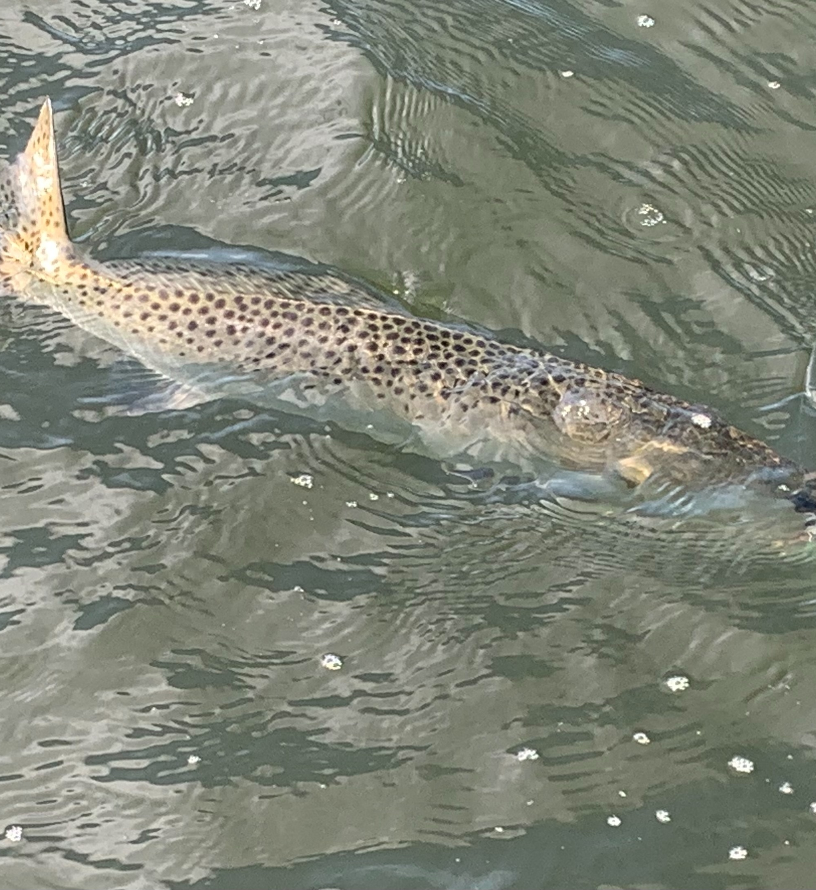

Run from the storms to stay safe.

Pic: Big trout are eating up jigs on the flats

With our summer rain pattern now in overdrive watching both the sky and the weather radar on your phone is more important than ever. These fast moving thunderstorms are dangerous often packing lightening, strong winds and heavy rains. The last place you want to be is on a boat being caught out during one of these storms. Lately anything after about 2pm your chances for being chased off the water are pretty good.

During lower tide periods drifting the passes has been on fire for Snook, redfish and even a few trout. The boat of choice has been small to medium grunts and pinfish rigged with just enough weight for then to skip along the bottom while the boat drifts on the current. Depending on the speed of the drift you may need to change the size of the sinker so you are making contact with the bottom. Make long casts up tide and keep the line tight and the tip up so the strike will bend the rod. This method is deadly all summer long.

When we have higher tides mangrove fishing has been the better choice. Look for the fish to be way up under the tree’s, back in the shade. Favorite baits for this include a well trimmed pinfish along with cut ladyfish and mullet. Making that perfect low skip cast to get the bait way up under the tree’s will often make all the difference between catching and not.

When set up against the mangroves cutting smaller chunks of ladyfish or mullet and chumming will draw the redfish in. Another way that works really well during these hot water periods is a jumbo frozen shrimp fished under a float. Throw this rig up to the mangroves and by letting line out and reeling it in let the float drift down the shoreline. When the water is as hot as it is now fish get lazy and eat a dead bait quicker than anything else.

Trout fishing out on the flats has remained strong with locating small fry bait and feeding birds being the key. Jigs have been working better for me than even live baits. Glass minnow jigs and soft plastics cast around the bait schools have been catching lots of trout along with a mixed bag of mackerel, jacks and ladyfish. Many swim jigs only require a slow retrieve to get bites. Seems most of the fry bait schools have been up on the edges of the bars that are in close proximity to grassy flats. Some days the best action has been as shallow as 2-3ft.

