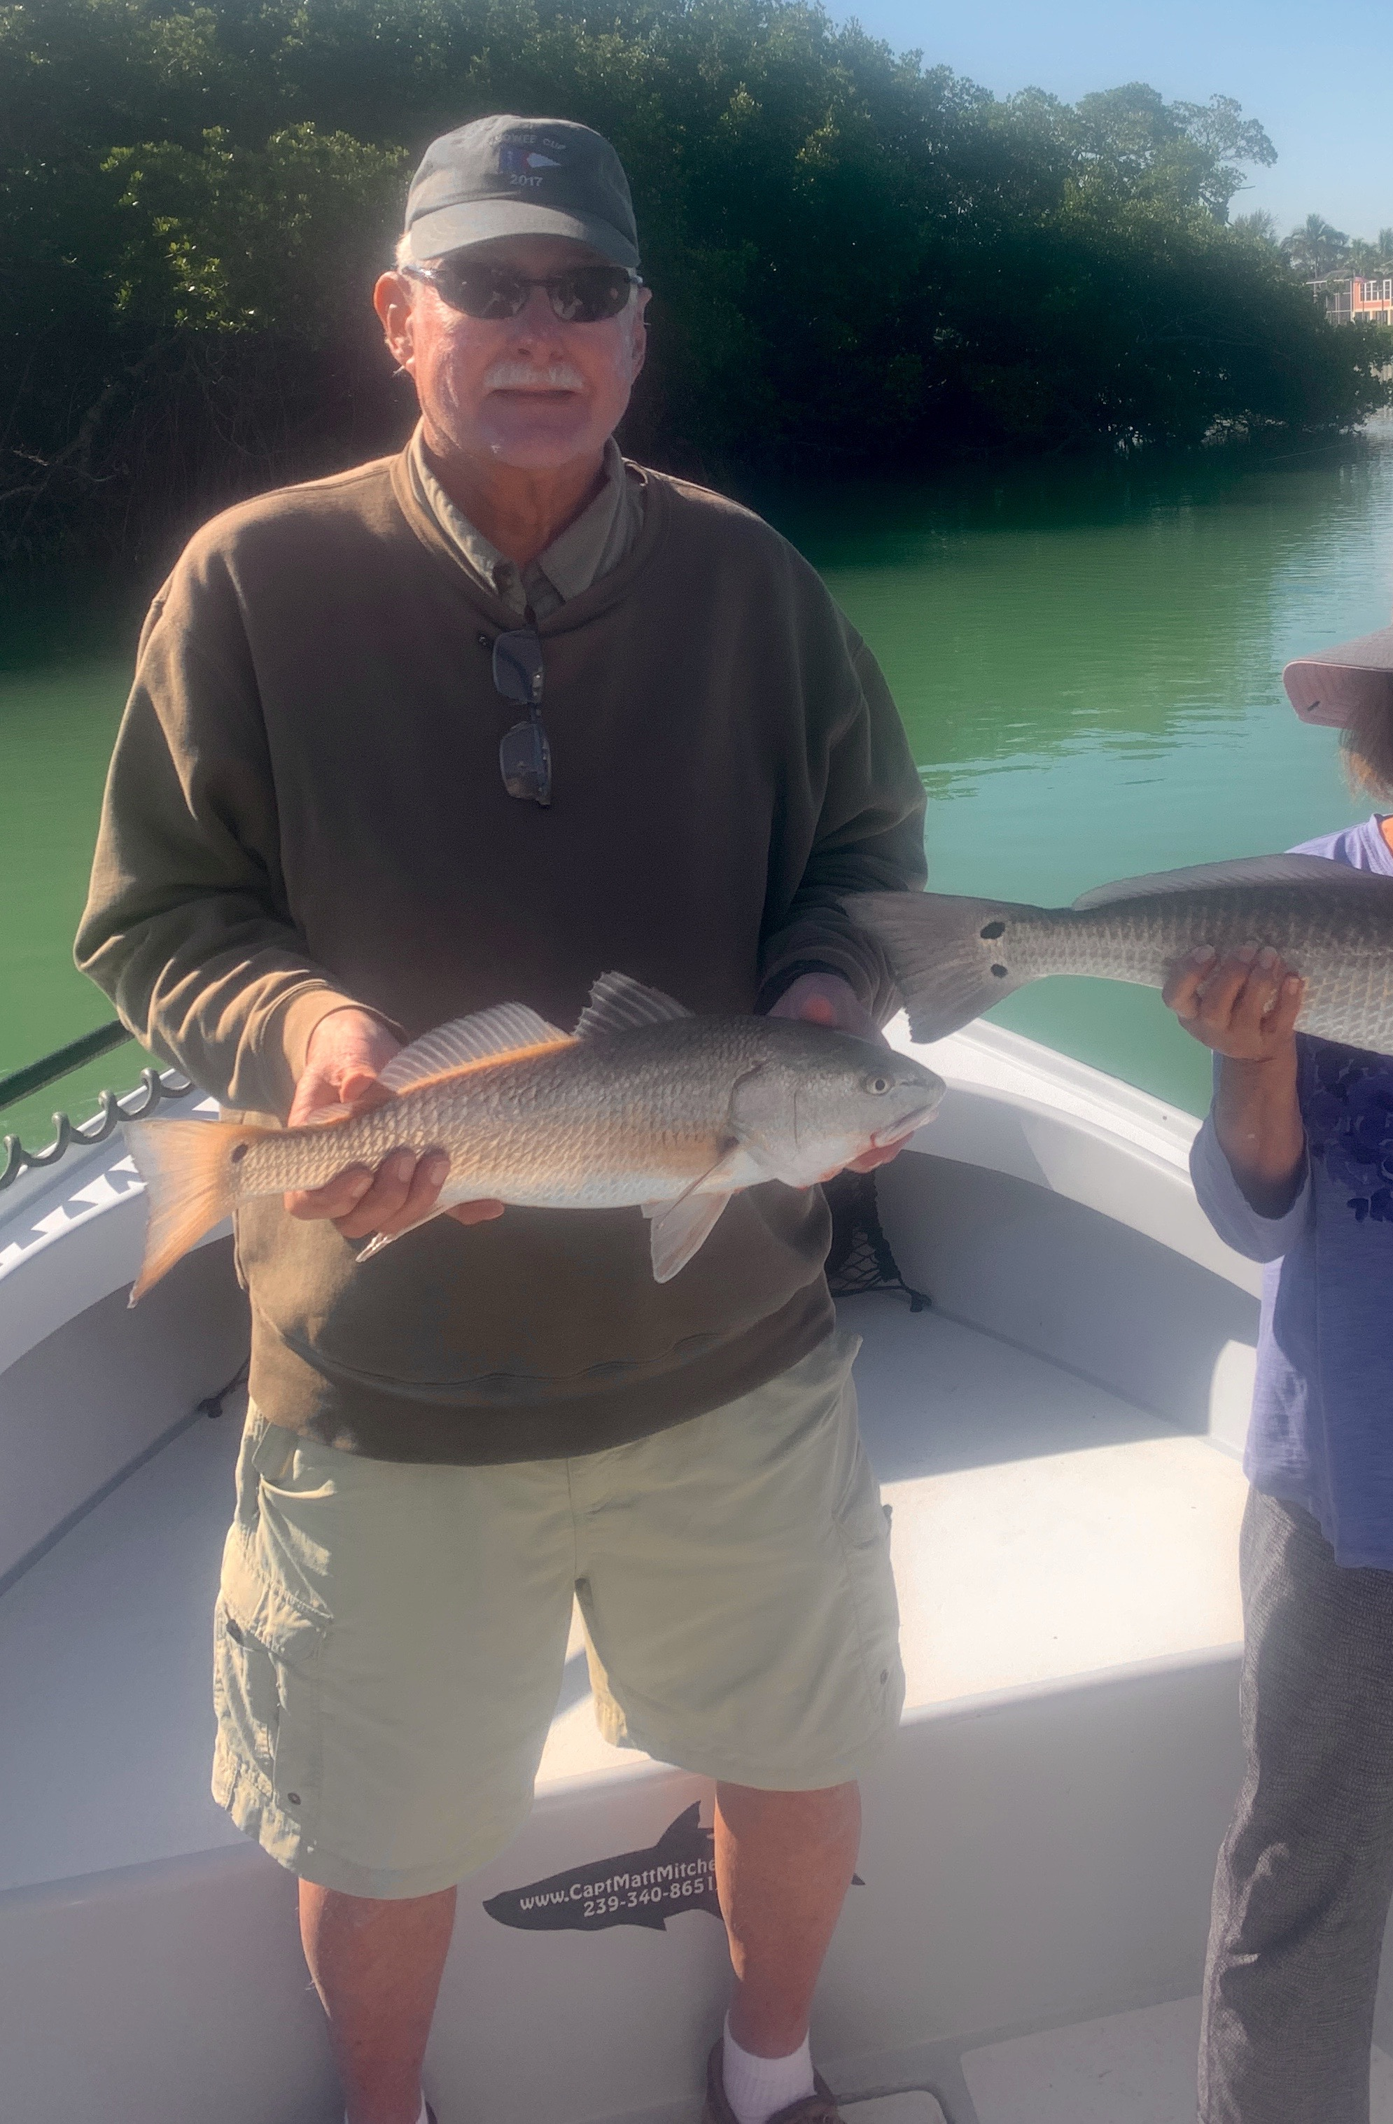

Redfish, redfish, redfish!!!
Pic: Chia and Terry from SC got in on the crazy Redfish action while fishing with Capt Matt Mitchell this week

Last winter we caught more redfish than I can ever remember. This past few weeks its been even better. Switching baits from shiners to shrimp we had several 50 redfish trips. What has made it even more amazing is the average size of these fish is now right around 20-26 inches. All the little rat reds we caught last year have had a chance to grow up with the closure.

With clean clear water its been possible at times to spot these redfish sat under mangrove limbs. During the morning lower tides look for them to be close to deeper water right where deeper channels butt up against the mangroves. Once located its been as fast paced as you can get a bait in to these hungry fish. The better bite for me has come while using live shrimp rigged on a jig head.

Snook fishing has remained strong while fishing live shiners. All the passes have had good numbers of them. Find fast moving current along with structure and the snook will be there. As the water got much clearer this last few days this bite has got a little tougher than it has been in the past weeks. The better snook action has come during the last few hours of the outgoing tide as the water gets a little dirtier.

When fishing with shiners this time of year eventually your going to hook a bird. These sea gulls during are cooler winter months always seem to be hungry and aggressive. Often sea gulls will simply let go of your shiner if you just wind tight. When a gull does grabs your bait avoid trying to yank on the bait as this will set the hook. If you do hook one gently reel it in all the way to the boat. Once you get it close cover its head with a towel to calm it. While keeping the birds head covered get a good solid grip and carefully untangle it. Two sets of hands work better than one. Most importantly do not panic and cut your line leaving yards of loose line hanging from the bird as this is a slow death sentence. At times this week the gulls got so bad the only option was to move.

After struggling to keep shiners alive for what seemed like the last month I’m happy to report no issues this week. The small amount of red tide that has been lingering around at the east end of Sanibel island seems to be finally gone. After loading up on shiners at the causeway I’ve fished the entire sound without a single casualty.

