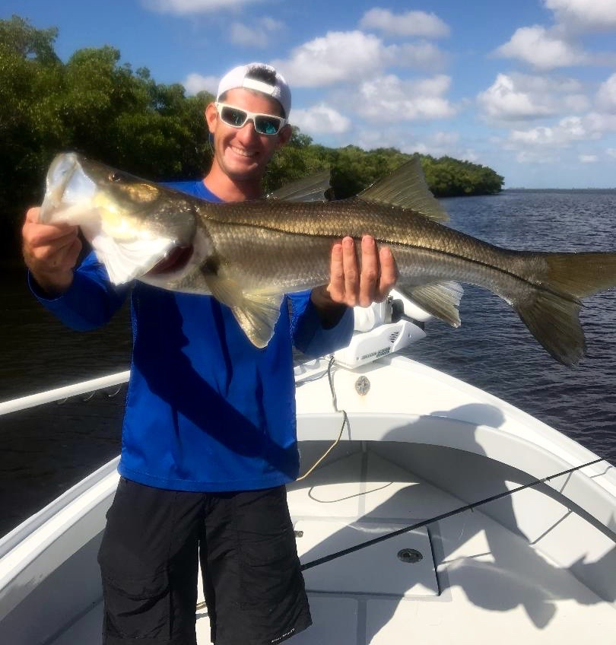

Pic: Sean from Pine Island with a 34.5 inch Snook caught and released while fishing with Capt Matt Mitchell this week

Red tide is gone but not forgotten.

Our gradual change of seasons is taking place. It not drastic enough to notice yet unless your up early to enjoy the cooler morning temperatures along with the significant drop in humidity. Feeding fish and birds working schools of small fry bait have begun to appear all over the sound as the southerly bait migration of fall is firing up. No matter if its Spring or Fall the change of season always offers anglers some of the best fishing opportunities all year.

Another clue that Fall is here is the prevailing easterly wind direction which we have had for the past few weeks.. This wind is just what we needed to totally push the last little patches of red tide in the sound offshore. For the first time in months our beaches along with the sound got a clean bill of health and is red tide free. Water in the sound is not only clear but alive again with all kinds of life.

This week brought some of the best catch and release snook fishing I have experienced in months. I’ve been averaging over 20 snook a trip while casting live shiners to both oyster bars and mangrove shorelines. This week we had several snook over 30 inches and often had many favorite well known snook honey holes all to ourselves. The biggest Snook of the week measured 34.5 inches and was landed by Sean while out with his Fiancé Monica. Sean was under pressure right from the start when when Monica landed one 32.5 inches early in the trip, Sean lost a giant boat side mid way through the morning that broke his heart then right at the end he pulled out a buzzer beater and got it done.

Nothing has been more frustrating over the past few months than to hear people who have not been out on our water for weeks or even months speak out about how this red tide was catastrophic killing all the life in our waters. Nothing could be further from the truth as opposed to popular belief our fishing been outstanding over at least the last month. Simply looking at a very vague red tide map gives you no idea that are waters have made a incredible recovery.

This red tide/ green algae nightmare has been a real catch 22 for all our local business. We all want and need this water quality issue taken care once and for all. Seeing the same Red tide story in the headlines since July is both good and bad. It does bring national attention to this major water quality issue although on the other hand it has suffocated local businesses with the slowest August anyone can ever remember. Even now that this red tide has gone its still very fresh in peoples minds who don’t even live here. With so much misinformation out there tourists are understandably very apprehensive to return.

The most frustrating part of all is that the solution to this water quality crisis is so very simple, restore the natural flow from lake O flow south into the everglades. This solution requires the purchase of all the farmland south of the Lake and with this only permeant fix not being on the table for either of the candidates for Senate, we can only vote for a new governor that will get this way overdue Everglades restoration done. Both Senate candidates plan is to re-enforce the dikes around the lake and come up with more water storage areas which is only a band aid. Neither one of the candidates for Senate have done anything to help our water quality. Both there plans for Lake O will only let it hold more water to dump on us during high water periods. Even though we are now red tide free we cannot let this environmental catastrophe happen again.

