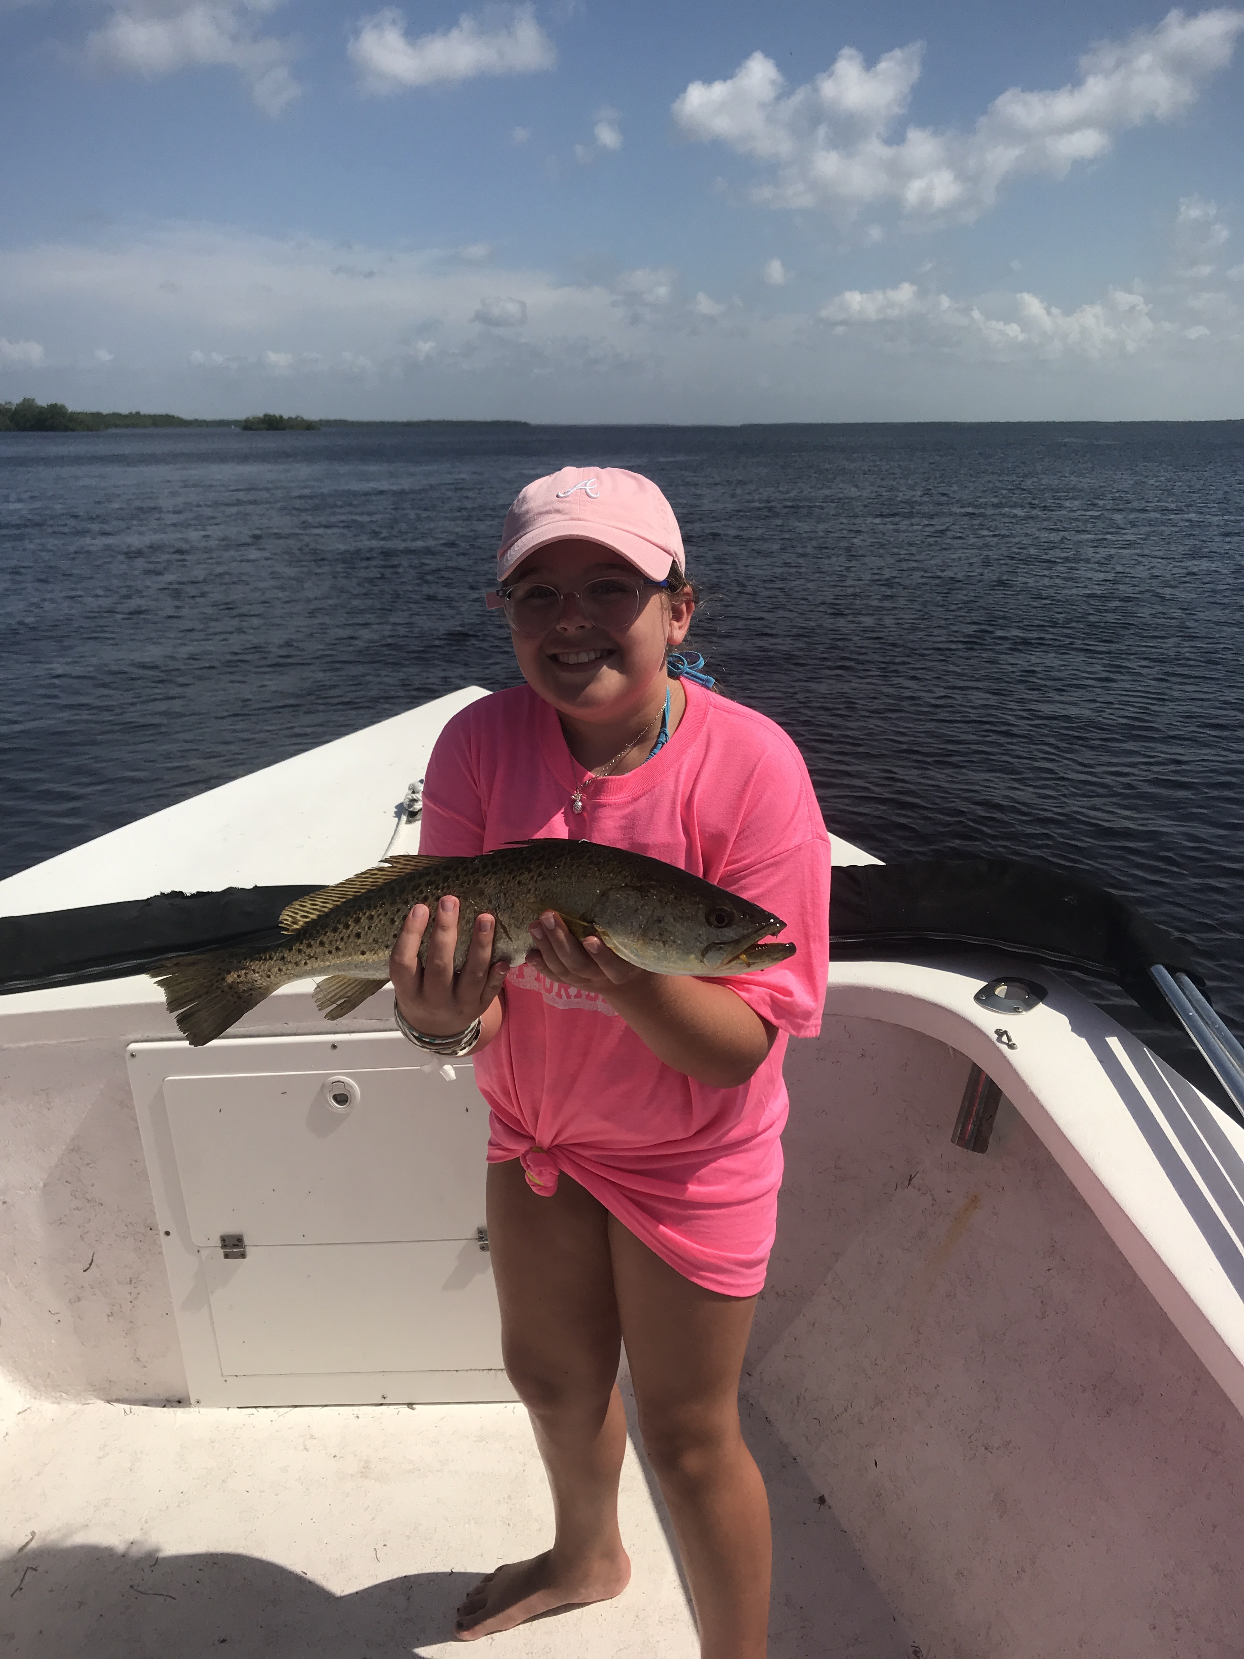

Red tide clean up underway

Picture: Emily from Georgia with a big trout caught while fishing with Capt Matt Mitchell

Early this week I experienced a heart breaking couple of days of what I think was the worst red tide fish kills in San Carlos Bay I may have ever seen in the 35 plus years I’ve been fishing. Thousands of dead fish of all varieties where floating lifeless on the surface then on the tide lines all you could see was white as these dead fish where pushed together on top of each other. Though the majority of the dead fish where pinfish, catfish, mullet and threadfin herring once in a while you would see a few trout a goliath grouper then very occasionally a Snook or redfish.

Over the next few days the floating dead fish gradually made their way northwest pushing up to the powerlines and saturating Chino Island. The channel on the east side of Chino which is the natural way the current moves had dead fish stacked up against the island 20ft deep. Running further northward in the sound things slowly improved with areas past Redlight shoal with the eastern side of the sound looking clean and without any floating fish. Areas inside all our passes also had dead floating fish, which looked like they had been decomposing for several days as they slowly got pushed in and out on the tide.

I only had a few charters booked early this week and was extremely transparent with my clients explaining the red tide situation. I totally understand that when your here visiting and see thousands of dead fish all over the beach its hard to believe its worth going fishing. Although its not the type of live shiner fishing I’m used to doing this time of year action on the 3 trips I took was surprisingly good once we got to the cleaner water. Live shrimp where my go to bait as they stay alive in the red tide water while baitfish won’t.

My target species on these trips was mangrove Snapper and we had great success coming home with limits on each trip. Structure in areas from redfish pass to Captiva pass on either side of the sound was loaded up with these fun fish to catch. They ranged in size from 10-14 inches and once located we caught them basically on every cast. Down sizing the gear to cast free lined shrimp these fish are as fun to catch, as they are tasty. While up in the Captiva pass area one day I did see lots of Snook on the docks along with lots of small white bait. Trying to catch bait has been a little different than usual, as if and when I locate it I’ve been making a few casts with my clients on board.

With a huge beach clean up now underway and easterly winds forecast for the next week the amount of dead fish washing in will only get less and less. August is one of our slower months for business anyway as kids go back to school and family summer vacations come to a end but when you add in the water quality crisis being highlighted on the national news things are going to be slower than usual for everyone who makes a living through tourism in southwest Florida.

