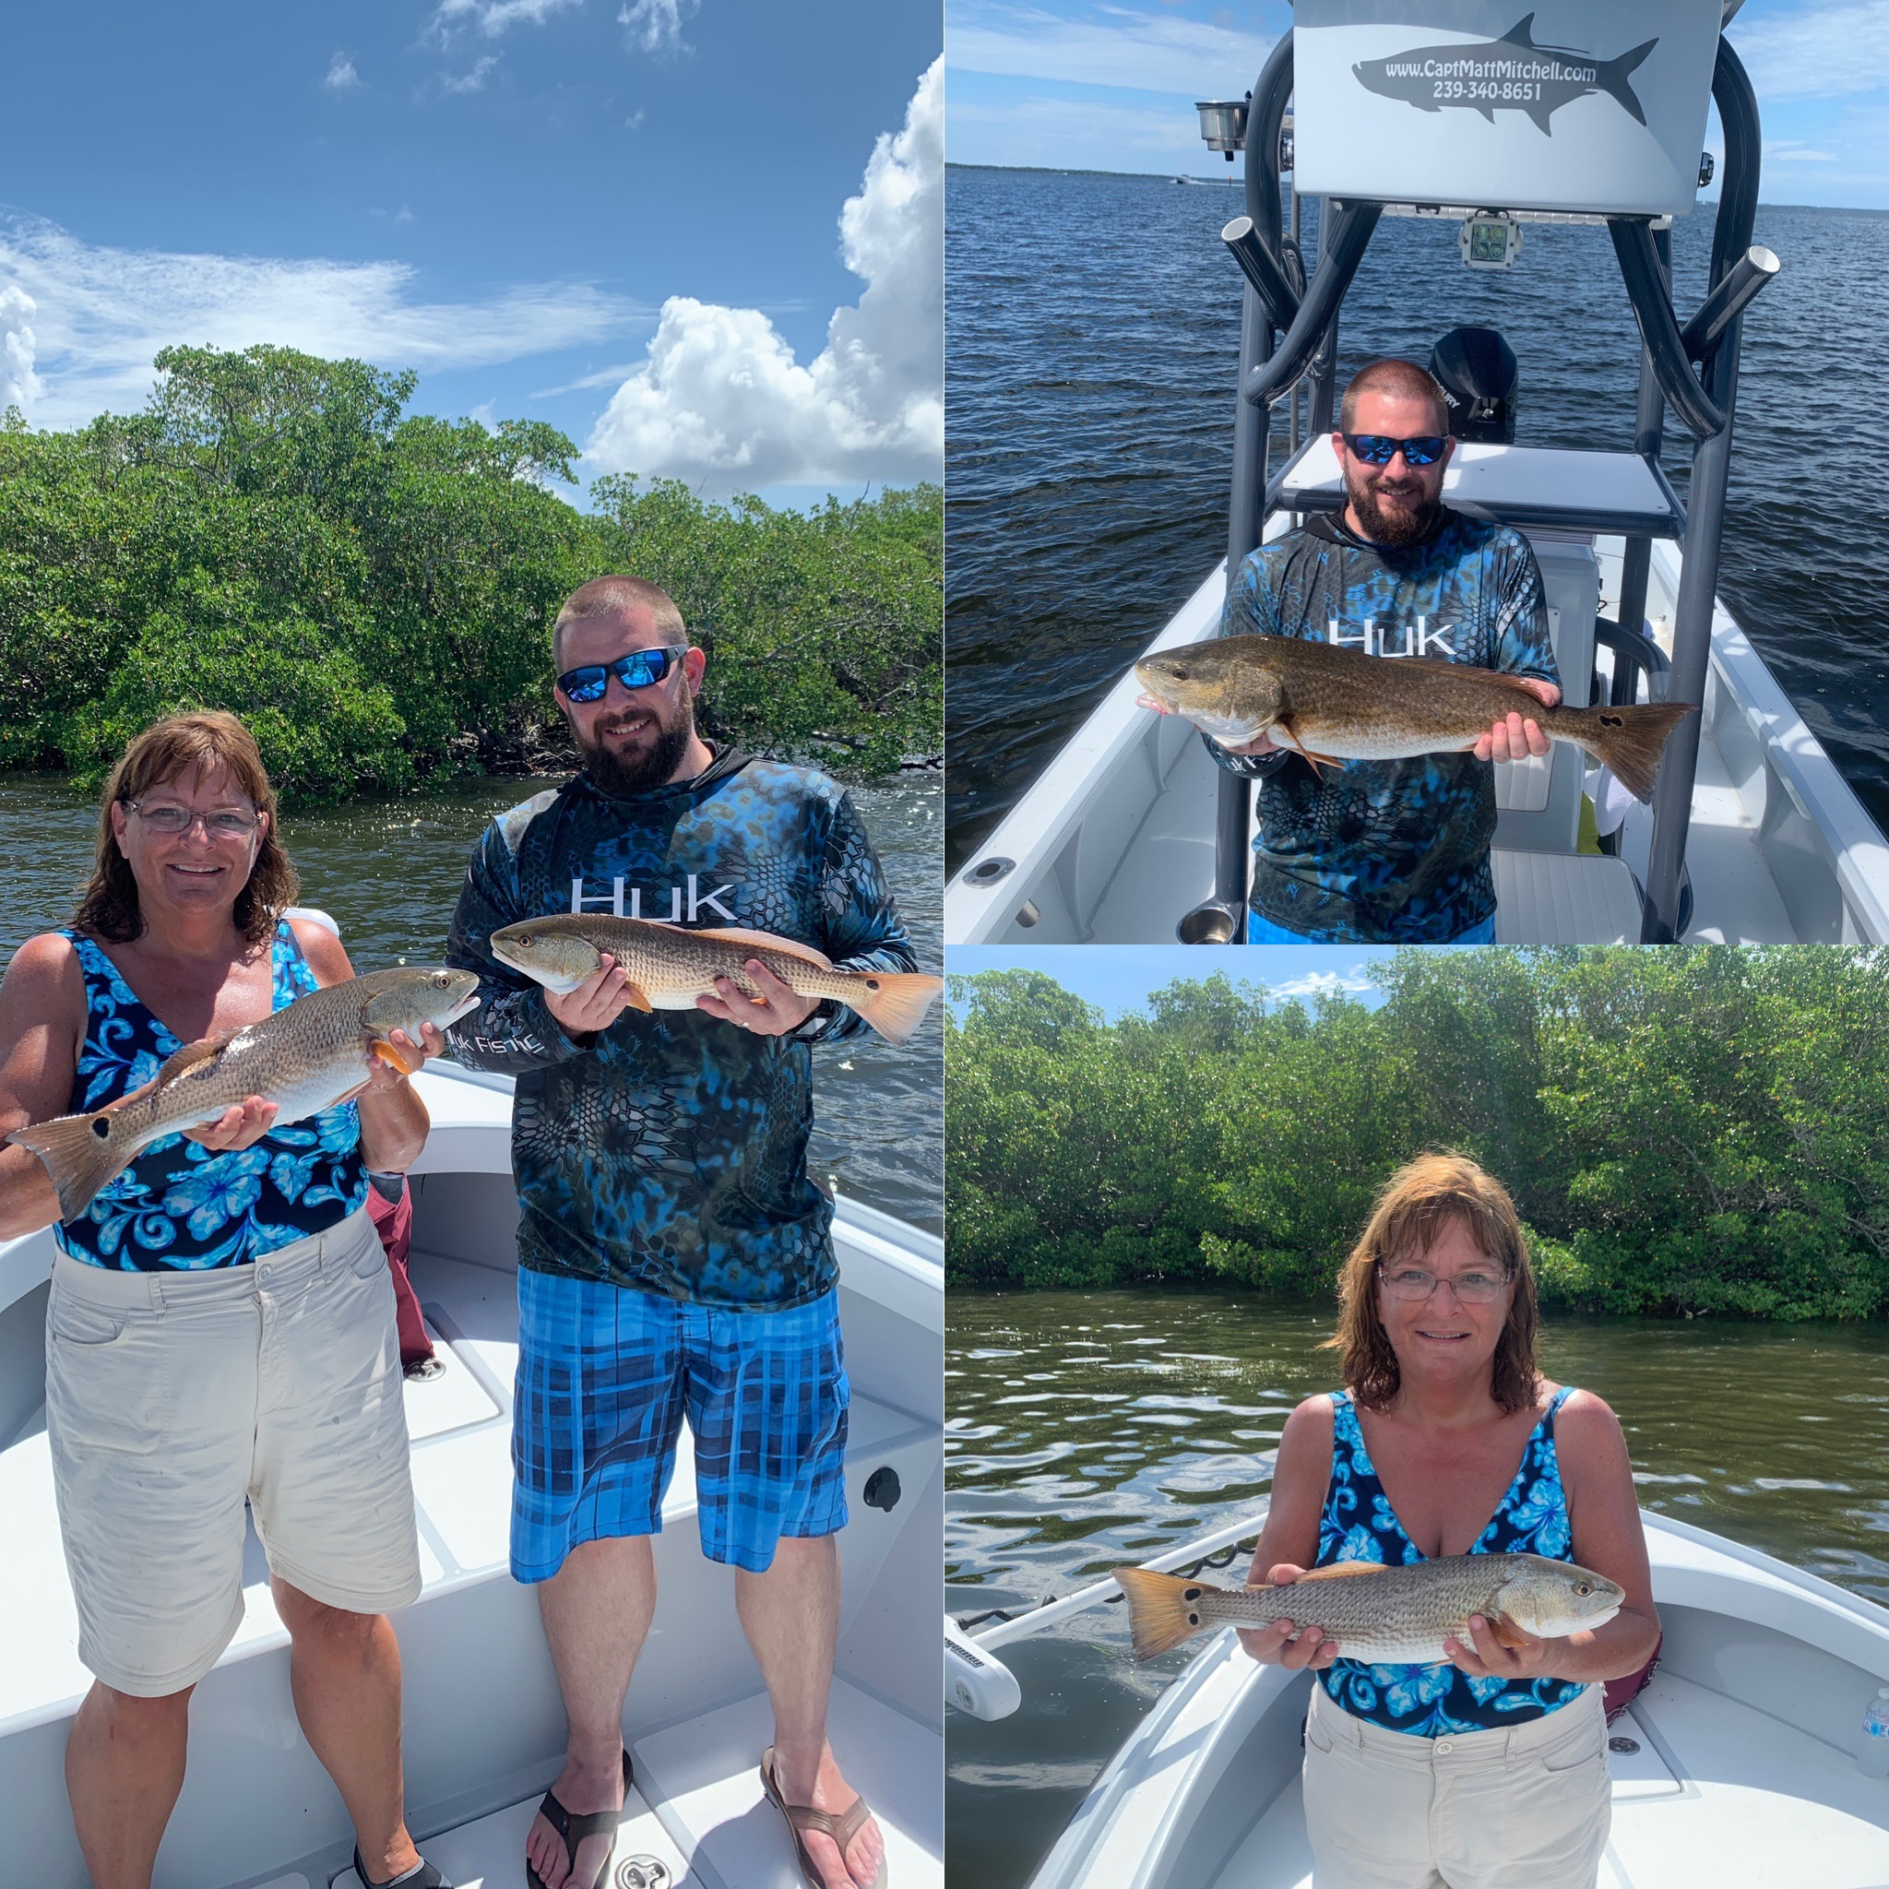

Pic: Shawna and Chad from NC got in on the hot redfish bite with Capt Matt Mitchell this week.

Rainy day redfish bite

Rain and even more rain at basically anytime made getting out fishing this week a crapshoot. On the days I did get out we dodged the heavy stuff and experienced some great fishing while enjoying cooler overcast conditions. On the mornings of stronger thunder storms and lightening it just wasn't safe to even leave the dock. Going out and catching bait before having to cancel is frustrating though being out in the lightening is just not a option.

The trips I did get done this week fishing was awesome with Snook, trout and redfish being caught. Morning high incoming tide, west wind and rain cooled stained water was the perfect set up to get in on some of the best redfish fishing I have been on in a long time. Catching a dozen or so redfish along with double hook ups is as good as it gets.

Redfish from 20 to 30 inches where caught during the last few hours of the incoming tide and the first hour of the outgoing tide. The redfish action this week came on Mangrove shorelines from St James city to Regla Island as well as the Fosters point area of North Captiva. Finding the windblown shorelines with moving tide we targeted the points catching these fish both on live shiners and tail hooked pinfish. If I did not get a bite after 5 minutes, I’d bump a little further down the shoreline. Once I did find these fish its was just a matter of landing that money cast up under the tree’s and bang. Tiny little overhanging mangrove points would sometimes be holding a half dozen or so redfish.

Trout fishing out on the flats from Chino to Red light shoal was a great way to get my guests quickly hooked up and catching fish. Feeding birds made finding action on the flats easy. Trout up to 22 inches where caught both under popping corks and while slowly retrieving free lined live shiners. Along with the trout we also caught mangrove snapper, mackerel, ladyfish and jacks. This crazy flats bite has to be partly due to the mass of baitfish we are seeing all through the area.

Deeper mangrove channels during the lower incoming tide held lots of juvenile snook with these fish coming almost every cast at times. Bigger snook are still hanging out in and around the passes and have been feeding better on the outgoing tide which we will get in the mornings this next week. The mangrove bite for snook continues to be on shiners while the better pass action is on grunts and pinfish fished with a sinker close to the bottom

Rain cooled waters have done wonders to keep good numbers of late summer tarpon around. Several times while catching trout out on the flats this week we saw a few rolling tarpon. I’ve been getting a few reports from other guides catching these tarpon on both live pinfish under a float and cut bait fishing. If you plan on targeting these tarpon pick a slick calm day and check out all the usual places in the sound. Find the bait and you will find the tarpon. better yet they generally feed much better now than they did pre spawn in the spring.

