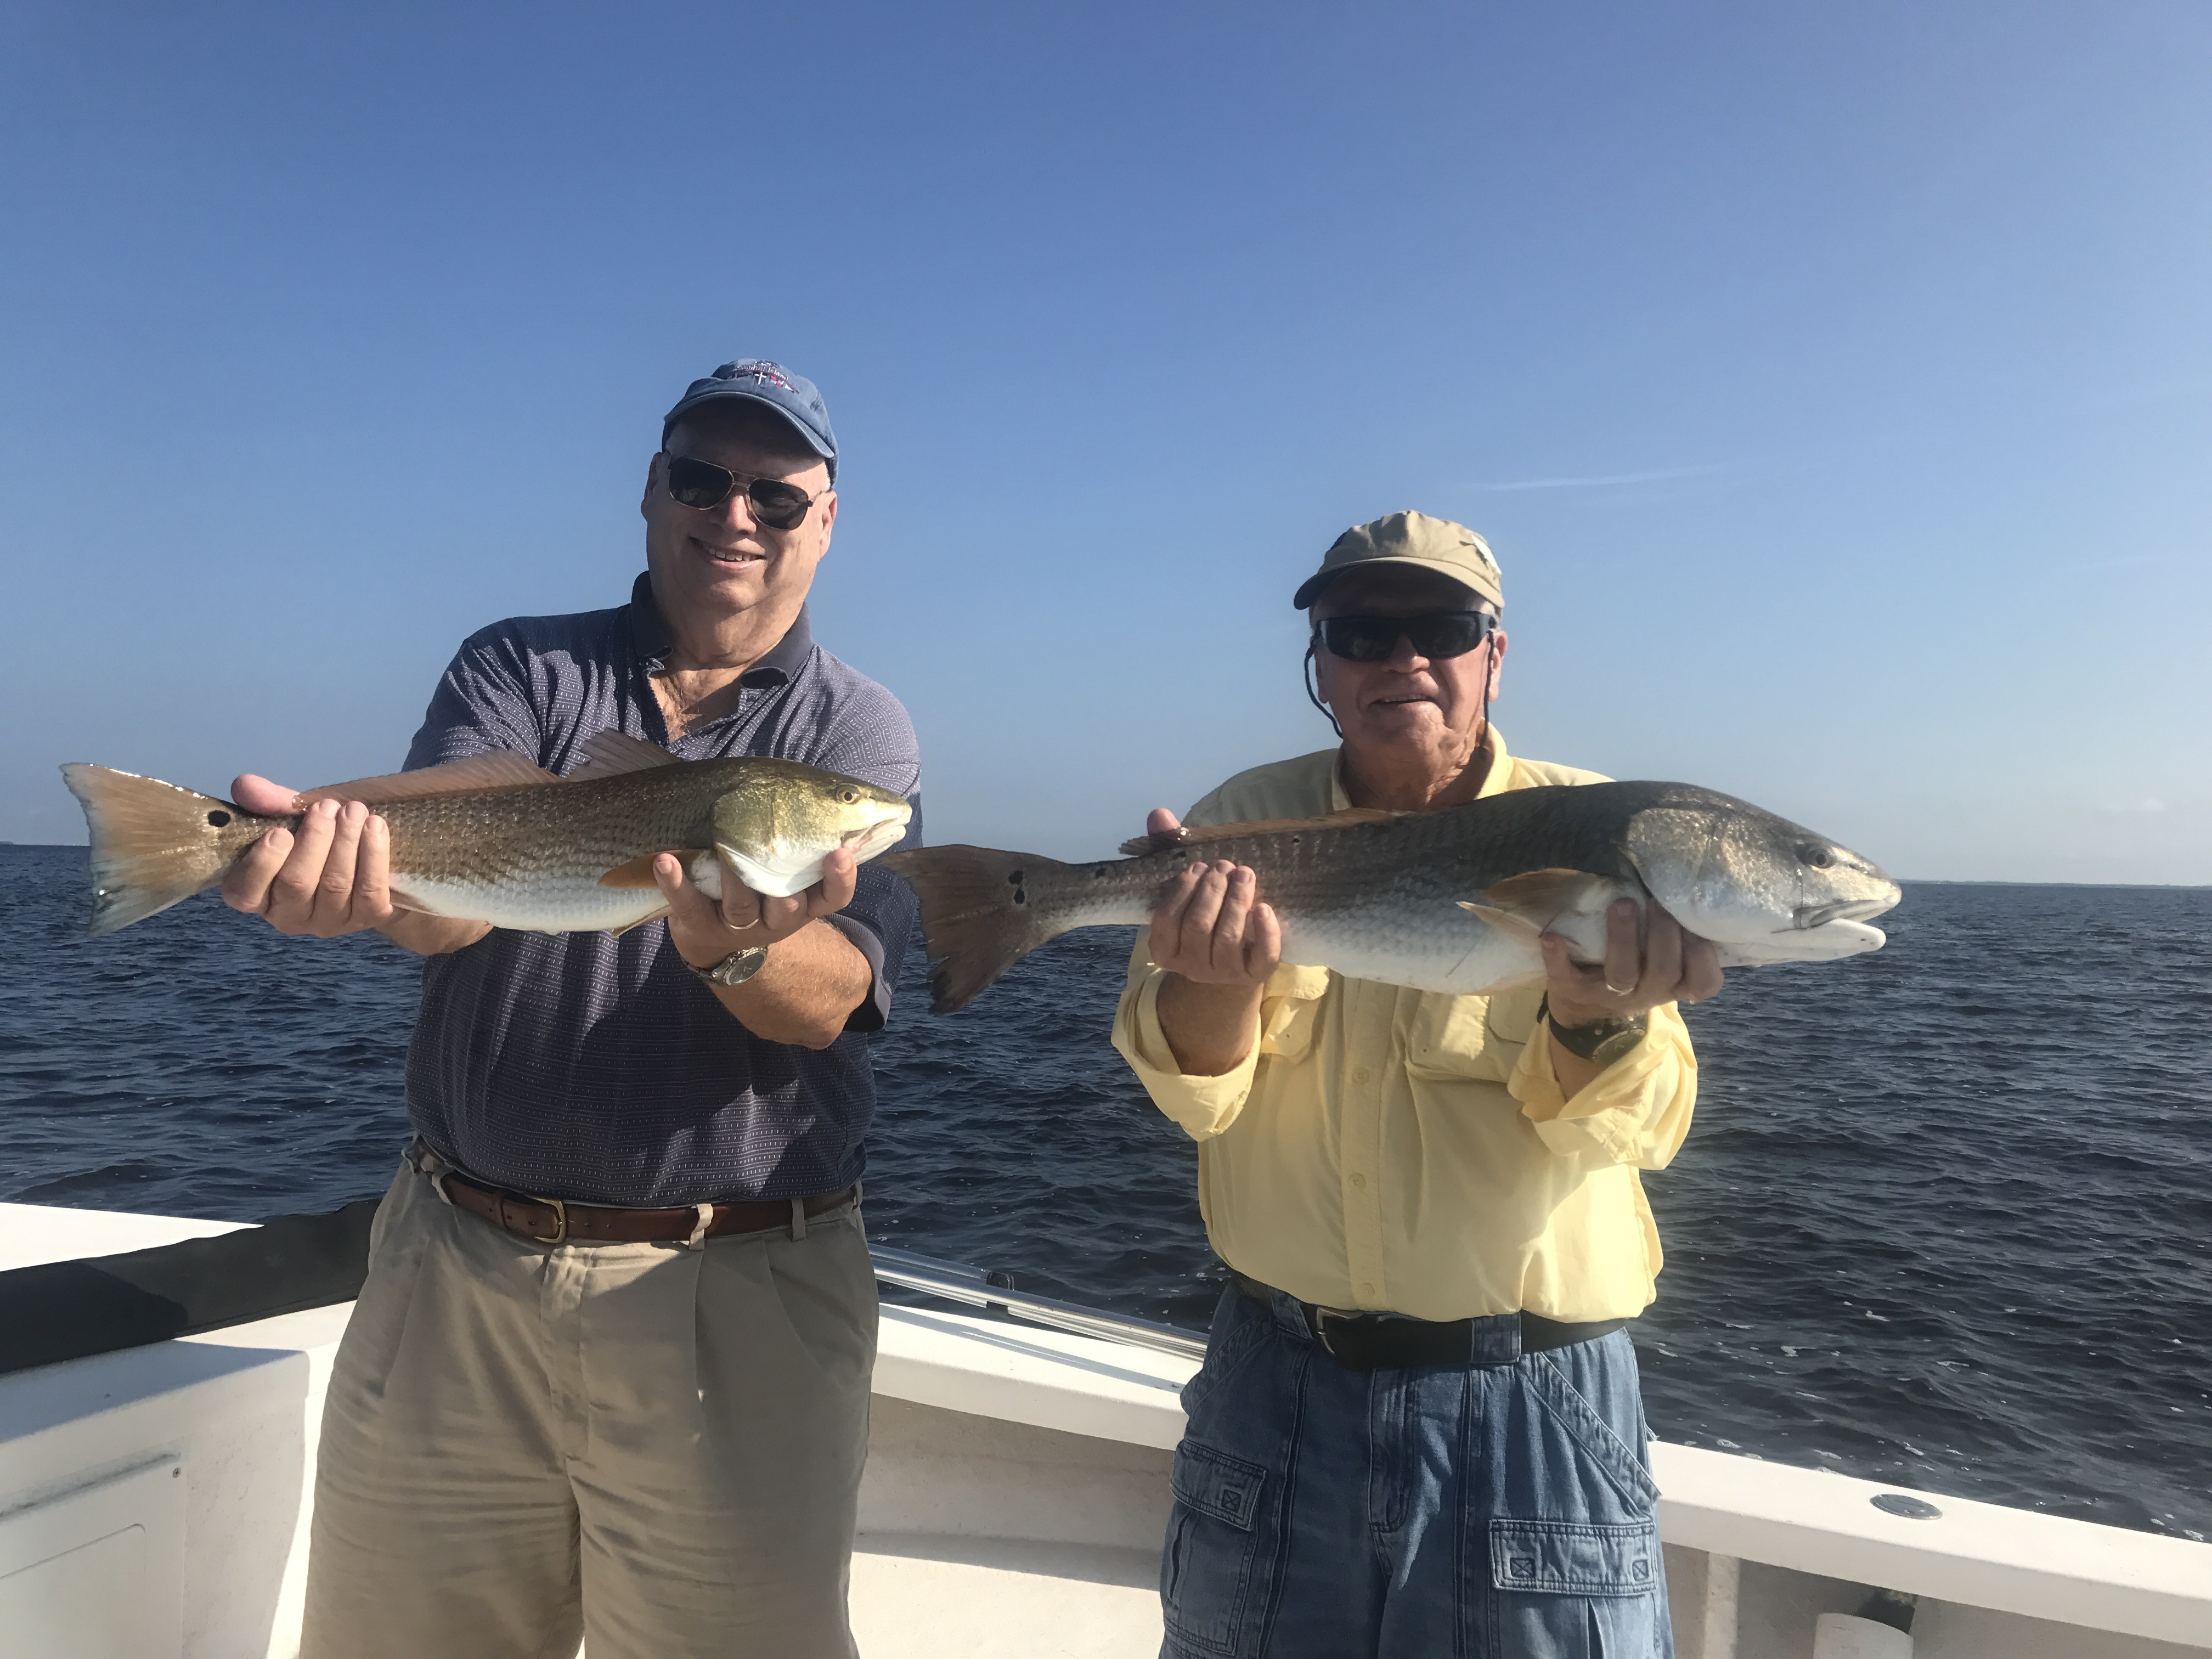

Picture: Bill Farmer and Jack Campbell with a Post hurricane Irma Redfish double caught this week with Capt Matt Mitchell.

Post Irma bite going off

Returning back to fishing this week after the Lee county barrier islands dodged the bullet of hurricane Irma it was a much needed relief. Getting back to work after not being on the water for almost a week I found little to no damage out there, all the channel markers and no wake signs even made it though the storm The lack of boats on the water was the most noticeable change and best of all despite the brown water from all the run off fishing was on fire.

My first day back on the water I went without clients just to see what had changed and locate the bait and fish. Heading out the canal at 1st light I expected to see damage in the Sound like hurricane Charley had caused stripping many of the mangrove islands and changing the whole look of the bay. To my delight it was hard to tell we had any kind of weather event let alone a Cat 3 hurricane. The local neighborhood canals and waterways where not clogged with screen enclosures and carports the only visible damage was a few damaged docks, torn screened lanai’s and boat lift covers ripped down by the wind.

Usually the first thing that is effected by a major weather event is the bait which either moves offshore or just disappears. Running up by Redfish pass the water was still a funky brown color but after only a few minutes of chumming in moving current on a favorite grass flat shiners and pinfish came right in. A few throws of my cast net the live well was full and I could go fishing. Having a live well full of bait was a big relief as things finally felt like they where getting back to normal again. Only a few days earlier I was not sure if I would even have a house or boats to return back to. A hurricane really gives you a priority reality check and is a small price to pay in the overall picture for living in paradise.

Big high water was the perfect set up to fish oyster bars and wow was the bite good. Returning to theses same Oyster bars the following day with clients paid off with Redfish up to 30 inches and lots of snook to 24 inches. During the morning charter we fished 4 or 5 different oyster bars all with the same set up and caught fish at every stop. This brown brackish cooler water was what it took to fire off these fish.

September is always one of the slower months for fishing guides and other local businesses. This major hurricane we somehow dodged along with all the national TV news coverage of total devastation caused in other areas of Florida certainly won’t help anyones sales this month. If you feel like getting away from the stress of last week I can’t think of a better place to do it than out on our local waters fishing, There is very little pressure out there and the fishing is some of the best we have seen in months.

