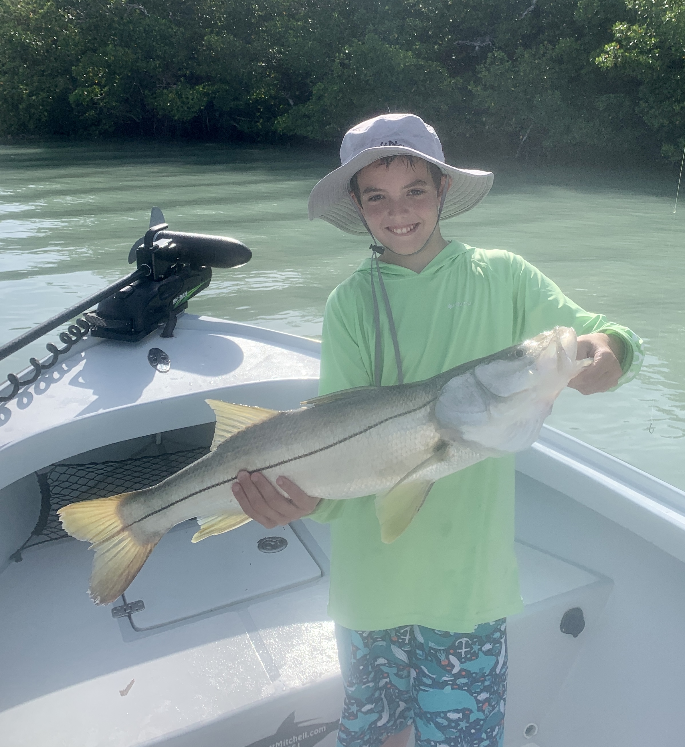

Pic: 12 yr old Nick caught this 31 inch snook while out with capt Matt Mitchell this week

Post Elsa action

After a few rain days off work due to effects of Elsa once back at it we experienced cooler water temperatures which did wonders to fire up the fishing. The western side of the bay and beaches was stirred up for several days while the eastern side of the sound remained remarkably clear. Dirty stirred up water in the passes does wonders for the snook bite while trout fishing in the clear water of the sound was also a good choice. For as much rain and wind we had after a few days and tide cycles things quickly got back to normal.

Snook and Redfish action was strong around the passes while the water was still sandy and cloudy from the rough conditions of the storm. Some days the better bite came while drifting the passes while other days it was better from a stationary boat. Often working a whole shoreline is what it took to pick away at some really quality fish. Returning to these same shorelines for several days on the same incoming tide period clients caught both snook and redfish over 30 inches.

Grunts and pinfish have remained the baits of choice when going in and around the passes. When I fish mangrove shorelines close to the passes i prefer to tail hook these baits pitching them under the structure. This method makes the bait swim up under the tree’s while they putt out lots of vibration. When the tide is moving really fast or your drifting add a split shot up on the leader and hook the bait through the mouth to keep them skipping along the bottom. Getting the presentation down changes by the day and tide, mix it up till you get it dialed in.

Tarpon are still around though not in the huge numbers they have been the past few months. They have become a little harder to locate but if you are willing to put in a little more search time the effort can and will pay off. Running a tarpon trip over the past weekend I was surprised at how few other boats where tarpon fishing. After a few stops I did find some happy slow rolling fish in the bay. Creeping around on them we jumped 3 all on pinfish under a float though we just could not get one to stick. These post spawn fish just feed better than they do in the spring.

No matter what species you choose to target big schools of small fry/hatch bait are marking the way. When you find this tiny bait in the passes look for snook and redfish to be under it. When its out on the flats the trout will be there. In deeper water when ladyfish and mackerel are in it the tarpon should be there too.

