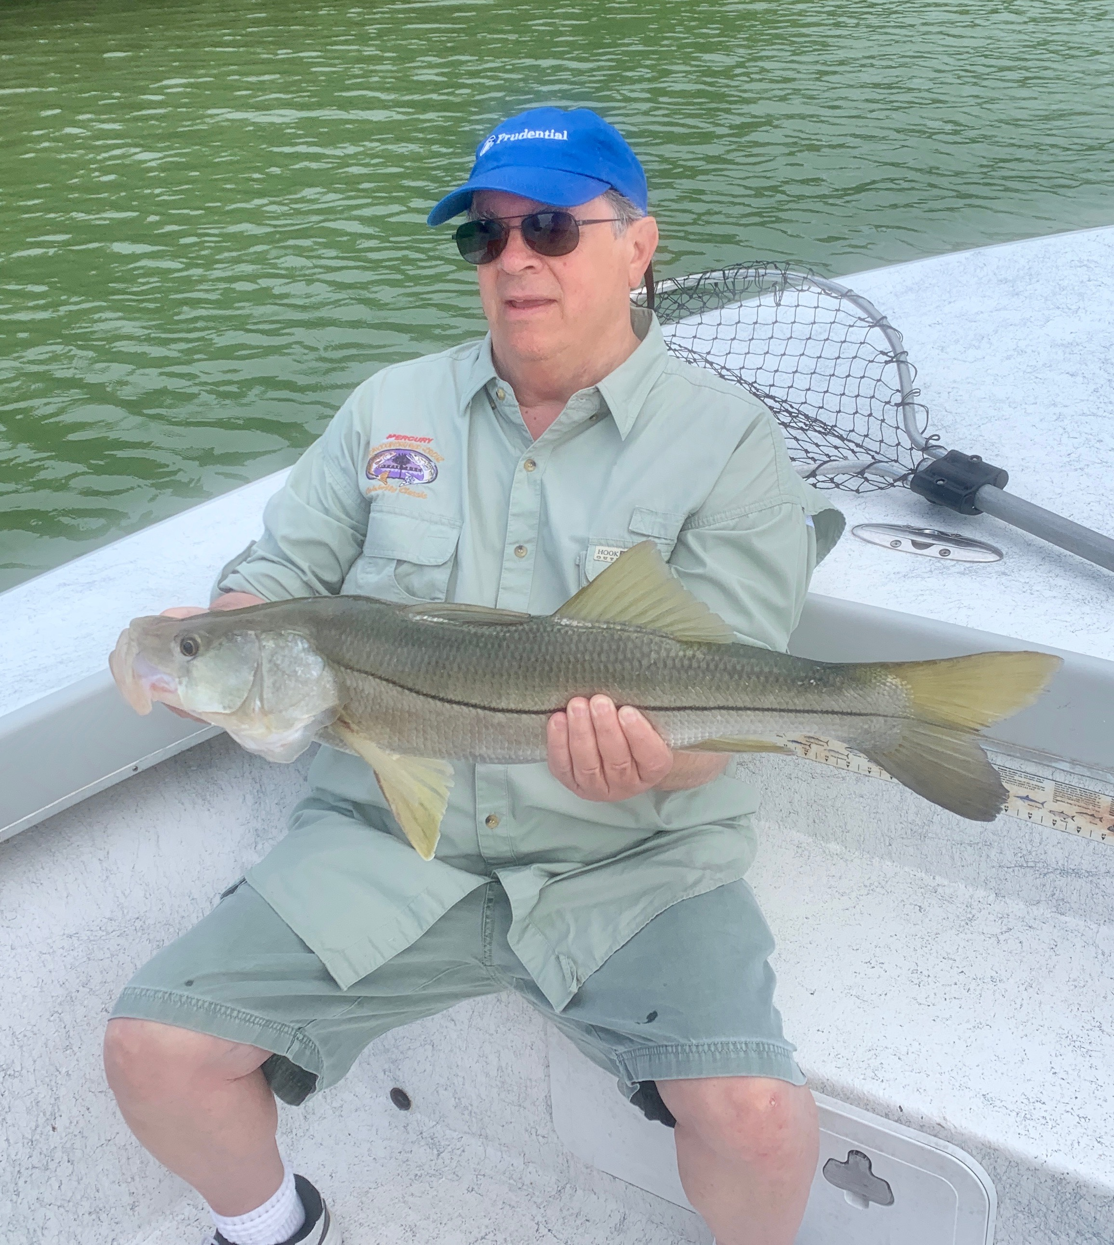

Pic: Jed Jerozal from San Ramon CA with a 29 inch Snook caught while pass fishing with Capt Matt Mitchell this week

Passes heat up

With slow morning outgoing tides this week we mixed it up and did what we usually do this time of year and fished in the passes. When there is no moving water anywhere else you can often find at least a little movement in the inlets. All our passes offered a wide variety of species and once the tide finally did flip over giving us a few hours of outgoing water the bite was on with lots of quality fish.

Both drifting or anchoring in the passes will catch fish though when I’m targeting docks I prefer to set up on the anchor. Live shiners, pinfish and grunts got the job done catching Snook and redfish. Timing is everything as depending on which pass you choose the bite can be best on a incoming or a outgoing tide. Big jacks, Bluefish and ladyfish kept clients busy until the Snook and redfish found our baits. During the faster moving current a split shot or even knocker rig will keep the bait down in the strike zone. Most of our fishing this week on the slower tides we used free lined baits to get it done.

Pass fishing for Snook is usually our goto fishing starting the Spring though this year this bite has only started to happen this past few weeks. Along with the passes the beach Snook bite has also turned on which is a real staple for our area all summer long.

Tarpon continue to pop up around the sound though with the heat of summer really on us they have been a little harder to locate. While spending the weekend on Cabbage key we found fish behind Cayo Costa and managed to jump two fish in two days. The first few hours after sun up have been the best action and definitely the most comfortable time to be out fishing.

This past weekend marked the start of summer on the calendar yet by mid afternoon it was just oppressive to be outside. Staying hydrated is extremely important to avoid getting heat stroke. Get out on the water early or late to avoid the heat of mid day. If you are going to head out sunblock and protective clothing are a must if you want to spend more than just a few hours out in this heat.

