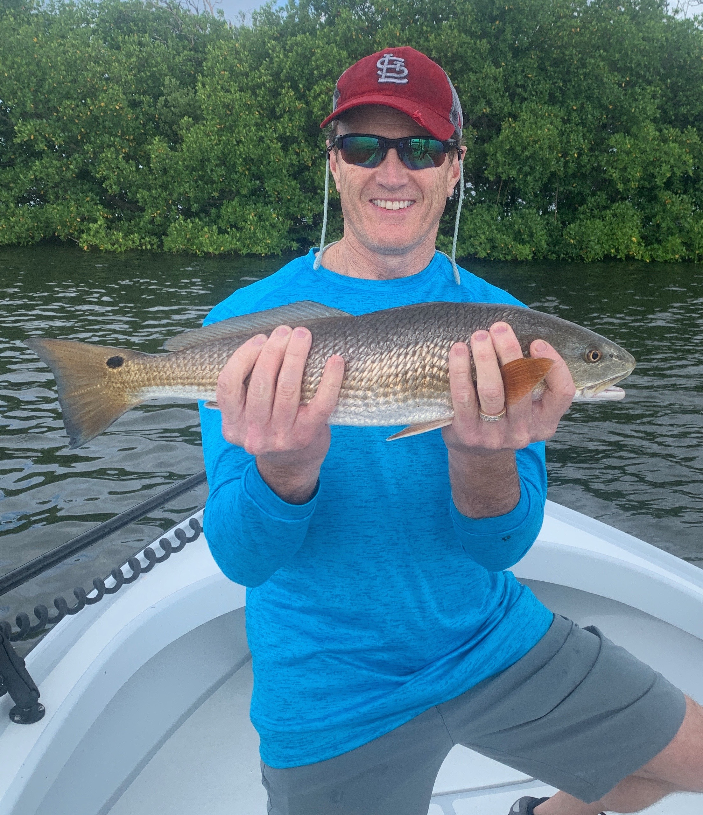

Picture: Terry Rogers from St Louis braved the wind and even some rain to catch some quality redfish with Capt Matt Mitchell this week

Mother nature will keep you on your toes.

There are some days when guiding clients, it just feels like mother nature is fighting everything you do. This is the only way I can describe how most of this week played out. Wind, rain and even patchy red tide made at least a small part of each day a struggle.
Any knowledge from the previous days trip just would not roll over and help me out. Just when you thought you had a gimmie in your back pocket from the day before something would change and it would not pan out and the fish were gone.

These days are all about moving and finding something new to put your clients on the action. For several days in a row we caught quality redfish on one mangrove island during the last few hours of the incoming tide then for no reason these fish just vanished. Even little mangrove creeks that held snook one day would not pan out the next day. I have plenty of confidence spots that always seem to hold fish during curtain tide and wind directions. This week it took running and gunning between a lot of these places to get it done.

Catching bait continued to be the easy part of the days fishing. Keeping a eye on the condition of this bait was a big deal this week as a few times we where in bad water when baits started to go belly up in the live well and it was time to leave. Unfortunately, there is no visual indicator that you are in or approaching an area of red tide until your bait starts to die. Though most of our waters are free of red tide all it takes is one bad area and all your bait is dead.

Fishing in area’s that had bait and jumping mullet is one of the few ways to know you are safe. Wherever this patchy red tide is has been changing from one day to the next. After being on a great bite for a few days in and around blind pass a small area of red tide pushed in and although we did not see any dead fish the fish moved and the bite was over. The mouth of the river has been an area that has not seen any effects of the red tide and has remained some of the better action around. The same is true for the south end of Matlacha pass and Pine Island sound.

One thing that rings true is that it only takes one hot spot to make a trip. Some days that hot spot can be your very first stop and other days it takes many stops to find that special place. As long as it happens at some point during the day its still a good day.

