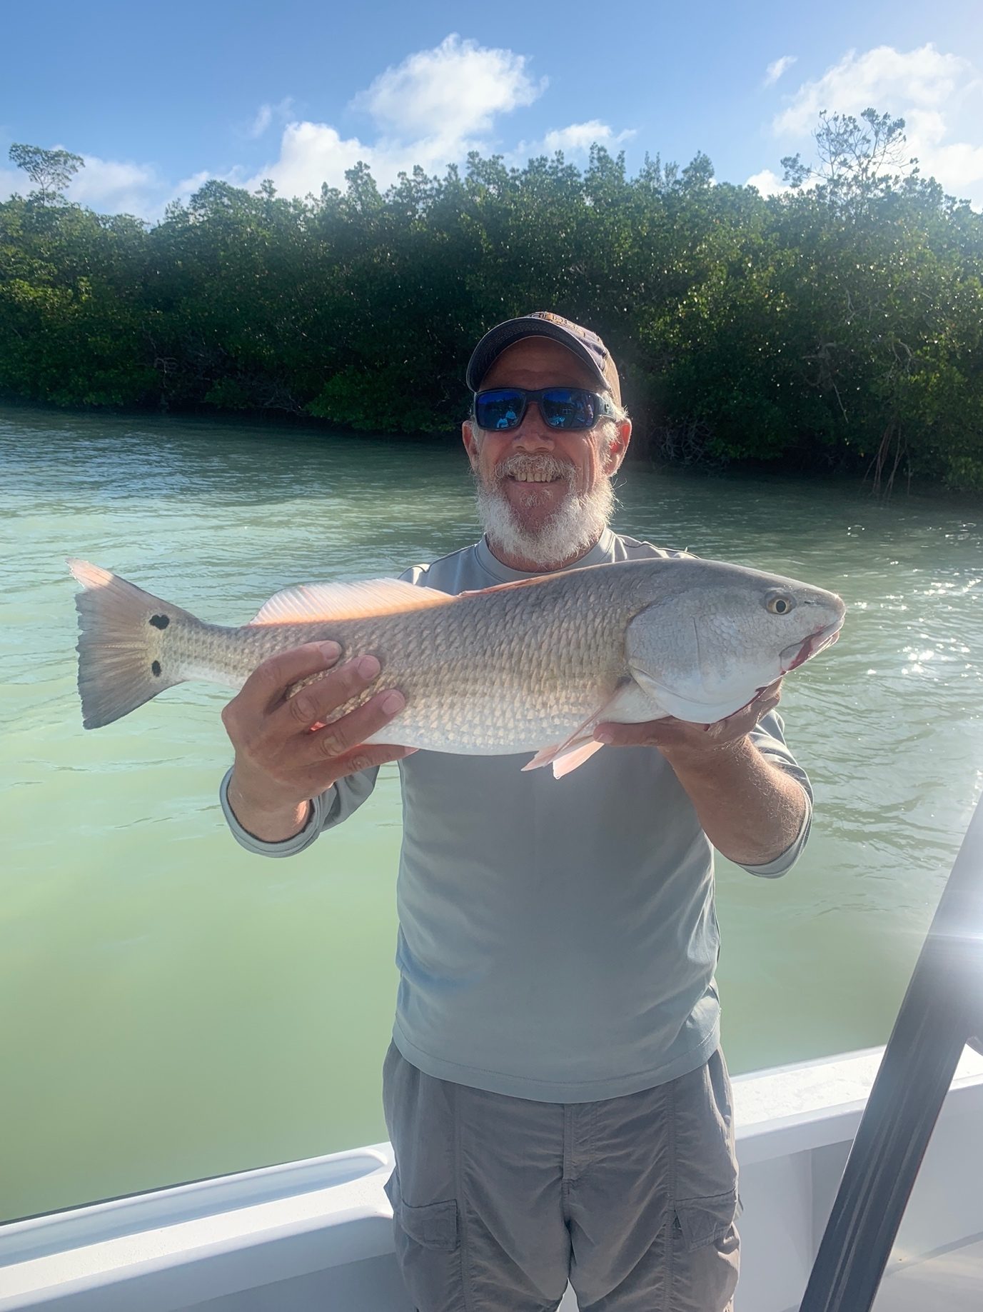

Pic: Zig Black with a redfish caught while mangrove fishing with Capt Matt Mitchell

Mother nature rules

Our first tropical system of the season brought massive amounts of rain and forced everyone off the water for at least a day or two.
Most of last week I spent tarpon fishing with the fish being located day after day in the northern sound. Returning to these Cayo Costa fish all week the pack of boats grew daily. Big weather events like this generally push our tarpon offshore until conditions get stabile again.

With tarpon trips booked all week my plan will be to do some recon looking in all the usual places. Hopefully we will find some fish though it may take a few tide cycles for our water to clean up. Sitting and soaking cut baits in some of the more travelled tarpon hang outs will be a option.

All this rain is a plus for other species as it will fire up the snook and redfish action. Beach and pass fishing for snook has kicked into high gear as these fish have started the annual spawn. When pass fishing plan your time around the fastest moving tides for the best action. Redfish will also be caught in the passes all summer though during high tides mangrove fishing will be the better bite.

As we move into June our mangrove snapper action both in the passes and out on the flats really gets rolling. These bigger mangrove snappers can be found all through our inshore waters for those anglers looking for a fresh fish dinner. Many of the same area’s we catch trout on the flats are also loaded with these snappers. As summer goes on these fish average between 12-14 inches with a few larger ones in the mix. Both live shiners and shrimp get these fish fired up.

Trout fishing has also remained strong with fish being caught both on the flats and out on the beaches. Some of the largest trout we catch all year are caught while targeting snook out on the beach snags and rocks. We even catch some monster trout while drifting pinfish for tarpon.

With June being a huge tarpon month for everyone this tropical weather event quickly threw a wrench in the works. Simply put mother nature doesn’t care about anyone’s plans. With so many tarpon here the past few weeks my fingers are crossed conditions quickly improve and these fish return in big numbers.

