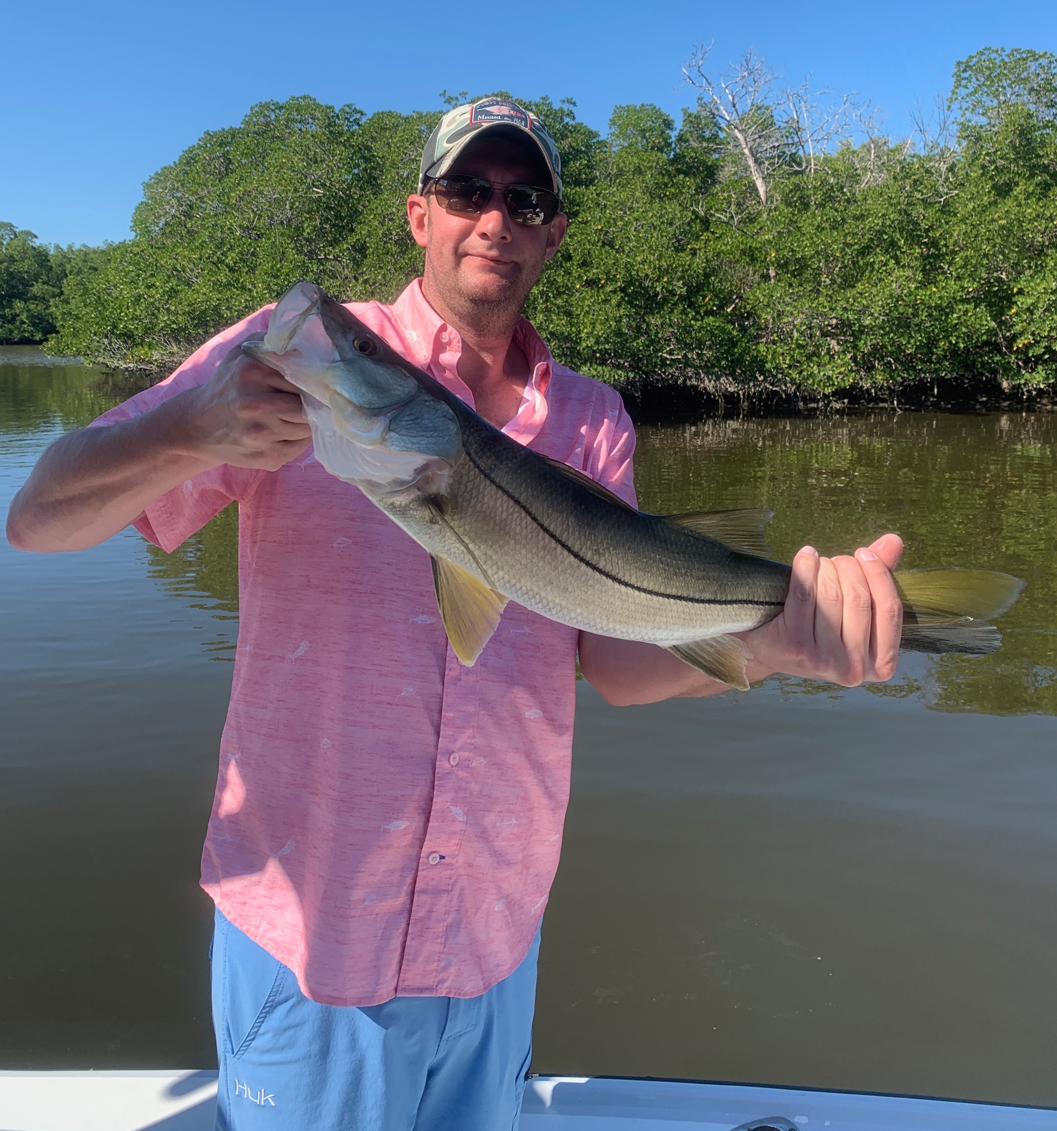

Picture: Brian Little from Ohio with a Snook caught and released with Capt Matt Mitchell

Magical childhood creek

Thanksgiving weeks weather was as good as it gets in southwest Florida. Waterways where busy with boaters and fishermen alike getting out during the holiday to enjoy the water. The slow gradual warm up of our water temperature made the fishing improve everyday. Redfish and snook where our main targets. Redfish action has been on fire on what seems like either tide while the better snook bite has been happening a little later in the morning as the water temperature slowly warmed.

I did catch fish all over the southern sound this week though after finding fish in one magical creek from my childhood. I returned to it almost daily. This is the first time this winter I’ve found a one of these creeks with fast moving current and clean clear water that is just loaded up with fish. Many of these narrow feeder creeks that connect smaller bays can be amazing during our colder winter months. This creek was a hot spot all week long. The Redfish action was impossible to ignore along with an exciting sight fishing for snook once it warmed up.

Trying to get into this creek which is protected by a sandbar was challenging during the big minus low tides we experienced this week. Two days in a row I had to get out of the boat and push it across this super shallow hump as I was not patient enough to let the tide come up. Once in the creek the water is plenty deep no matter how low the tide was. During the first few hours of the low incoming tide the redfish bite was amazing and the water so clear you could see the fish.

The more time I spent in this creek the more snook I began to see. We did manage to catch a few on free lined shrimp. As conditions warmed later in the week I knew I had to find some live shiners to take in here. Waiting till late morning we slid into the creek and immediately saw the snook I’d been watching for the past few days. Pitching a few live shiners along the edges, it did not take long until the whole creek turned on with snook chasing and feeding on the live bait. Baiting up and sight casting to snook exploding on the surface was the best snook bite I have been on in quite some time and made having to push the boat across the bar all worthwhile.

