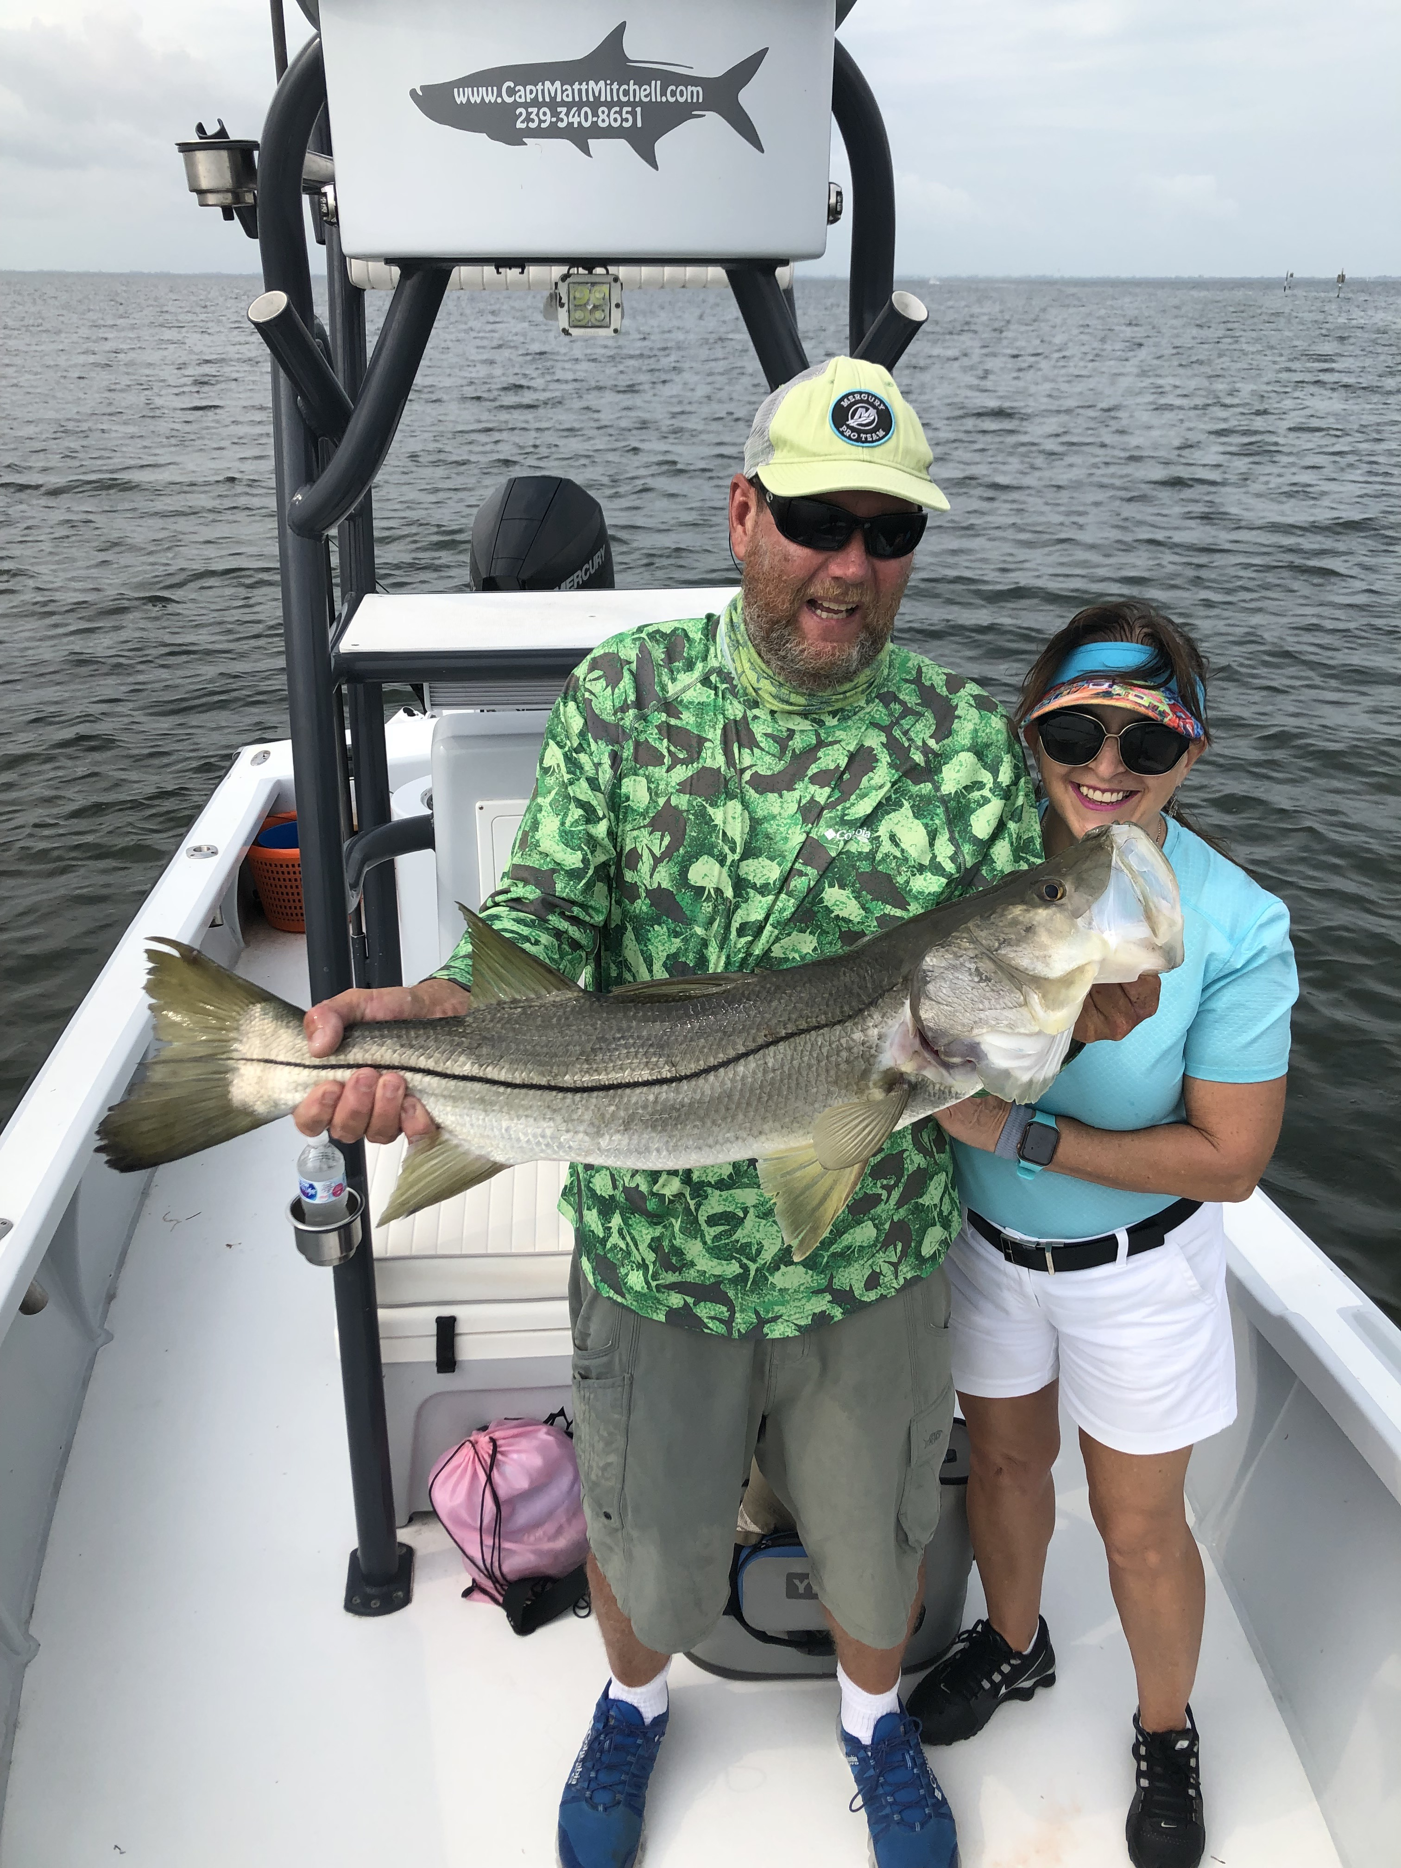

Karens killer day.

Pic: Karen Little from Naples with a 34 inch snook caught with Capt Matt Mitchell this week

Some of the best fishing fishing can happen right before a front pushes through. This really played out for me on a charter this week. My clients got to experience one of the most wide open snook bites I have been lucky enough to see in a few weeks.

This particular morning started off with light winds as I picked up long time client Nick from Naples. What made this trip different was he was fishing with his wife Karen who has only been out with us once before. Leaving the dock our plan was to look for tarpon for the first hour of the trip and if that didn't pan out switch it up and target snook.

Even with super smooth water conditions we only saw a few tarpon and quickly changed gears. Pulling into a deeper mangrove shoreline it did not take long to start catching snook. Chumming live shiners had these fish fired up and within 10 minutes Karen had her first ever snook a mid 20inch size model. We moved around on this same shoreline for about a hour and kept this bite going strong.

Casting a shiner up close to a downed tree stump Karen hooked into a much bigger snook. This fish made a quick 25 yard run down the shoreline before turning and coming right back at us. After hanging her up in the mangroves she handed me the rod. I fed the fish some slack line managing to get it free and quickly passed it back. This fish was set on breaking us off in the trees. It tangled up again this time on a sunken root ball. This last burst of energy caused it to lay up on the surface exhausted and worn out. Creeping in quietly we netted this 32 inch snook.

With a strong incoming tide and our winds picking up from the south as the front approached the water was now up high. Heading for a favorite oyster bar on the eastern side of the sound I was now keeping a eye on the radar as rain was on the way. Our first few cast both Nick and Karen caught a few snook, then all hell broke loose as Karen stuck a much bigger fish. This snook struggled to get its whole body out of the water on the first jump only managing to show us its wide shoulders.

Coaching Karen this fish ran all over making strong runs as it tried to make it back to the oyster bar. Each time it was in danger of crossing the bar she managed to turn this big snook and get it almost back to the boat. Once close enough I gently netted this snook to remove the hook and get a few awesome pictures. After a few more stops we also managed a 24 inch trout but could just not get a redfish to complete the slam before the rain ran us in.

Timing on a approaching front or weather event can be the major factor in making the fish chew. Any time the barometer drops as the wind turns from the south fishing can go from mild to wild and this was one of those mornings. After dropping them off at the boat ramp I raced back across the sound as I unsuccessfully tried to beat the rain. Even getting wet coming down the canal I was still all smiles at the amazing morning snook bite we had been lucky enough to enjoy.

