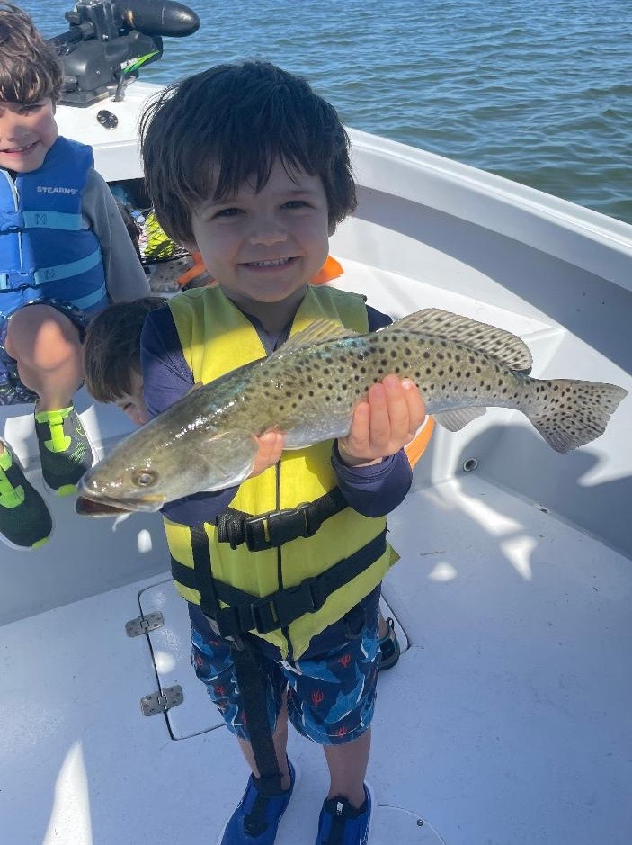

Its a Spring thing

Pic: Roy “the boy” 4yrs old from NY got in on the great action with Capt Matt Mitchell this week

Over the past few weeks, we have been on all that can be described as a warming trend. With water temperatures creeping into the mid 70’s we are now in the Spring pattern despite it only being early March. Bait fish have popped up on the many grass flats all over the bay. After more than a month of cold water shrimp fishing it feels good to be back pitching snook candy pilchards.

Despite what was a week of little to no day time tide movement with shiners we still managed to catch some quality snook. Mangrove creek fishing was great action with lots of snook caught every trip. These same creeks also produced mangrove snapper, gag grouper and even a few redfish. Snook fishing is my bread and butter and after what has been a few cold weeks of winter it feels so good to be back in my groove.

Trout fishing has got even better by having shiners too. The average size of the trout I’m catching has increased with the switch from live shrimp to shiners. I’m still rigging these shiners on a popping cork like I do with shrimp and fishing the exact same places I have caught them over the past month.

Near shore action has also lit up with the warming water. Within a few miles of our beaches, we are seeing Bonita along with lots of Cobia.
Patches of live bottom, county wrecks and reefs have been loaded up with Mangrove snapper, sheepshead and Grunts. Live hand picked shrimp on a 1/0 light wire circle hook with just enough weight to drop to the bottom have been catching an awesome variety of species. If you’re looking for a fish dinner this nearshore fishery is on fire.

With our water already in the mid 70’s I’ve already started to see some early season tarpon in the sound. It’s certainly not prime time yet though these migratory fish don’t carry a calendar they move according to the water temperature. Some early season hot spots include the deep water holes by marker #4 along with Marker #18. Soaking cut baits on circle hooks in these area’s is the go-to method with mullet and catfish tails being on the top of the list. When the tide is really moving add a twist on sinker to keep the offering on the bottom. These first tarpon to show up are usually the giants often going well over 100 pounds.

