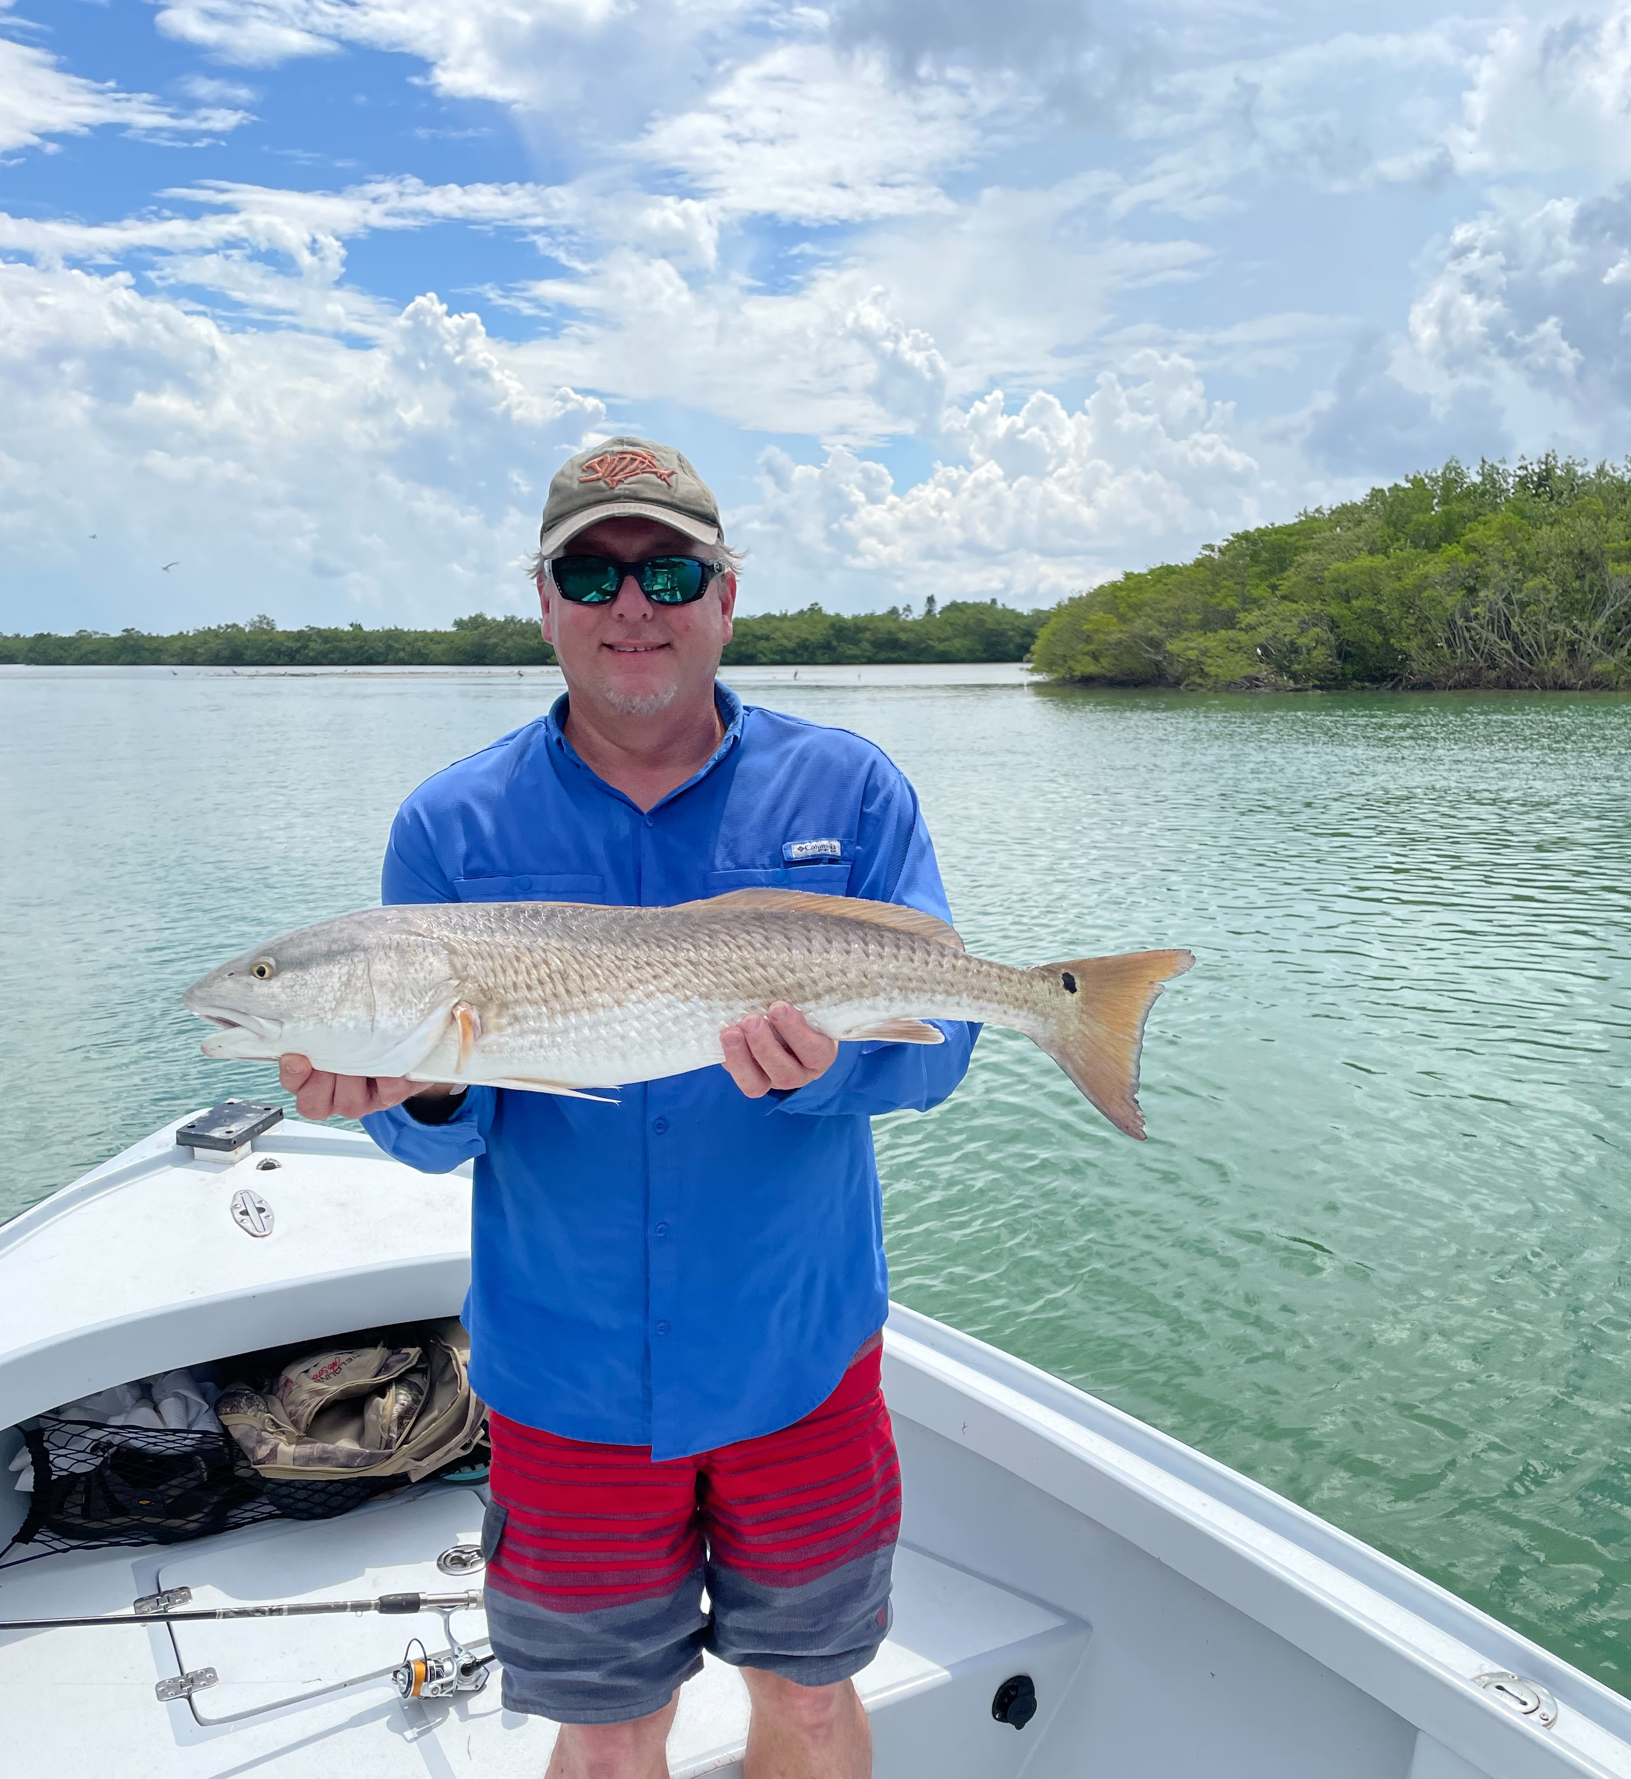

Hot with a chance of hotter

Pic: Steve from VA got a big birthday Redfish while fishing with Capt Matt Mitchell

With summer fishing in full swing the massive schools of fry bait mark where the action is. Having so much of this small bait around has many different species fired up and feeding. For fast paced action fishing around these bait schools is hard to beat. Trout, Mackerel, mangrove snapper and even a few blacktip sharks kept the clients rods bent. It seems we have mush more of this bait in the bay than in the past few years which is awesome.

When fishing around these bait schools we have been free lining these same shiners. I like to down size my gear to 2500 spinning reels to make it possible to cast these small baits. Use a 1/0 light wire hook and 20# fluorocarbon leader. Chumming a few of this plentiful bait every 5 minutes or so will keep the fish fired up. When you see the pops on the surface cast into it and quickly get tight as the bite is often instant. I can’t think of a better way to start a family fishing charter than with this non stop action to get everyone involved and put some dinner on the table.

Summer pass fishing is also going off on both Snook and Redfish. Seeing hundreds of laid up snook in and around the passes is an amazing sight. Look under the docks and around blow downs to see these fish staged up. Casting free lined shiners at these fish you often see them either follow or chase the bait as it sweeps by them. Along with these snook in the passes we have also been catching some quality redfish during the lower tide periods. Small pinfish and even the free lined shiners caught redfish this week up to 32 inches.

Over the past few weeks we have seen our water temperatures running between 86-89 degree’s. With our heat index over 100 degree’s most days afternoons can only be described as a blast furnace. During periods of west winds we have seen morning coastal showers. These often slow moving soakers can make staying dry a challenge. East winds mean afternoon thunderstorms. Basically our rains and storms can build and happen at any time with our supercharged atmosphere.

Like I tell my clients who get fixated on our weather forecasts “Our chance of rain is 50% from June till October”. Summer in the tropic’s requires you keeping your eye on sky and changing the days plan at anytime. For the next few months our weather is fast changing and extremely unpredictable.

