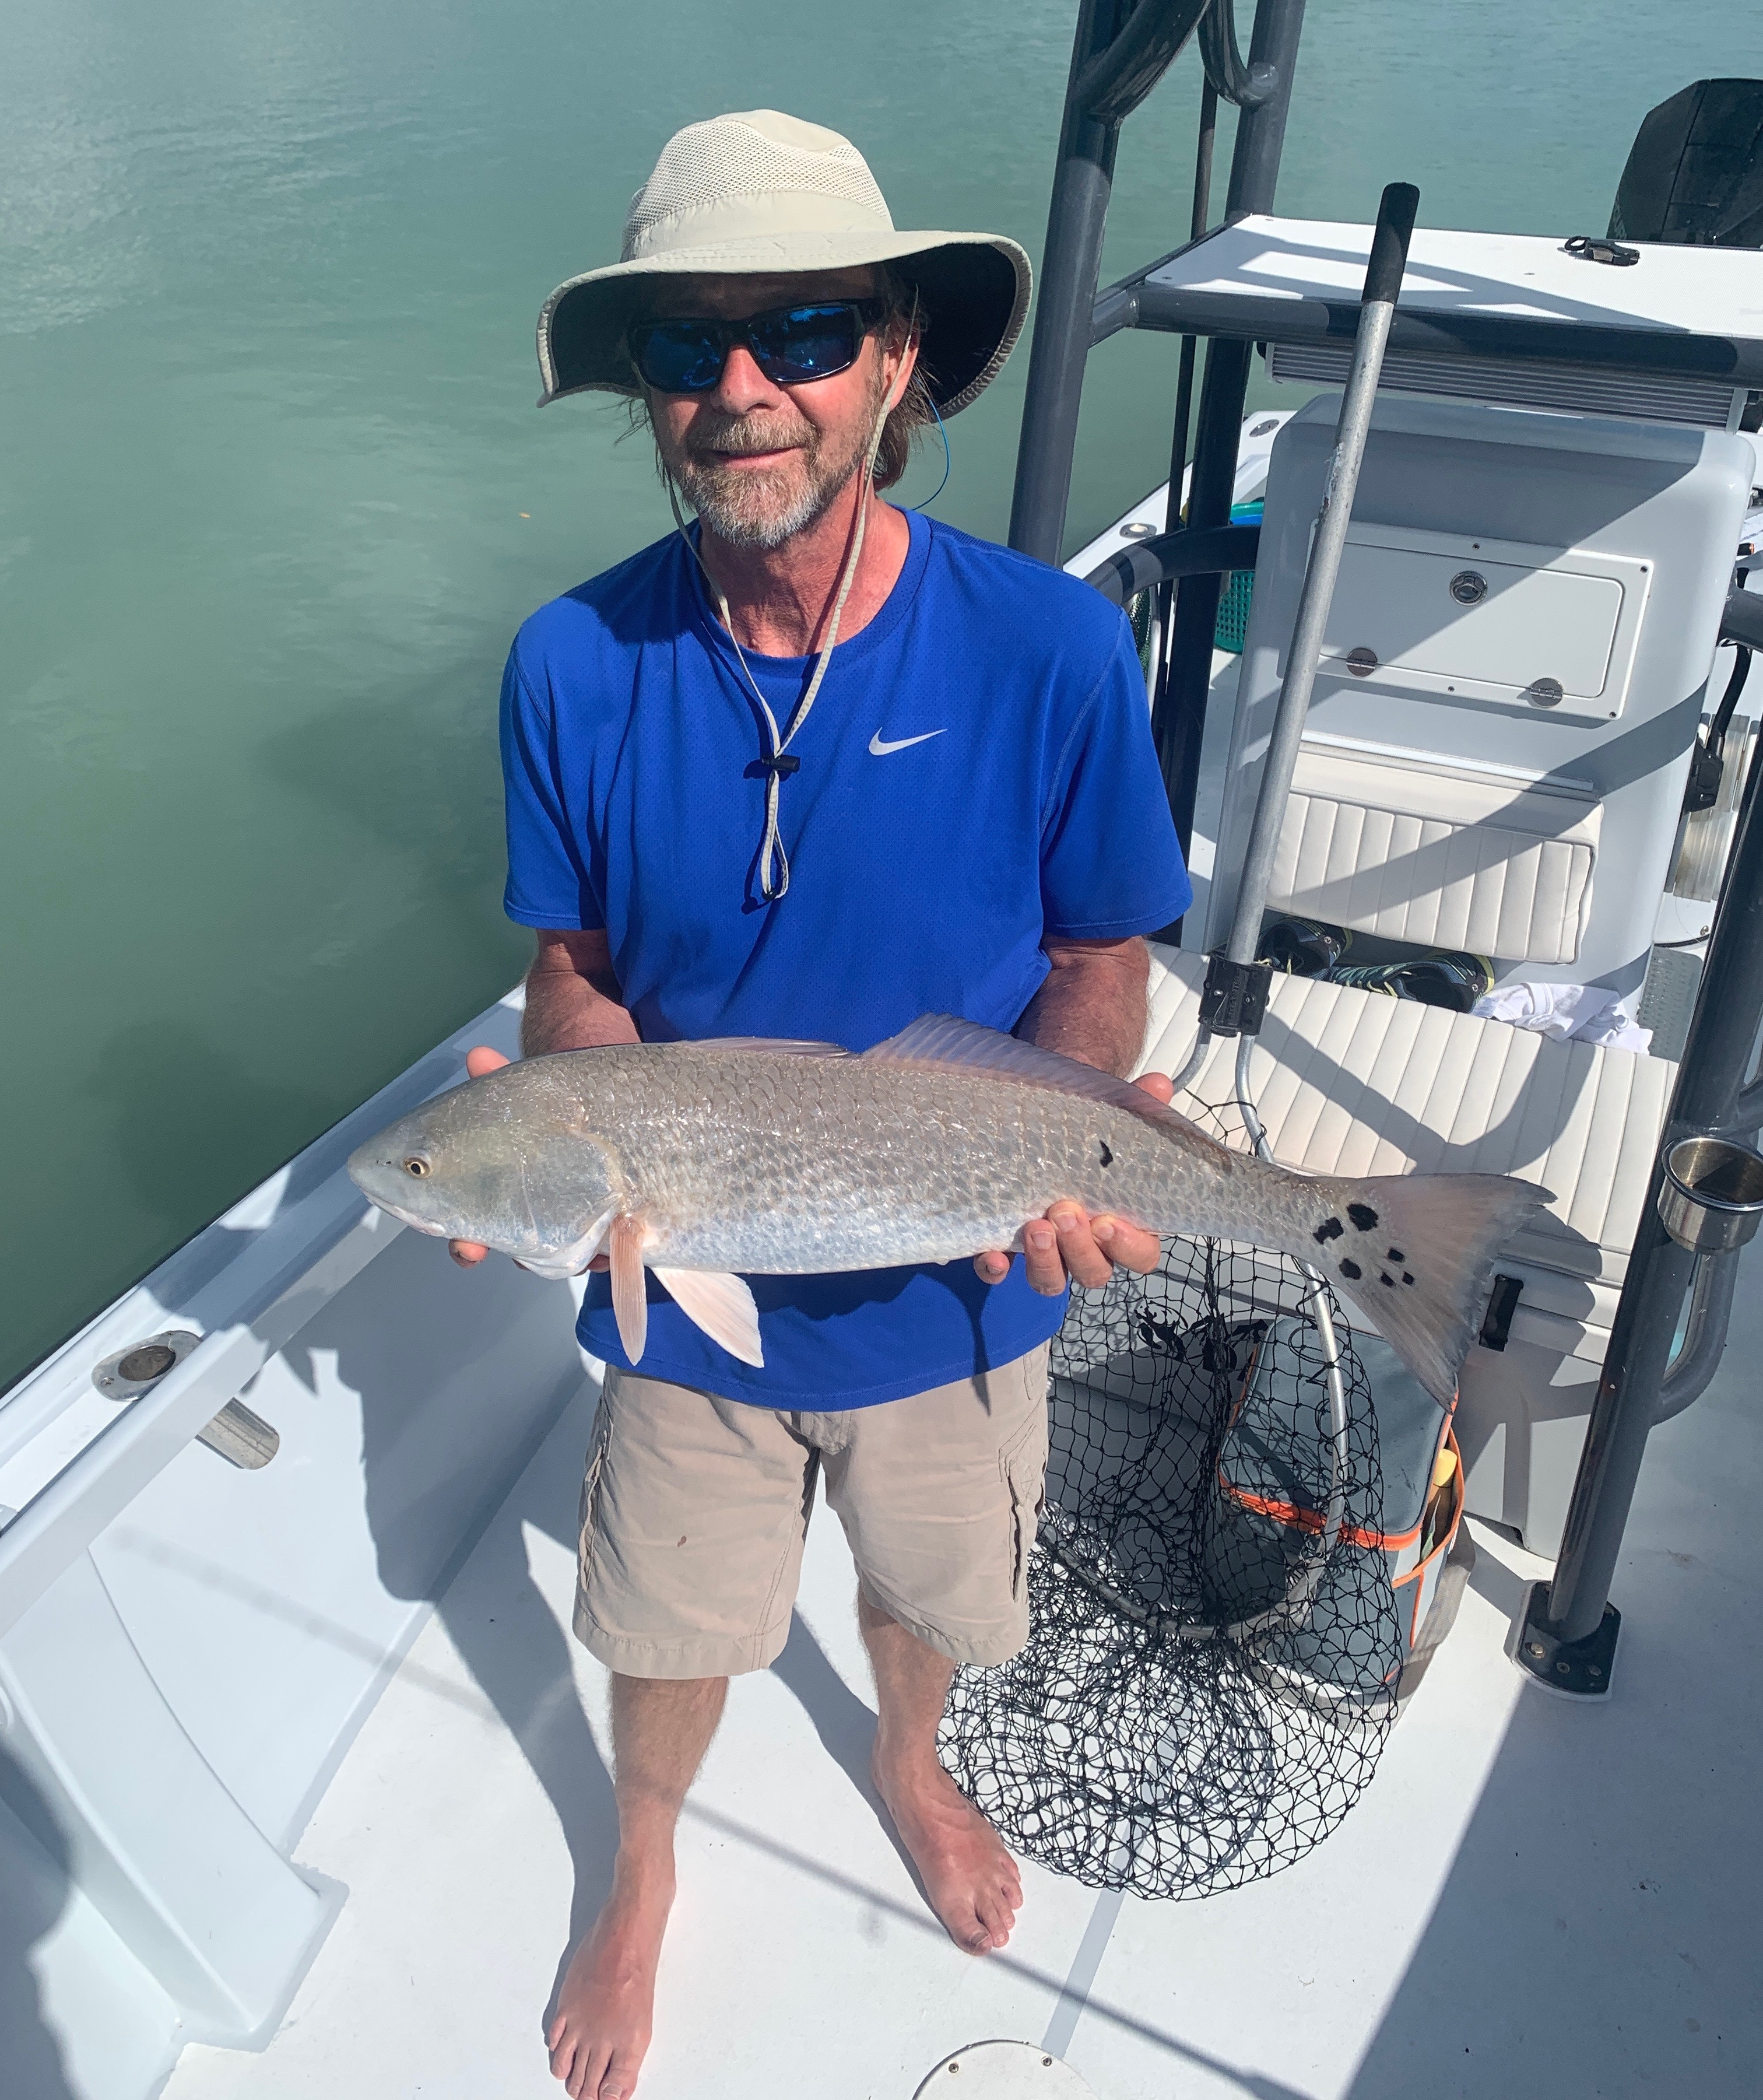

Hot Spanish Mackerel bite

Pic: Jeff Nicholson with a 30-inch redfish that hard 19 spots caught while fishing with Capt Matt Mitchell this week.

Catching quality fish this week required grinding it out as Snook and redfish did not come easy. These fish are spread out and with cooler mornings dropping water temperatures we did catch them but it was often slow going. Once things warmed up by the afternoon we got shut down with slow to no tide movement. Thankfully we had a variety of other species to catch that would keep the rods bent when the Snook did not want to cooperate.

Watching snook laid up that just would not respond to a bait was frustrating. Chumming them with live bait would not sometimes not even get a response. Oyster bars in the middle sound where most productive for me this week with the shallow clear water holding lots of fish. Seeing Snook laid up in sand holes before you even pitch a bait gives you much more patience than when you don’t even know they are there.

Both Redfish and Captiva pass where great places to fish this week with lots of Mackerel, jacks and ladyfish. Setting up on the edges of the passes and chumming live shiners in the moving current had Spanish mackerel up to 28 inches exploding on the surface. When Mackerel fishing with shiners I like to use a small piece of light 17# test single strand wire leader to avoid the cut offs. Once these Mackerel are fired up a small heavy silver spoon rigged with a J-hook is hard to beat. It casts mile and can be ripped across the surface. Casting to breaking fish is a fun way to catch these fish or if you like something a little more relaxing trolling these same spoons will also catch em.

Inside the passes have been good for Ladyfish, jacks and a few pompano. A silly willy jig cast and bounced slowly across the bottom has caught all these species. Watch for the pompano to skip while you are idling around these area’s and once you do catch a Pompano put a GPS mark so you can re drift the crime scene.

Shark fishing in Rocky Channel and the inside of Captiva pass has also been a another option with sharks of all types being caught while soaking cut baits. While sat shark fishing this week we had rolling tarpon all around us during a morning charter for over a hour. Seeing these tarpon everywhere really fires you up for tarpon season which is just around the corner.

