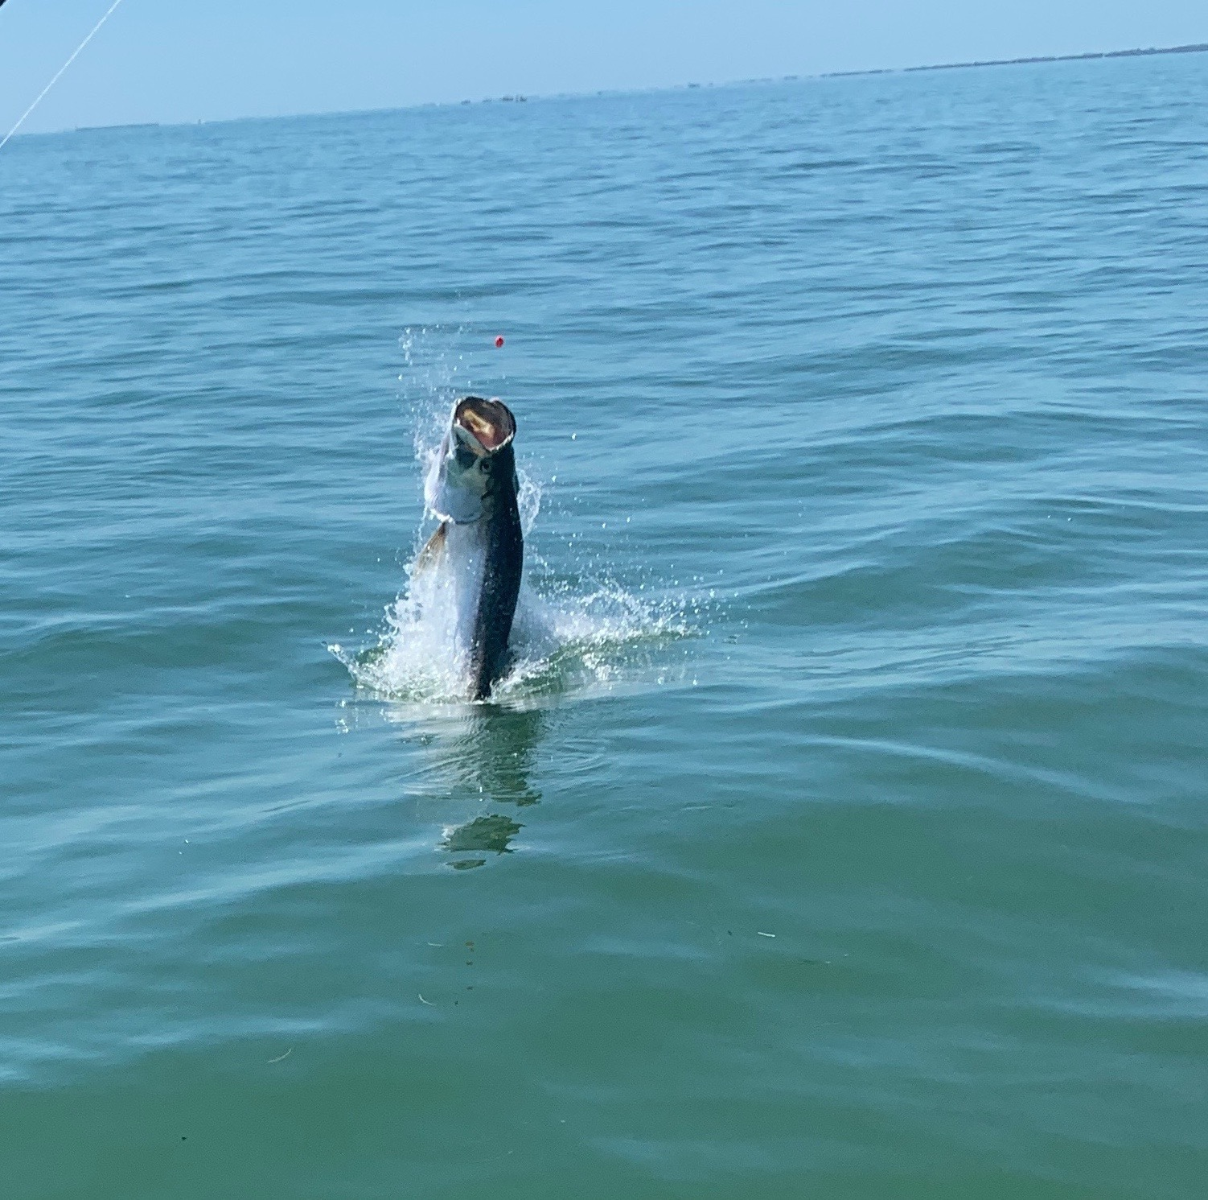

Pic: A hooked tarpon takes off before being caught by Gary Biltgen while fishing with Capt Matt Mitchell this week

Great action close to home

Tarpon fishing around the full moon is always tough as these fish simply disappear heading offshore to spawn. This proved true this week as we tried chasing them up and down the beaches with very little success. Pods of fast moving high rolling fish out on the Gulf side were hard to keep up with and almost impossible to get a shot at with a bait.

Moving inside the bay we found some slower moving fish that for the most part would not cooperate either. Anchored up in slick calm water while seeing hundreds of tarpon is an amazing sight. When your sat in a pack and not a single boat hooked up while watching them roll in and around our baits can be crazy frustrating but its all part of the daily routine if you wanna catch a tarpon.

When tarpon fishing it only takes one bite to turn your day. around One day this week after a long morning of no bites we set up in rolling fish again and after a while spotted a group of tarpon that seemed almost stationary. Creeping up on slow circling pod of fish on the trolling motor we got into range and with one cast it was on. After a whole morning of being in tarpon why this group decided to eat I will never know but that’s all it takes.

On the few days I did not tarpon fish we had great action on both Snook, trout and mangrove snapper. Live shiners caught fish after fish while working the southern tip of Pine Island during the morning incoming tide. One small shallow hard bottom bar in Matlacha pass was loaded up with more quality size trout than I have seen since last summer.

Many of the mangrove channels in this area that have hard shell bottom and fast moving water seem to be what these fish are looking for. These mangrove creeks are loaded with not only Snook but lots of keeper sized mangrove snapper too.

It has made a welcome change to be able to catch quality fish right in my neighborhood all this week. Over the past week we also found good numbers of tarpon in the southern sound too. The closer to home the fish are the more time you can spend fishing and the less time you spend running which is just good for everyone.

