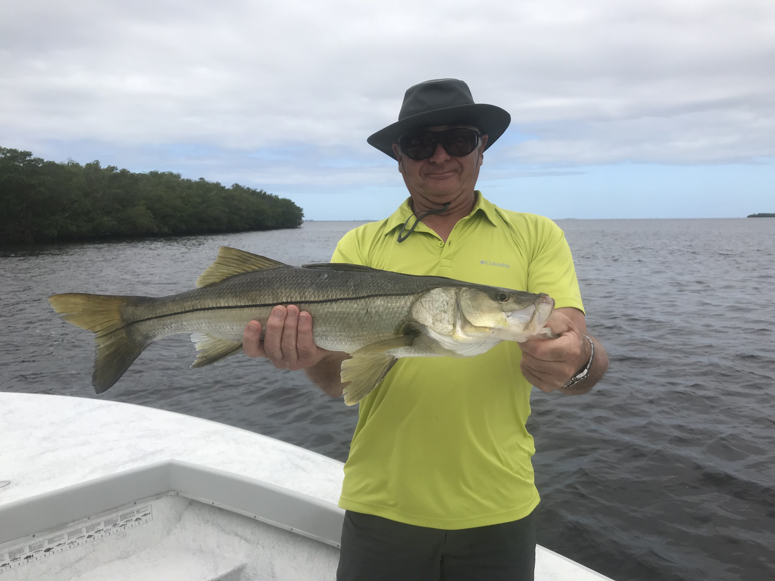

Picture: Joe Monkofsky from Lake Champlain NY with a 30 inch Snook caught while fishing with Capt Matt Mitchell this week.

Great tides equals lots of fishing options.

Consistent conditions lead to consistent fishing and after finally having the same north east wind direction for over a week for the first time in months the fish have began to get in a pattern staying in the same places for a few days. Snook where my main target this week and being able to go right to where you caught fish the day before is always a plus. Redfish action was much more hit and miss than it should be this time of year although catching sharks, Spanish mackerel and Trout filled in that redfish void.

Snook fishing this week was outstanding with multiple keeper sized fish caught on back to back days. Chumming live shiners on oyster bars during the higher periods of the tide had these fish fired up as clients had lots of multiple hook ups on under the slot sized fish. During lower water conditions I started fishing some of the deeper shorelines I usually don’t fish until November with excellent results. North east wind is our prevailing fall and winter wind so I have lots of mangrove shorelines that fish really well on this wind set up. One favorite shoreline in the southern sound produced three keeper snook in two days along with lots of other snook all on live shiners.

Shark fishing was also a good choice in the northern sound. Setting up in the natural deeper channels during the last few hours of the outgoing tide was the perfect set up to catch lots of Blacktip and Spinner sharks ranging from 3ft to 5ft. Chunks of fresh mullet on a large circle hook had these sharks going off. While sitting on the anchor you could watch lots of these little Blacktips buzz the boat. Just for fun I would through a few handfuls of live shiners out and watch mackerel, bluefish and ladyfish blow up in these same places. The most productive areas for this action where from Hemp Key to Pineland. Any natural channel that was 5ft plus in depth cutting through a shallow grass flat produced this same mixed bag action.

For the first time in weeks I finally found a few places that had clearer water which seems pretty amazing. The outside of Captiva pass has finally started to clear up a little bit and not quite as brown as the rest of the sound. Spanish Mackerel action against the outer Gulfside sandbars was really good during the outgoing tide. Live shiners free lined on a long shank J-hook caught Spanish mackerel to 30 inches. These fast swimming fish are just fast and fun to catch. Once these fish get fired up spoons and and small diving spoons are a great option for catching these Mackerel.

All in all it was another great week on the water with big morning hide tides offering anglers lots of options. When we are in such a great tide pattern and weather conditions cooperate it sure makes my job much easier.

