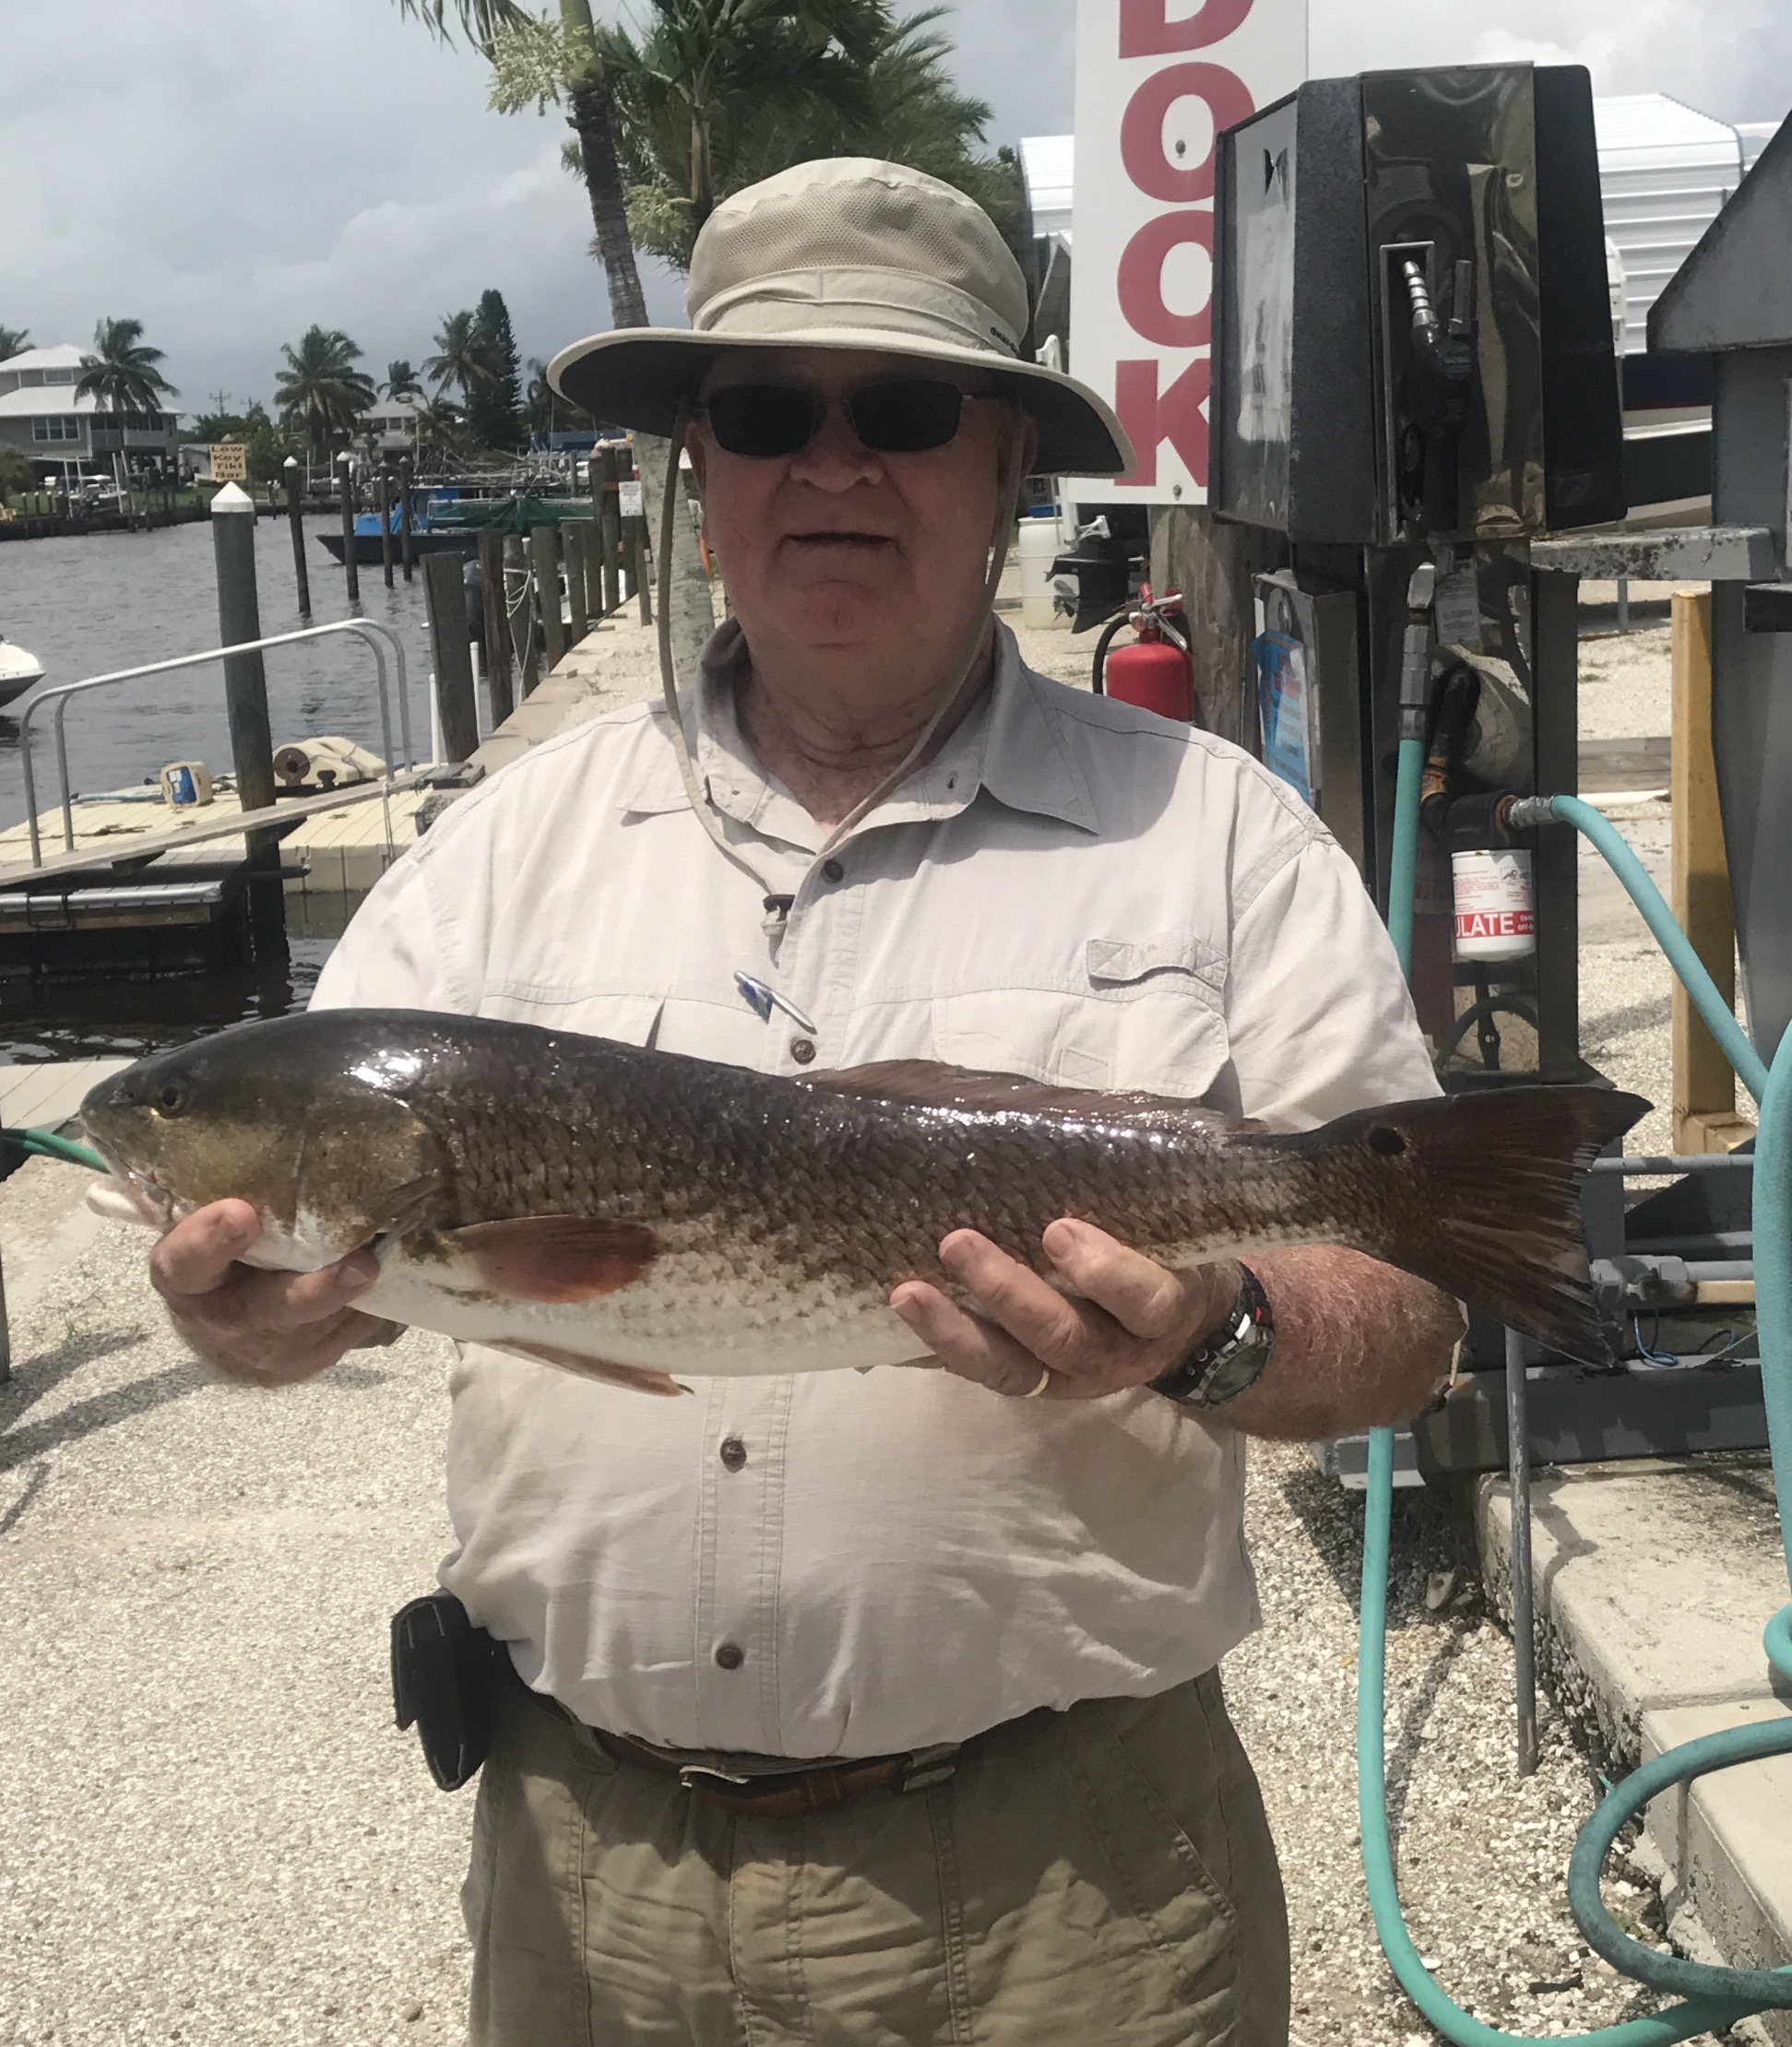

Great flats action all week long

Pic: Gillie Russell with a slot sized Redfish caught while fishing with Capt Matt Mitchell

Despite red tide reports all over the news the southern end of pine island sound has not been affected. In fact some of the open water flats fishing that is going on is amazing. Although the water is brown it is still pretty clear. Once you get up past the middle sound there are large patches of floating grass making it hard to fish. In the very northern end around cabbage key and Useppa we are seeing floating dead fish.

Small baits either shiners or small pinfish fished under a popping cork have brought some crazy non-stop action from St James City all the way up to Flamingo Bay channel. Limits of trout along with lots of small sharks and Spanish Mackerel have kept the rods bent basically until you run out of bait. This southeastern end of the sound for some reason has been the prettiest water around and is just filled with life.

Soft plastic jigs in a shiner pattern have also been getting it done in these same area’s. Soft plastic’s can either be fished under a popping cork like you would a like bait or fan cast and bounced along the bottom. The variety of fish in these 3-6ft grass flats has been amazing.

With water temperatures topping out shiners have all but disappeared for at least the next few months. Pinfish have become the go to bait with smaller pinfish catching lots of keeper sized trout. Another option with the hot water temperature is to use frozen jumbo shrimp to pitch against the mangroves for redfish. Floating a big piece of shrimp on a jig head close to the mangroves and letting the current move it down the bank has drawn the redfish in when nothing else will.

Getting out early morning or late night is the only way to beat this summer heat. Although the afternoon bite has been ok its been tough to dodge the afternoon thunderstorms. These fast moving storms can be filled with lightening and should not be taken lightly especially when out on a boat. Even if it means wrapping the day’s trip up early its always better to be safe than sorry.

Low tides have been late night and are the perfect set up to fish docks or the passes for some great snook action. Not only do you beat the heat you will usually have the whole pass to yourself. Flies work great for this along with large live baits in the fast moving current. The better snook bite in the passes has come during this outgoing tide.

