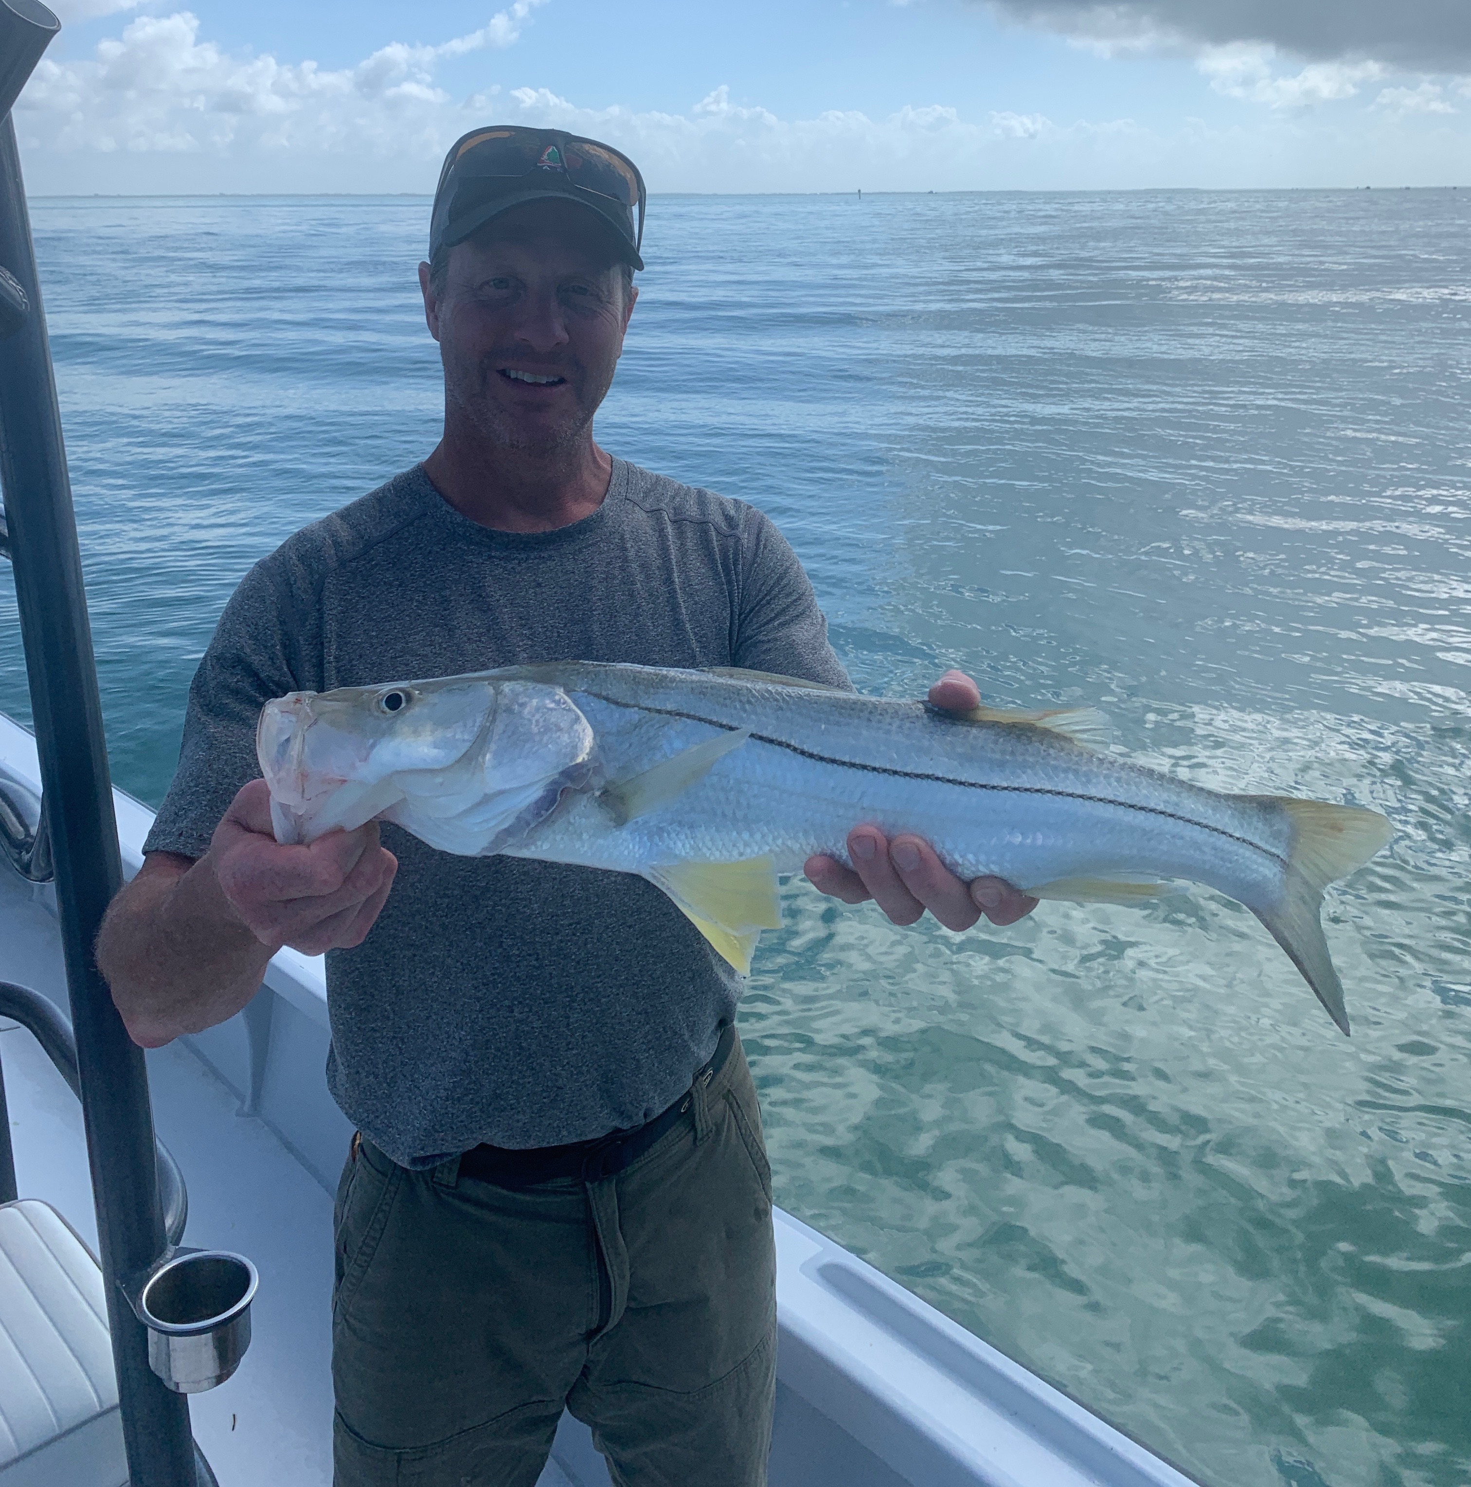

Pic: Fritz Neubauer from Ohio got in on the amazing Snook action with Capt Matt Mitchell this week.

Good bye early Spring!

After what was an amazing week of Spring fishing the bottom fell out overnight as a strong cold front crashed the party. This drastic temperature crash along with a couple of days of strong winds kept us off the water. After a extended time of warm conditions this cold front felt extreme and was a reality check that its still only mid February and not May.

Before the front with water temperatures up to 78 anglers had just begun to catch early season tarpon. Several times this past week I ran across full size tarpon in the sound. I saw laid up fish in clear water around Captiva then again rolling in the marker #18 ditch. Though I did not fish them I saw and heard of other Captains catching
them. Early season tarpon fishing is all about water temperature. These fish do not carry a calendar, when the water temperature is in the mid 70’s they just appear.

Sight fishing for snook around the passes was my fishing of choice this week. All our passes held huge numbers of snook on what seemed like any downed tree of piece of structure. Spotting these fish and pitching live shiners to them was all it took. This non stop snook action was amazing with many multiple hook ups for happy clients. Nuisance dolphins often made us move on as they would grab our hooked fish. No matter how great the snook bite is if the dolphins come in on you its time to move.

Big Jack Crevalle where also found in large numbers in and around the passes too this week. These fish may be one of the most underrated gamefish we catch, they are crazy strong and super aggressive. Watching them follow a hooked pack member up to the boat is always exciting. These hungry schools of Jacks usually don’t show up till spring though with so much bait around and warm water they are here early also.

Great news for anglers this week, the FWC this has decided to continue the closure of Snook, Trout and Redfish for our region until at least May of 2021.These fisheries have been catch and release only since the destructive red tide of 2017/18. This is fabulous news for our fishery as it will let the amazing recovery we are experiencing continue.

