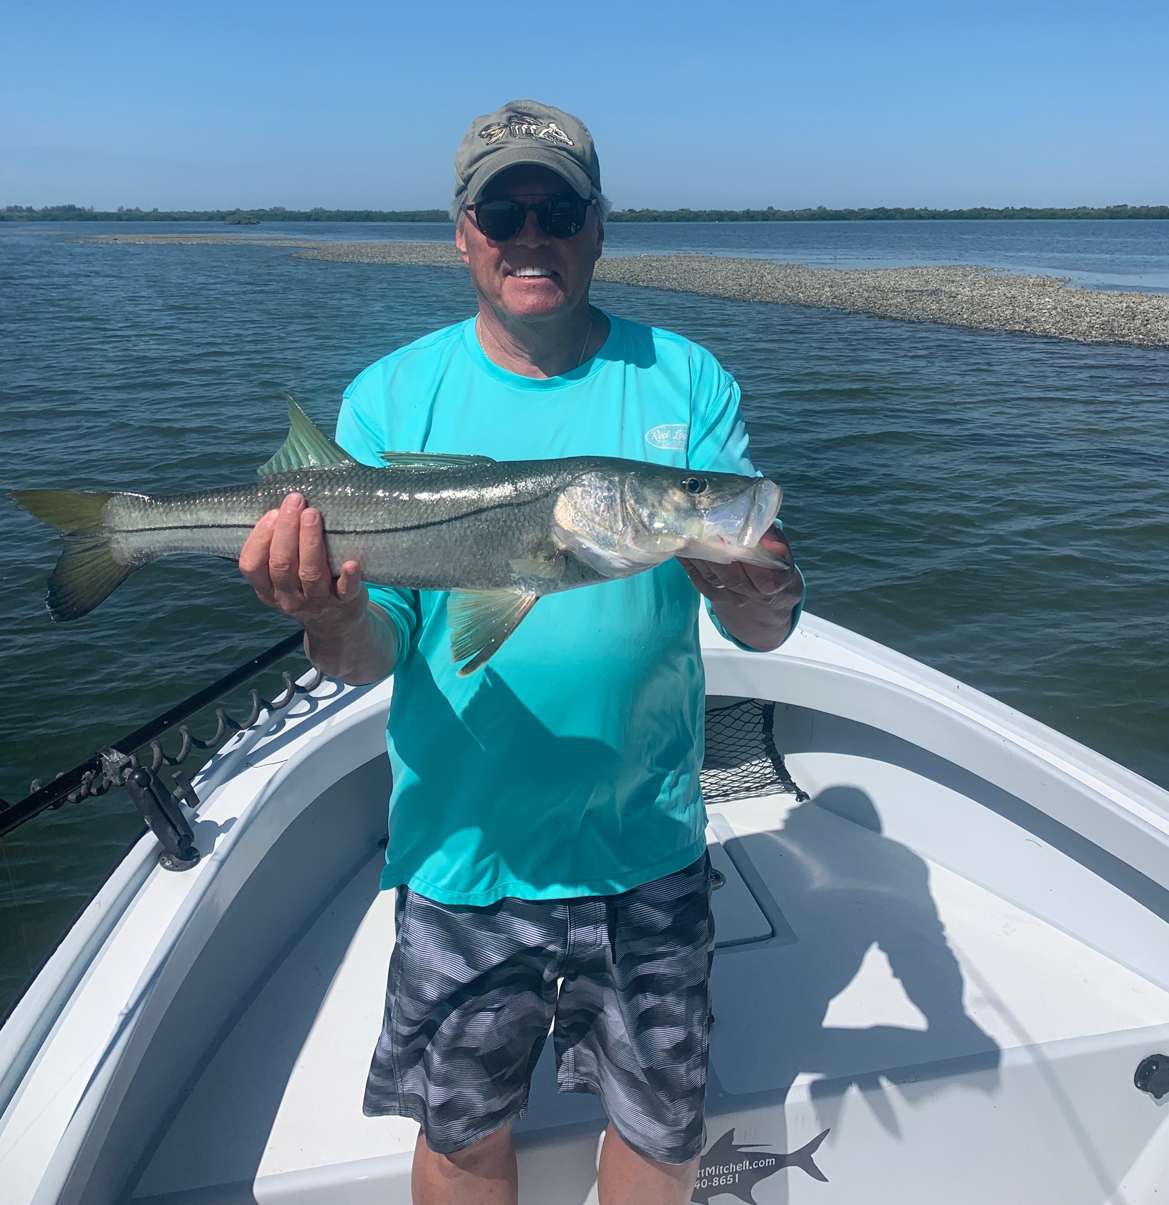

Full moon arrival

Pic: Pat from NY got in on the low tide oyster bar bite this week

After what turned out to be a few days off early last week due to a stalled front bringing rain and thunderstorms it felt sure felt good to get back out on the water. Changes in weather are all part of the game and locating the fish once back at it didn’t take long. Going right back to our same spring time patterns the snook had not moved and better yet if anything they had been untouched for a few days the bite was better than we had before the weather.

Extreme south winds over the weekend blew the tides up much higher than predicted by the tide chart and made for a near perfect oyster bar set up. Of all the wind we fish through nothing fires up snook fishing more than a south wind, Add in a strong incoming tide and you often have what can only be described as a beat down. Pick a oyster bar that sets up on a south wind. This will allow you to sit a long way out and make a super long wind aided cast. The fish have no idea your even there and eat with abandon.

The huge full moon of April early this week is the traditional start of our Spring tarpon migration. As conditions gradually calmed down anglers where greeted by tarpon throughout our area. From the beaches to the passes and the sound the switch has been flipped to the on position as the silver king has arrived in massive numbers. Making my usual rounds while staying on the lee side of the bay we saw tarpon everywhere we went.

Making that switch to tarpon fishing in May still excites me. We are lucky enough to live in the most premier tarpon fishery on the planet. This annual change of pace as a guide is much anticipated. Knowing your chasing that bucket list fish with clients makes it even higher stress than usual . Locating these fish is the easy part of the equation. Sitting in hundreds of rolling tarpon certainly does not always guarantee success, its still up to the fish when they decide they want to eat. When everything does come together with a face grab there is not a better feeling.

