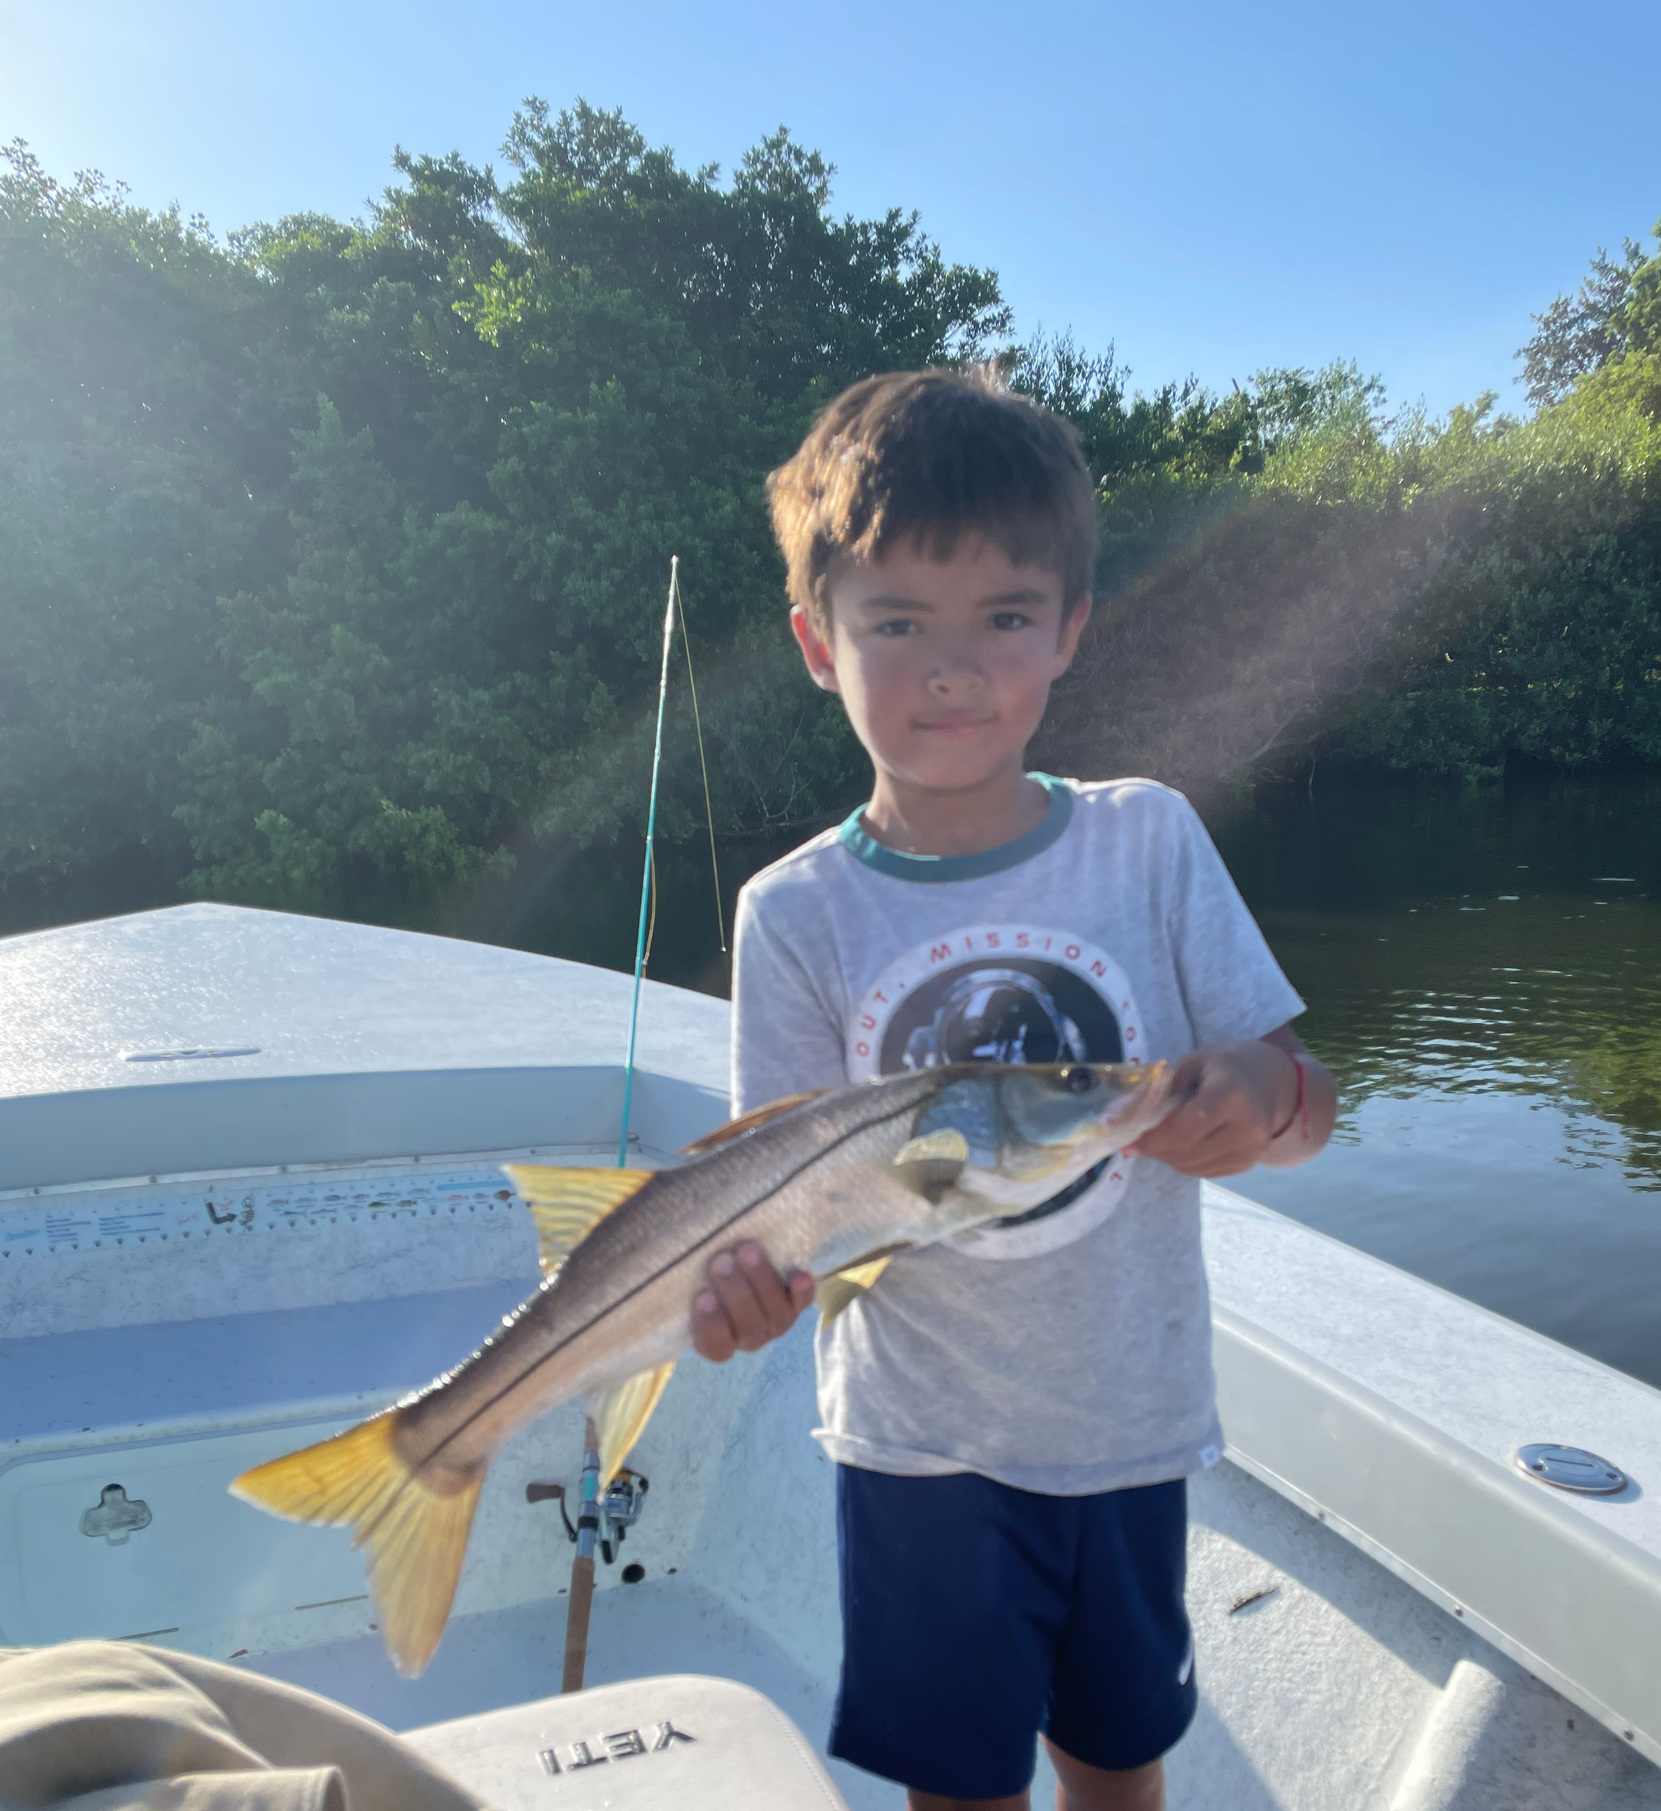

Fish concierge

Pic: Miguel age 7 wanted to catch a snook on his birthday.

Some fishing trips are about catching that bucket list fish, some are about groceries and others are about friendly competition. During our summer months most of our trips are about quality family time on the water and making memories. Introducing young anglers and clients who have never fished our waters are some of my favorite outings. When I’m lucky enough to be given that opportunity to take someone on there 1st saltwater fishing trip it’s something I don’t take lightly.

When taking these trips I like to show the clients the variety of species our amazing back yard offers up everyday. Starting out the trip with a fast paced bite on either snapper or trout quickly grabs everyone’s attention. Coaching anglers to catch fish no matter what there skill level is all part of the challenge of being a guide. Over the years you learn to recognize the small things that make all the difference why one angler does well while another may struggle. By the end of the days trip watching everyone succeed is what it’s all about.

As guides we are not only fishermen but the concierge to this amazing place we are lucky enough to call home. From where to stay or eat to environmental issues ask your guide. The eco part of the tour is always open while out on the water. We never know what we will see from day to day. Turtles, dolphins, manatees and birds are all part of the experience.

After 21 years of guiding I’m confident in saying I have the best job out there. Getting to spend over 300 days a year on the water doing what I love I’m living the dream. Yes there are some tough days when Mother Nature fights you but day in day out I can’t think of any other place I’d prefer to be.
Most people work there whole life to retire and do what I get to do everyday.
Clients often ask what I do when I have time off. The answer is fish.

