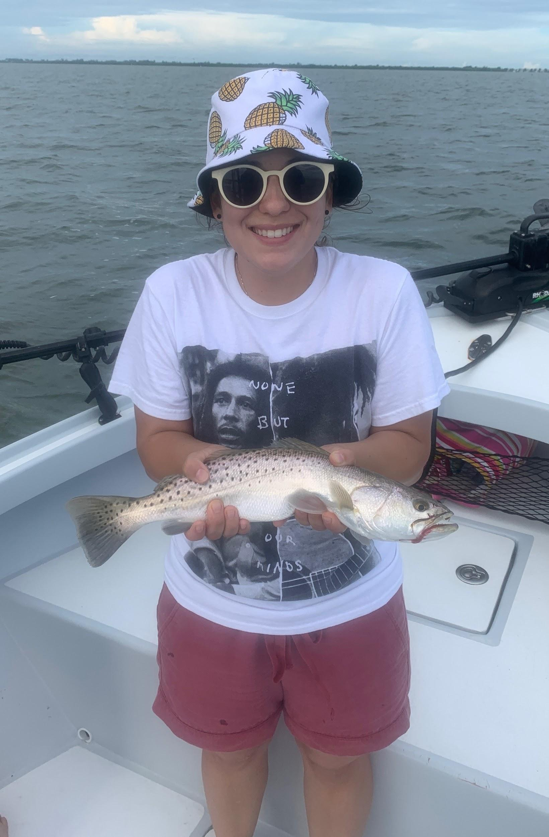

Find the fry bait and you find the fish

Pic: Big trout have become more and more common over the past few weeks.

For the past few weeks throughout the sound and the passes there is a massive amount of what I like to call fry bait. This small bait is around all summer and is a mix of shiners, glass minnows and threadfin herring. What this bait lacks in size it make up for by covering huge area’s and has to number in the millions.

Once you locate this bait its just a matter of making a few throws of a small mesh cast net and its time to go catching. I’ve been catching this bait up on top of shallow grass flats all through the sound. Move out to the deeper water and flats in the 5-7ft depth range anchor up and start chumming. My goto rig has been a small 1/0 light wire circle hook, a piece of 20# leader and a popping cork.

The amount of trout we are catching has to be experienced to be believed, with quite a few going over 20 inches. Along with the trout Mangrove snapper, ladyfish, mackerel and small blacktip sharks have all been keeping the rods bent. Once you get this bite started its been almost non stop action. Some of the most productive places for me this week have been between Chino island and redlight shoal, Captiva Rocks and the outside of Wulfert keys.

The one draw back of this small fry bait is that with such hot water temperatures it only lives for a few hours in the live well. I’ve been starting of my trips with this type of fast paced fishing then by mid morning switching it up for snook and redfish. After catching big numbers of fish out on the flats I have either been heading to the passes or going mangrove fishing.

During the lower tides I’ve been drifting the passes with the pinfish and grunts that outlive the fry bait. Then during the higher tides I’ve been taking the ladyfish which where caught on the flats with the fry bait and pitching chunks of it up under the tree’s. Bait management during these hotter summer months is key to catching fish all day.

