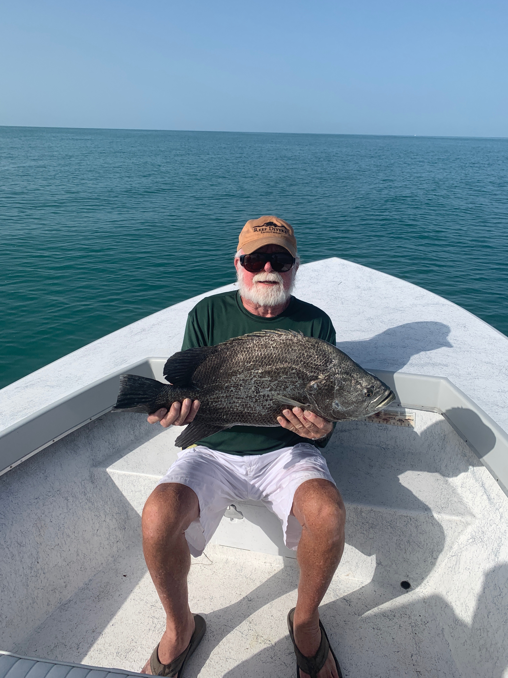

Pic: The 1st of the 3 fathers day tripletail caught while fishing with Capt Matt Mitchell this week

Fathers Day Fillets

Fishing this week was all about the passes and the beach for Snook and sea trout. Basically any structure you could find out on the beach was holding these fish. Many years ago the whole north end of Sanibel beaches was covered up with downed tree’s which made great summer time snook habitat. After hurricane Charley roughly 15 years ago all of this great fish structure was removed as part of the Bowmans beach clean up.

Erosion on some of our barrier islands is never ending with the beach constantly moving from one end of a island to the other. Certain places it creates sand bars while moving sand out from the beaches. Many of the places that are experiencing this beach erosion now have some great structure once again out on the beach. On most of the barrier islands from Cayo Costa south you can find a few places with downed tree, exposed tree stumps and even rock ledges. All these places are worth fishing as they are all holding Snook and Sea trout. If you find the right one often you can catch a few dozen fish on one submerged tree if the tide is right.

JW, the goto guy at my marina had a charter scheduled with me last week to take his dad out for father’s day. His goal was to put his dad on his first Snook. Heading out we started in the pass and after no bites I opted to head out on the beach. While on the way to a favorite beach blow down spot I was running no wake buoys and almost immediately saw several big tripletail just below the surface.

Turning the boat around we quickly hooked one of the large 15 pound tripletail and after a long fight my heart dropped as the hook pulled boat side. Returning to the marker I was expecting that the other fish would have spooked but luckily they had not. The next fish we hooked was about 12 pounds and came to the boat relatively quickly. After a few more cast we had 3 tripletail in the cooler all between 12-18 pounds. Could not think of a better way to start a trip. Moving down the beach we did manage to catch that 1st ever snook for JW’s dad on the snags. All in all it was a very memorable trip but not because of the snook.

