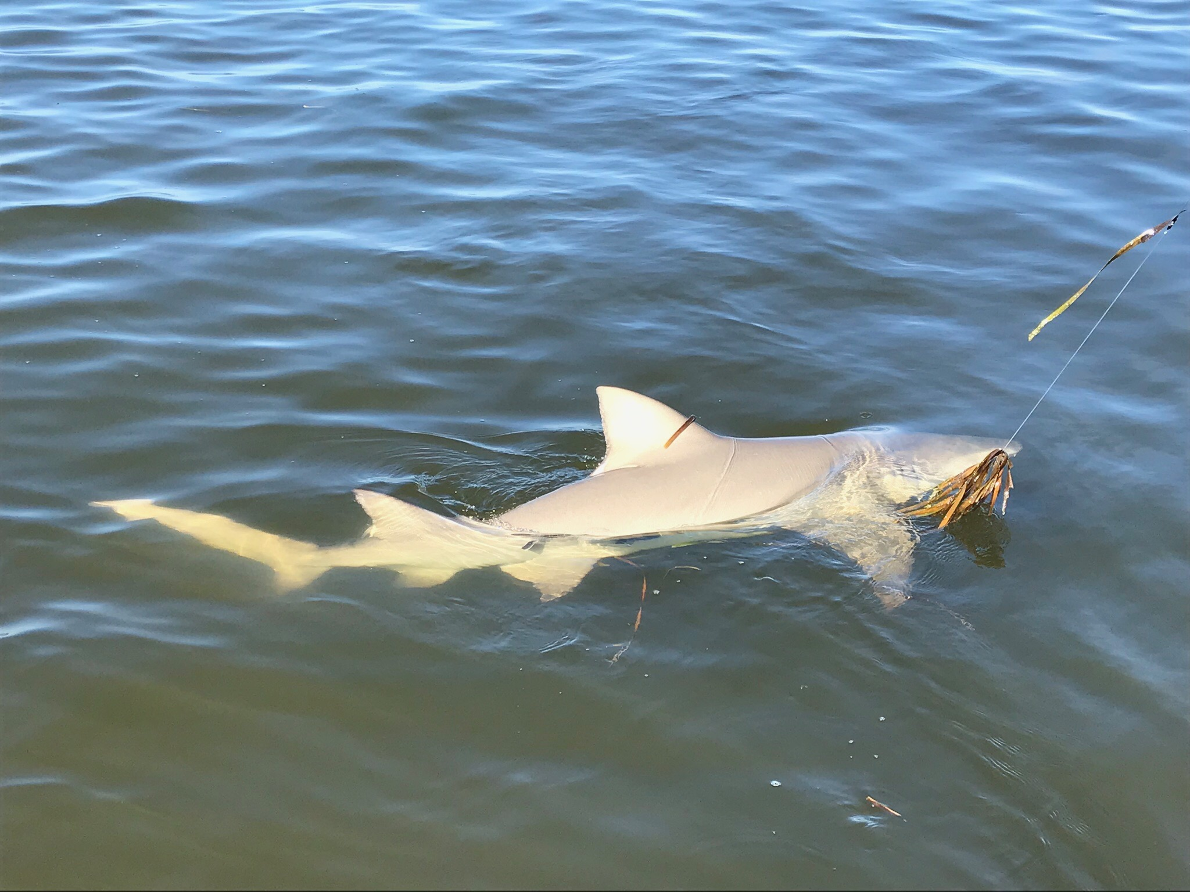

Fast paced action is easy to find

Picture: The shark bite is still going off both in the sound and out on the beaches

Weather and fishing was simply awesome this week. I did a few trips targeting sharks along with some family style fishing trips casting jigs in and around fish feeding frenzies all through the sound. The catch and release snook bite also continued to be good on both tides

Casting soft plastic jigs in and around the many feeding birds in the sound has just been on fire. Small green plastic tails on a 1/4oz jig head caught a wide variety of fish including trout, mackerel. ladyfish, gag grouper, snapper and jacks. When the bite is this good jigs are just a better choice than even live bait often getting hit multiple times during a retrieve. If you want to catch shear numbers of fish this is it. The further north in the sound you got the better the water clarity was and the more schools of feeding fish and birds you found. From Red light shoal north to the fish camps was the most productive stretch of water for me this week. This same high activity fishing for ladyfish and jacks was a great place to put out a cut bait and catch a shark. Sharks of all varieties and sizes had clients smiling.

We also targeted Spanish mackerel both around the passes and out within sight of the beaches. To locate these Spanish watch for them jumping all the way out of the water as they gorge on the small fry bait schools. These fish can be caught by a variety of methods ranging from trolling to casting flies and are just a sporty, high activity fun fish to catch.

Probably the most popular way to catch these Spanish Mackerel is to cast through them with a small jig or spoon. A fast retrieve is key to this as these fish are crazy fast. I often tell my clients “you cant reel it too fast” when targeting these speedsters. Flies work really well for Spanish too with small clouser minnows being just deadly. The old school way and probably simplest method to catch them is to troll spoons out along the beaches in these schools of feeding fish. Free lining live shiners on a long shank hook is another option, long shanked hooks will save you many of the cut offs from there razor sharp teeth and get you lots more bites than using steel leader. What ever your skill level these fish just cooperate.

Out on the beaches and in the sound any place you locate birds and feeding fish there are going to be sharks of all sizes too. While fishing in these blitz like feeding frenzies a few times a trip we have a hooked trout, mackerel or ladyfish cut in two by the tax man. Have a bigger rod rigged and ready to go or better yet put out a live ladyfish on a circle hook and just sit it in the rod holder. Most of the time it wont take long to hook into something big.

