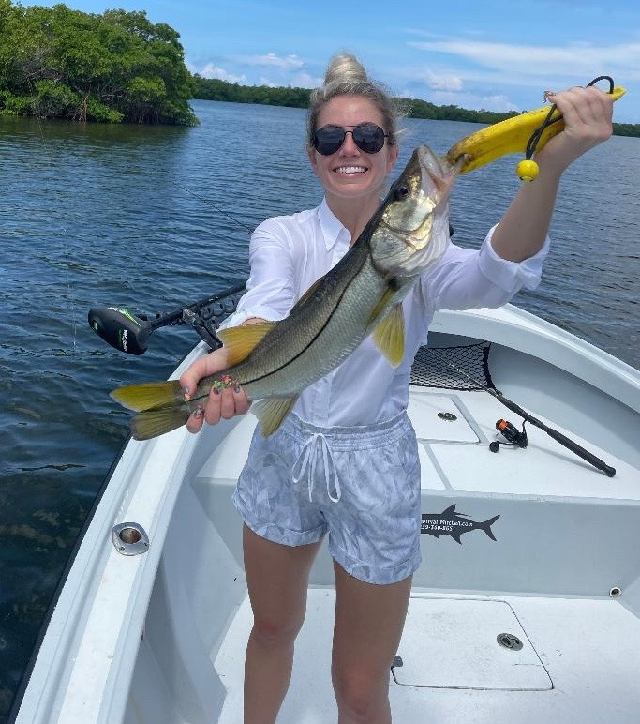

Family fun fishing

Pic: Malory from Winter Park with a snook caught while fishing with Capt Matt Mitchell this week

Much of the fishing I do this time of year is with family’s while they are here on summer vacation. This generally involves fishing with a few people on the trip who have either never fished or have very little fishing experience. Most of these charters are all about fast paced rod bending action and taking home fish to eat. The go to species to get this done all summer long are both trout and mangrove snapper.

Often, I catch both of these species while fishing in the same places. Bars in the sound including red light Shoal, Fosters point and Captiva Rocks are loaded up with both Snapper and Trout. I like to set up on the tips and points of these bars that have fast current moving over a nice bottom mix of both sand and grass. With the water being so clear look for area’s that are from 3-5ft. Make long casts with either free lined shiners or shiners under a float and let them travel on the tide.

The key for this fast-paced action has been having lots of small shiners. Chumming these areas with this plentiful bait has quickly lit the bite up with fish breaking the surface. My favourite method is to cast a free line shiner and slowly retrieving it. I tell the client to keep the rod tip up and simply reel and stop. As trout have such a soft mouth and often strike multiple times before they hook up once you feel a bite you just reel faster to create a bend in the rod which sets the hook.

Although there have been some mangrove snapper in the mix while fishing the above area’s docks, passes and deeper structure has been the better call for larger fish. Downsizing the leader to 15# fluorocarbon along with a light wire hook really makes a difference when targeting these wily fish. The less terminal tackle the better as snapper have amazing eye sight and are extremely leader shy. The same small shiners are the go-to bait and just like on the flats chumming some live ones will fire them up.

If you plan on keeping fish having a separate fish box or cooler filled with ice is a good idea. The faster you can get these fish cold the better the flesh will be to eat. Packing them in ice will also firm up the flesh and make them easier to fillet. A sharp flexible fillet knife will make quick work of these fish.
Sending clients home with a Ziplock of fresh fish for dinner is a major part of my summer time family trips.

