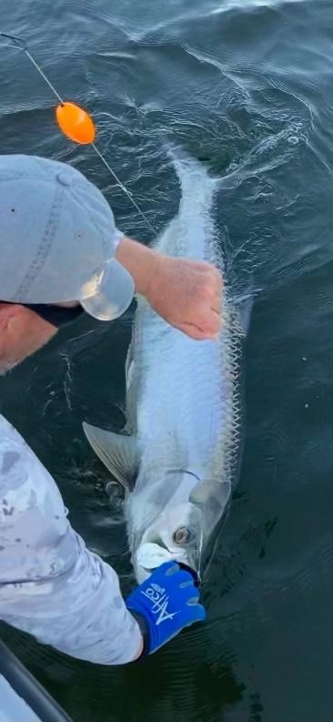

Fall hunting season

Pic: Success, a beach tarpon comes boat side before being released

Fall tarpon fishing continues to get better and better, out along the beaches I’m seeing lots of fish. Unlike our Spring time pre spawn tarpon these fish are hungry and eating. They will stay here on the unlimited bait buffet until the first hard cold front. With so much bait out along our beaches they pack on lots of calories before that upcoming annual journey south.

The most difficult part of getting in on this amazing world class fishery is locating these fish. Conditions will be the main factor as calm waters make spotting these rolling fish much easier. Some days we find these fish within the no wake buoys and can return to them for days as long as weather conditions remain the consistent. Then there are those other days you can run for miles and just never find them.

With great risk comes great reward and running the beach looking for these fish can either be a slam dunk or a big goose egg., No other fish we target draws as many comparisons to hunting, they are our big game. Once you do locate them you must position the boat within casting range so your angler has a shot. Wind direction plays a huge part in this as a downwind cast is a much longer cast than one up or cross wind.

Slowly drifting through these fish works really well while gently pointing your bow using the trolling motor as little as possible. Letting these fish come to you works takes much more patience but works much better than aggressively chasing them. The more relaxed and happier these tarpon are, the better they feed. Wait till they come into range before making a cast.

Finding birds and bait fish is usually the first part of a tarpon hunt. Giant schools of threadfin herring are where these tarpon want to be. Time of day has been critical as most days the bite was over by 9am. Although the bait was still there the tarpon had done there thing and simply quit showing in any kind of numbers. A few ways to get to these fish early is by catching your threadfins while out looking for tarpon. You can do this either with a heavy cast net to sink or with a sabiki rig. My favorite is to set a few pinfish traps the day before and pull them on the way to the beach tarpon grounds. Either don’t miss out on that few magical hours that tarpon are most active.

