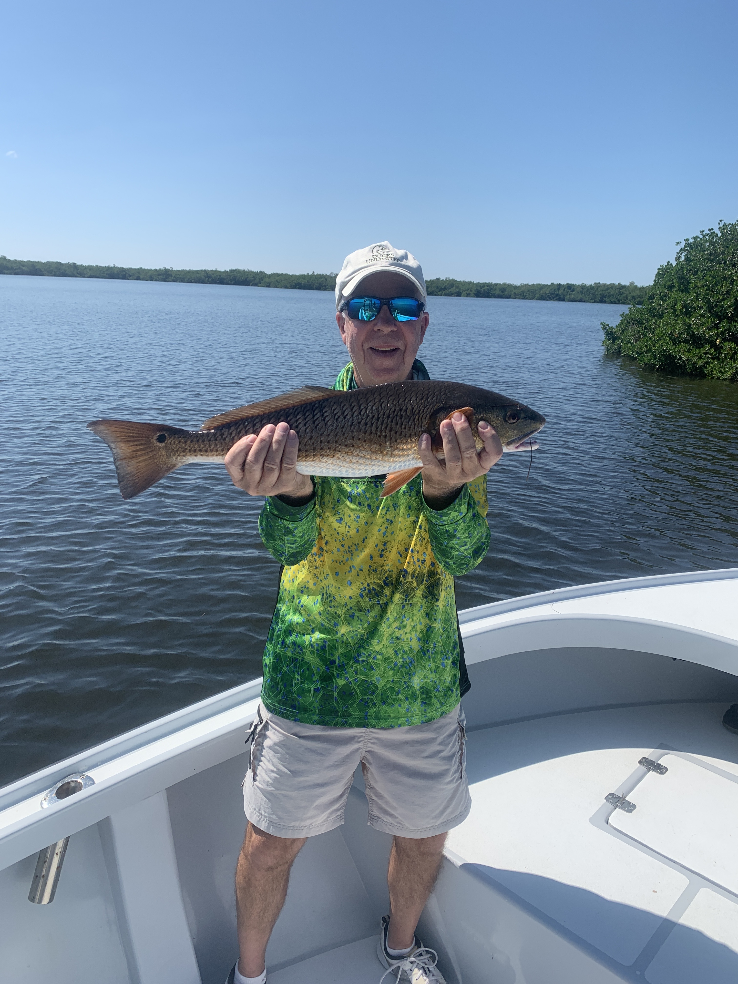

Fall fishing at its best

Pic: Micheal Cullen with a upper slot redfish caught while fishing with Capt Matt Mitchell this week.

Cooler less humid mornings along with calmer conditions than we have experienced in weeks made being out on the water the perfect place to be. Throughout the month of September there has been very little boat pressure on the sound along with lots of fish due to a slightly early start to the fall bait migration. Many mornings this week I caught bait alone and fished a entire morning charter only seeing a handful of other boats out. October is generally still a slow time for island businesses yet still some of our best fishing of the year.

Redfish continued to be our most sort after species with the best bite coming on the higher stages of the tide. Some days I would find these redfish right away other days they required a few stops though most days the result was the same with multiple hook ups. Tail hooked medium sized pinfish where the bait of choice though we did catch a few on cut mullet and ladyfish. Spotting mullet on the shoreline or oyster bar we usually meant the redfish were there. Redfish this week ranged from 20-30 inches. If you plan on doing a redfish trip tides have been the most important factor.

Most mornings out our trips have started out by catching trout, snapper and ladyfish under the diving birds in the middle sound. Larger Spanish mackerel have also been more plentiful in this same mix. Our baitfish schools are only getting larger in the sound as our water gradually cools. Anywhere from Demere to Bird key has been a great place to get started on this fast paced action. This week we made it a little further north on a few full day trips and found lots of action just inside the jug creek shoal at the tip of Bokeelia too. Hungry surface feeding fish could also be found between the C-span and tarpon bay.

The best big snook bite for us this week came during the last few hours of the falling tide. Working docks around St James city as the tide bottomed out we had a few trips where there was not a pinfish in the live well that was too big to get hit. Many of the larger snook are slowly making there way back across the sound from the passes and beaches they spent the summer. Oyster bars in the middle sound have been another good place to catch snook though this bite has been more on free lined shiners during the higher water periods.

More and more tarpon are being caught out along the beaches as cooling water temperatures and massive amounts of bait kick this bite into high gear. Anywhere down the entire length of the beach can hold these fish it just depends on where the large schools of bait congregate. Favorite places to look are just south of blind pass down to the West Wind inn and from roughly the middle of Ft Myers beach south to Bonita beach. East winds or no wind is key to finding these rolling fish. October can bring some of the best tarpon fishing of the year if the weather cooperates.

