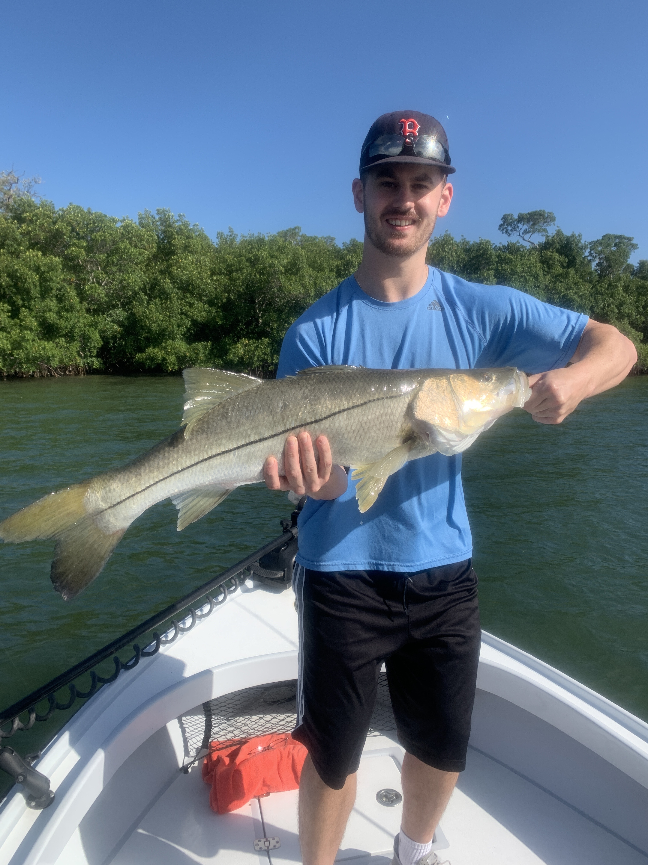

Escape to the water

Pic: Nick with his 38 inch snook caught this week with Capt Matt Mitchell.

In my last 20yrs of guiding we just do not get days off in May. With prime time tarpon season in full swing its just strange to see very few other boats fishing. With so many cancellations due to the corona virus I consider myself fortunate to be working at all. Luckily my local clients have kept me busy at least a few days a week as we all struggle to keep our business afloat during these crazy times.

Having an escape to jump on a boat and get out on water has made these tough times bearable. I could not imagine how hard its been for city people that have not been able to leave their own homes. Its really reminded me how much I enjoy fishing whether with or without clients. We really do have an amazing back yard.

Most of my fishing this week with clients was for Snook, redfish and trout. Staying in and around the passes for a few days made it possible to get this bite dialed in. One big surprise was the return of large trout in the passes like we haven’t seen in several years. During the first part of the falling tide was the best trout bite, while the better snook and redfish action came during the lower water periods.

Mangrove snook fishing has been another option. Some of the larger snook we caught this week came while throwing shiners to favorite shorelines. After fishing with Nick and Bob these past few Sunday’s Nick got lucky and landed a 38 inch monster. This big fish put on a battle like long time bass fisherman Nick had never experienced. After several crazy close calls with the Mangrove roots he managed to muscle this bruiser into the boat for a few quick photos.

Cooler mornings made finding any tarpon tough for a couple of days. As conditions improve and we have a full week of warmer weather forecasted things should get a whole lot better. Until then we have plenty of other options in both the mangroves and passes.

