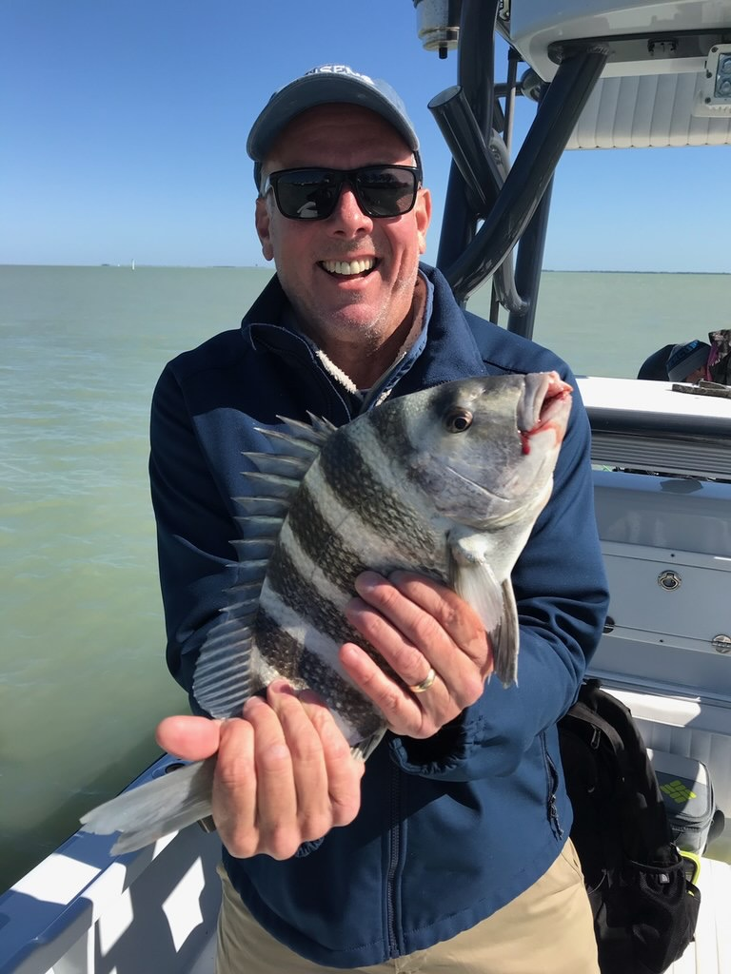

Endless options

Pic: Terry from Wisconsin got in on the cold water sheepshead bite this week with Capt Matt Mitchell.

A strong mid week cold front did little to shut down the great fishing we have been experiencing it was just a matter of changing the game plan. Water temperatures in the bay dropped 12 degrees’ almost over night and shut the Snook bite down for a couple of days. In the mean time I switched it up and had a great meat trip catching sheepshead on shrimp. I know its still way too early to quite call winter done although any more cold fronts should hopefully be brief.

Right before this last cold front passed action on Snook and mangrove snapper was non stop. Every windblown shore line seemed to hold fish. Then once the cold front passed late morning winds switched and blew hard from the North the bite was over. Timing with cold fronts is everything and as little as a hour can make the difference between crunching them or never bending a rod. Even a few days before a front you see the action getting better and better right up to the wide open bite we experience just before the cold front moves through. grinding

Catching sheepshead in and around the passes during these brief cold periods was a great option once you found the fish. Often this fishing requires making several moves until you locate them. This was the story for us this week as we had only caught a few keepers until we found that one dock that was loaded up. Within 30 minutes we had as many as we needed for a few good meals. Most of our sheepshead that day measured between 14-17 inches.

Pitching live shiners on the eastern side of the sound anglers enjoyed both great action and clean clear water. Snook and Mangrove snapper where the majority of the fish caught though we did manage a few redfish and an occasional trout. Once you cross the sound to the west side the water looks totally different and stirred up and dirty. During the last few hours of the outgoing tide water in and around the passes has cleaned up some this is the more productive time to fish the passes for Snook.

With another full week of warm weather in the forecast our water temperature should climb back into the mid 70’s making giving anglers endless possibilities. On calm days getting out mid day along the beaches for Mackerel and Bonita while searching for a tripletail is a great option bring a big stick too as you may run into big sharks. Right before this last cold front we had the first reports of tarpon both in Boca Grande along with a few showing on the clam leases and Rocky channel in the middle sound these fish should quickly return too as waters warm back up. The Burnt store bar all the way south to Matlacha has also been a good option if you have the time to sight fish for Cobia. I like to spend my days catch and release Snook fishing while keeping my eyes open to take advantage of anything else that pops up.

