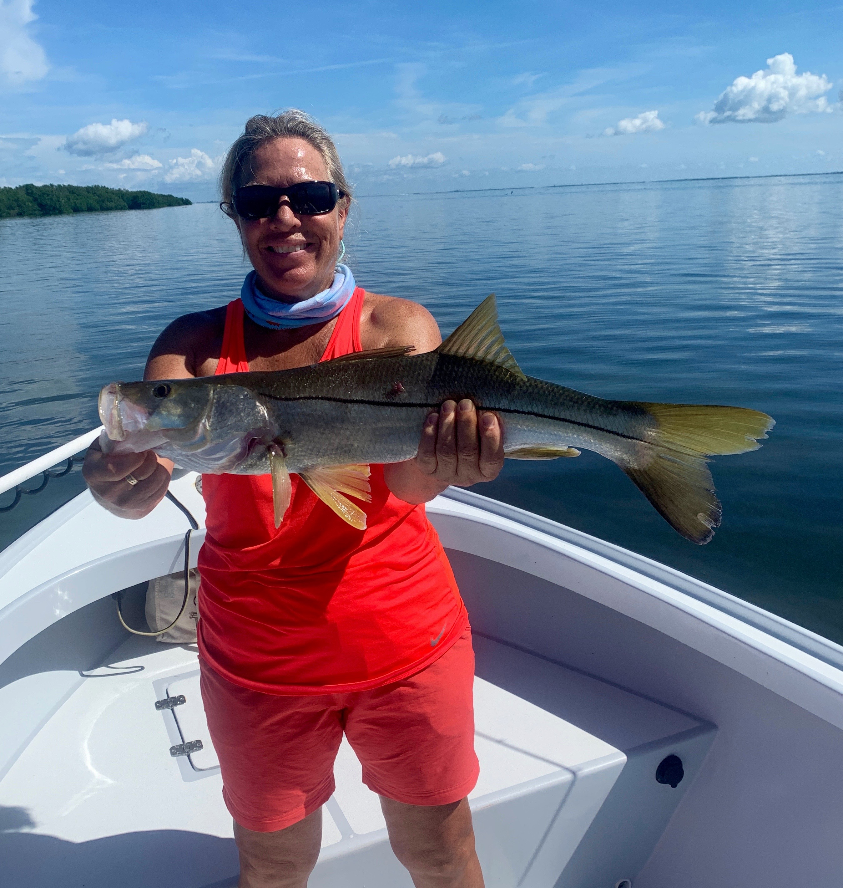

Pic: Mary Laser with a Snook caught while fishing with Capt Matt Mitchell this week

Don’t forget last August

With slow morning outgoing tides this week we mixed it up and did what we usually do this time of year and fished in the passes. When there is no moving water anywhere else you can often find at least a little movement in the inlets. All our passes offered a wide variety of species and once the tide finally did flip over giving us a few hours of outgoing water the bite was on with lots of quality fish.

Traffic on the water has started to gradually quiet down as it always does mid summer. Summertime fishing action does not slow and offers anglers lots of species options along with more marine wildlife to look at than at any other season. Been out on the water most mornings there is a cooling breeze that helps deal with the heat. This next few months are hands down my favorite time of year to be fishing as we have some of the most consistent fishing action of the year.

Catch and release snook fishing is still in full swing both around the passes and on the beaches. Redfish are also making a strong showing both in the passes and under the mangroves during the higher stages of the tide. Pinfish and grunts are the baits of choice for fishing in the passes while cut bait fishing the mangroves during the higher tides has been very effective, Trout are being caught both on the grass flats and out along the beaches. Most grass flats in the sound have come alive with jacks, ladyfish and mangrove snapper that are mixed in with the huge schools of small fry bait.

As we move into August I cannot help but think back at the ecological and economic nightmare we were all living in at this time last year. This was caused by the largest and most prolonged red tide anyone can ever remember to hit our area. Now with our water looking better than I have seen it in years its easy to forget what happened last summer. Our water quality issues in Florida are far from resolved.

The resilience of nature is amazing, seeing our waters clean and full of life again is something that has to be seen to be believed. Clean clear water and healthy grass flats have returned to the sound though we are only one hurricane, tropical storm or even a major rain event away from seeing the exact same devastating red tide issue caused by last summers massive water releases from Lake Okeechobee.

Until the natural flow is restored to Florida sending water south through the Everglades we are all living with a ticking time bomb that will not only wipe out our wildlife but do hundreds of billions in economic damage to our economy again. Everyone who lives in Florida even if you don’t live on the water are effected by our water quality.

