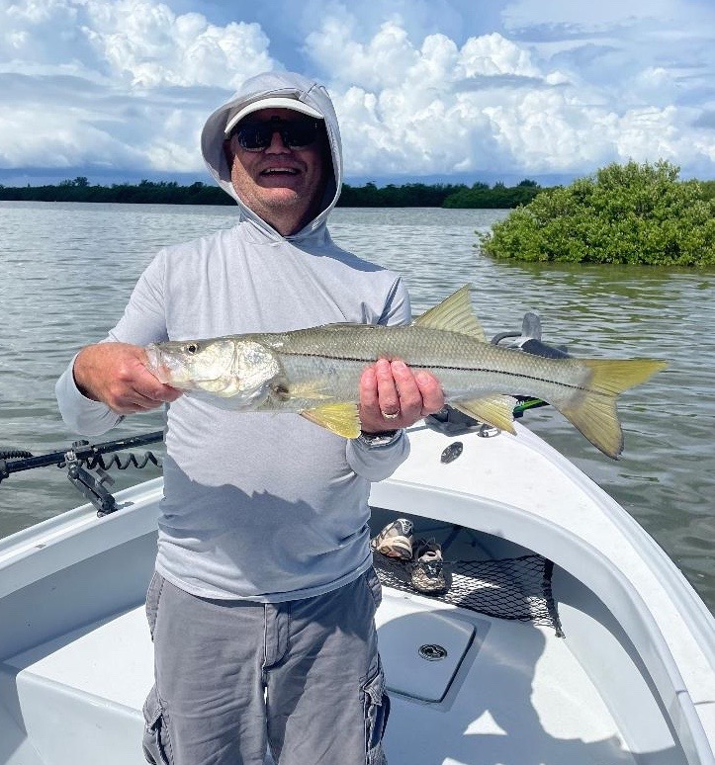

Pic: Paul from MN with his first snook caught while fishing with Capt Matt Mitchell this week

Dodging morning coastal showers

With this being one of the slower times of year on the water I have really enjoyed having what has seemed like the whole bay to myself. Big morning incoming tides gave us lots of options though catching food fish for clients has been the trend. The many mangrove creek systems of the sound have all been hard to beat for both mangrove snapper and trout. Once the dinner requests of my clients have been met, we have quickly switched it up to catch and release snook fishing.

Oyster bar fishing during the strong incoming tide has been outstanding throughout the sound. These bars are a big transition for snook and the key to this has been keeping the shiners moving while working them through the many sand holes around these bars. With many of these places extremely shallow this method not only keeps the bait from hanging in the bottom but also triggers the reaction strike snook cannot resist. The many bars around Buck key and also out from Pineland have been hard to beat.

When setting up on a oyster bar boat position is everything. You want to set the boat up just close enough you can reach the edges of the bar with a long downwind cast. Keeping the tip of the rod high on a stop and go retrieve will help keep the bait out of the grass bottom and make it flutter. Look for jumping mullet on the bars to show which ones will be most productive. While fishing these same bars catching redfish has become more and more common as we slowly approach Fall.

Of all the weather patterns we deal with out on the water I don’t think there is anything tougher to forecast or predict than when we get in that morning coastal shower pattern. This proved true this week with storms popping up and what seemed like exploding right on top of us. Even while watching the weather radar on the phone, they proved just about impossible to avoid. Other days we would race in due to lightening and heavy rains then once back at the dock the storm just broke up and never arrived. It’s always better to air on the side of caution with these often fast moving, unpredictable storms. Any time I see lightening while out on the water it’s time to get somewhere safe.

