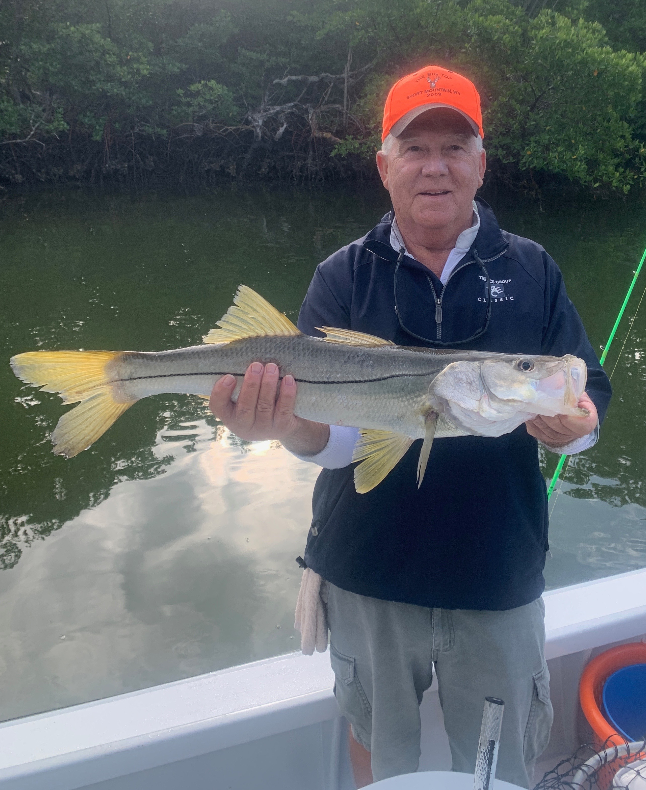

Cold water surprises

Pic: Bob Lauer with a Snook caught in the cold water while fishing with Capt Matt Mitchell

As forecast the coldest weather we have seen in over 2 years dropped the water temperature in the sound into the high 50’s. Bundling up and fishing all but on the coldest day as expected the sheepshead fishing was on fire. This cooler water pushed our big concentration of larger spawner’s into the sound so far this winter.

Black drum are a species that we seldom target though we do catch them while fishing for other species on shrimp. This winter has brought some of the most consistent black drum fishing I can remember along with even some low tide sight fishing opportunities on this under rated species. Several deeper channels going into St James City have held these fish day after day.

Redfish action has also heated up with the cold water and minus low tide set up. On just about every trip this week we came across a different place that had great numbers of these fish ranging from 16-24 inches. Bouncing a live shrimp across the bottom in some of the deeper holes the bite was often non stop. Seeing so many redfish is comforting that the closure has let these fish rebound in great numbers.

This week I had a group from NY in town that had planned on doing a shark fishing trip. We had spoken several times over the past few weeks and with cold water temperatures I did not think our chances of getting 10 yr old Joe his first shark in the cold water where very good. As we headed up towards Rocky Channel in the northern sound we talked about giving it a hour and having a plan B.

Within a hour of setting up Joe caught two large Blacktip’s on cut mullet. His first shark was right at 5ft then his 2nd about a 4ft model. I was surprised at how many runs we had in such cold water. Joe was all smiles after catching his first sharks.

