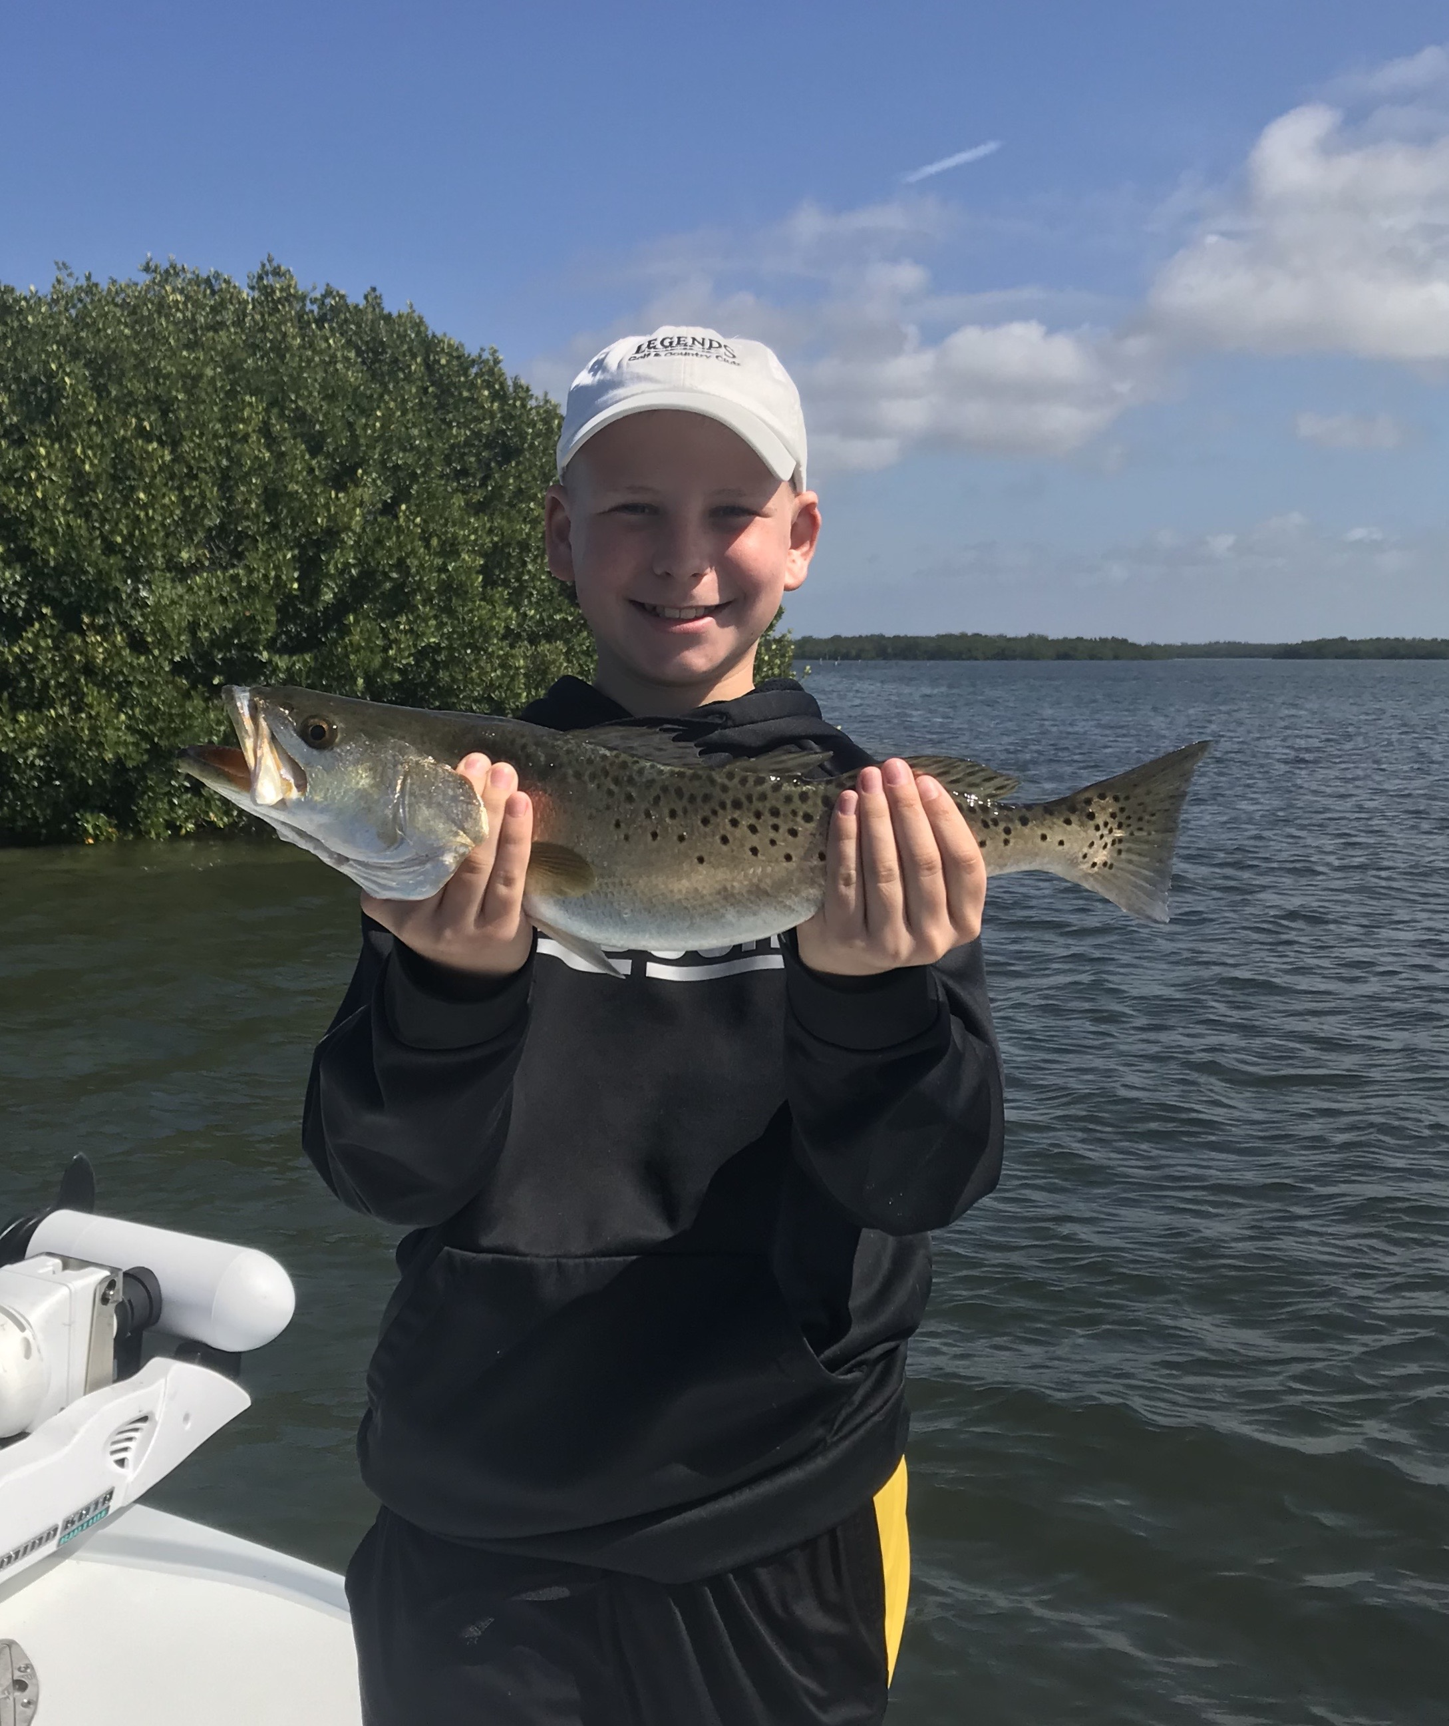

Picture: Jackson age 12 visiting from Wisconsin caught lots of big Trout this week with Capt Matt Mitchell.

Clean clear water equals big tTout

Fishing during the past weeks warming trend was a much needed change from the flip flopping hot/cold weather we experienced the entire month of March. Add in crystal clear water in the middle to northern sound and using live shiners for bait again and even a few days of crazy winds could not take the smile off my face. Now we are finally to April the last strong cold fronts should be behind us and now our fishing will kick into high gear. After a prolonged winter game fish are coming out of their winter hideouts hungry and ready to eat.

Really big Trout were the target species for me most of this week. During these clean clear water times we catch some real giants. Our spring Trout bite when we are lucky enough to have the clear water like we do now is about as good as it gets all year. Spotting these laid up fish while riding up in the tower of my boat can make this fishing super easy at times. Once I do find them its often just a matter of returning to these same sand potholes to catch them for what can be days in a row.

Some of the smaller mangrove islands in the middle to northern sound where the most productive big trout spots for me this week. The best big trout action came from Cork key north. Many of these tiny little mangrove islands that don’t even have names have sand holes right up against them and just out from them these are the places these trout like to hang out. Depending on the wind and tide movement being able to sit as far out as possible and make a long accurate cast to these sand holes was key to catching these big trout along with a few 25 inch plus monsters. Many of these islands and can only be reached on the higher water on an incoming tide.

Shallow sand holes on the open grass flats also held lots and lots of trout of all sizes during the lower water periods. Once we found that one magic sand hole we would often catch our limit of fish at just that one stop. Many of these trout are just shy or even over the 20 inch max. Pitching big live free lined shiners into these sand holes gave clients some awesome visuals as these big trout often blew up time and time again as they chased and missed the bait. When you find this clean clear water the big trout will be there.

