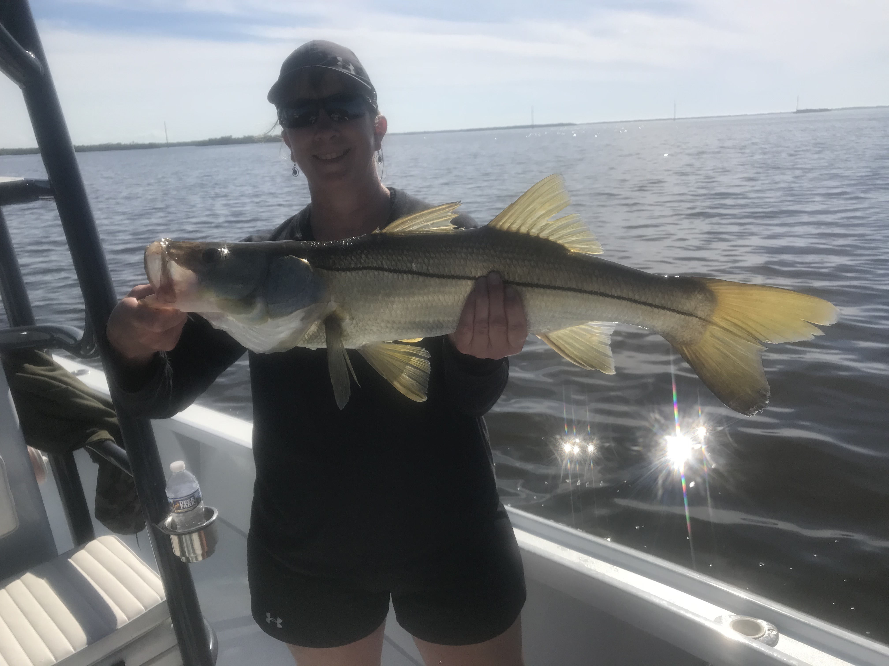
Pic: Kathy from Upstate Michigan escaped the snow and caught and released some snook with Capt Matt Mitchell this week

Christmas warm up

After a few cold days temperatures slowly rebounded and fishing kicked into high gear. Snook and trout where my target species this week and provided my clients with some great December action. Shiners reappeared on the causeway bridges and it was basically business as usual chumming live baits and catching lots of fish. To have a week of 80 degree plus temperatures is a real reminder why we enjoy December in southwest Florida.

Large mangrove creek mouths and the deeper shorelines just inside that had strong moving current provided a often non stop snook bite this week. Add a few scoops of live shiners to chum and not only snook but trout, grouper, jacks and mangrove snapper all quickly came to life. During the big morning low tides these deeper shoreline where almost the only place to fish as many of my regular fishing spots where just not accessible.

Warming water temperatures was bad news for sheepshead anglers with most of these fish just disappearing even from areas around the passes. We are still early for the sheepshead bite to kick into full swing with February and March being prime time spawning months for the bigger fish. Small mangrove moved into many of the places we target sheepshead and make it just about impossible to catch any other species as they are in such huge numbers.

Trout fishing in some of the more sheltered bays including Mcintirye creek and the Wulfert keys area had some of the most non stop trout action I have experienced so far this winter. Live shrimp on a popping cork rig caught as many trout as anglers could take. This crazy bite came in the sandy edges of the shallow bars during the low incoming tide. Once you found the depth these trout where hanging out in we caught them on almost every cast. Most of these fish are under the 15 inch minimum though a few as large as 18 inches where caught. There is not a better way to keep a boat full of kids entertained than this action and within a hour we had a nice cooler full of trout.

With outstanding weather for Christmas week in the forecast its going to be a very busy week out on the water. I can’t think of a better thing to do with out of town visitors than take them out on the water or to the beach and enjoy our Florida sunshine.

