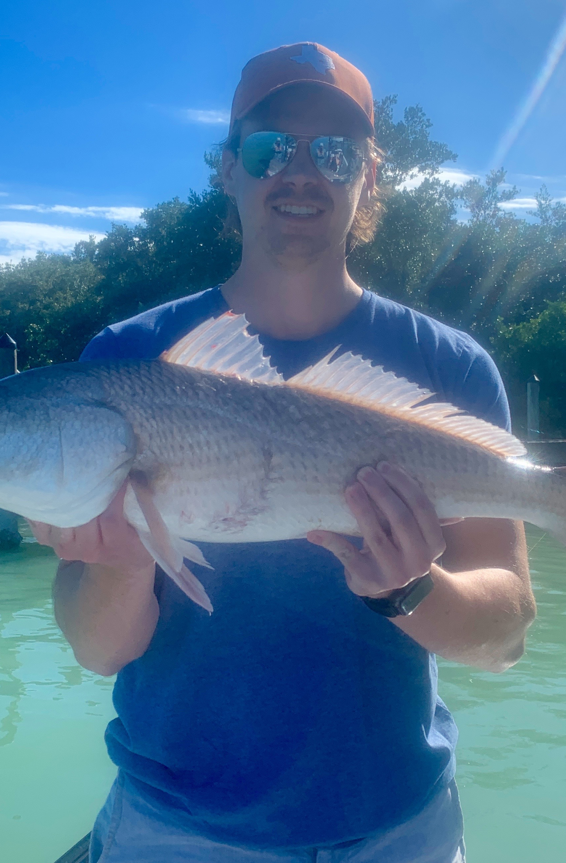

Christmas cool down.
Pic: Sam from Austin Texas caught a big redfish with Capt Matt Mitchell this week.

The coldest Christmas we have had in 25 years meant a drastic drop in our water temperature. The cold snap kept all but the most die hard anglers off the water for at least a few days. Anglers who braved the conditions where rewarded with some of the best Sheepshead action so far this winter. This amazing sheepshead bite occurred in a variety of places.

Having to wrap up in Ski gear to brave this bone chilling cold is not our usual Florida fishing. Deep in mangrove creeks out of the wind conditions where quite pleasant when the sun was out. These sheltered creeks held lots of rat redfish and trout. This action was non stop once you located the spot these fish had chose to ride out the cold. Holes deeper than 5ft often held these fish by the hundreds. This is the normal pattern during extreme cold as both these species seek refuge from the colder shallow flats.

Dock fishing both around the passes and off the inter-coastal was also a good choice. Moving tide was the major factor to locating the best dock to fish. My anglers not only caught Sheepshead up to 20 inches fishing this pattern but also lots of redfish too.

The colder the water the smaller and slower you need to fish your bait. Chunks of fresh shrimp rigged on a jig head and allowed to sit stationary on the bottom got bites when no other method would. Even though there where plenty of shiners around they just did not get bit when the water was in the low 60’s.

This weather proves that there is not bad weather just bad clothing. Wrapping up in layers our Florida cold is always manageable. Dress in layers when heading out on the water. Seeing clients from some frigid northern location show up in shorts this time of year is a recipe for a unpleasant experience. Even if you think your going to be way over dressed its always better than not being prepared. 50 degree’s on the water moving 30 mph on a open boat is cold no matter where you are from.

