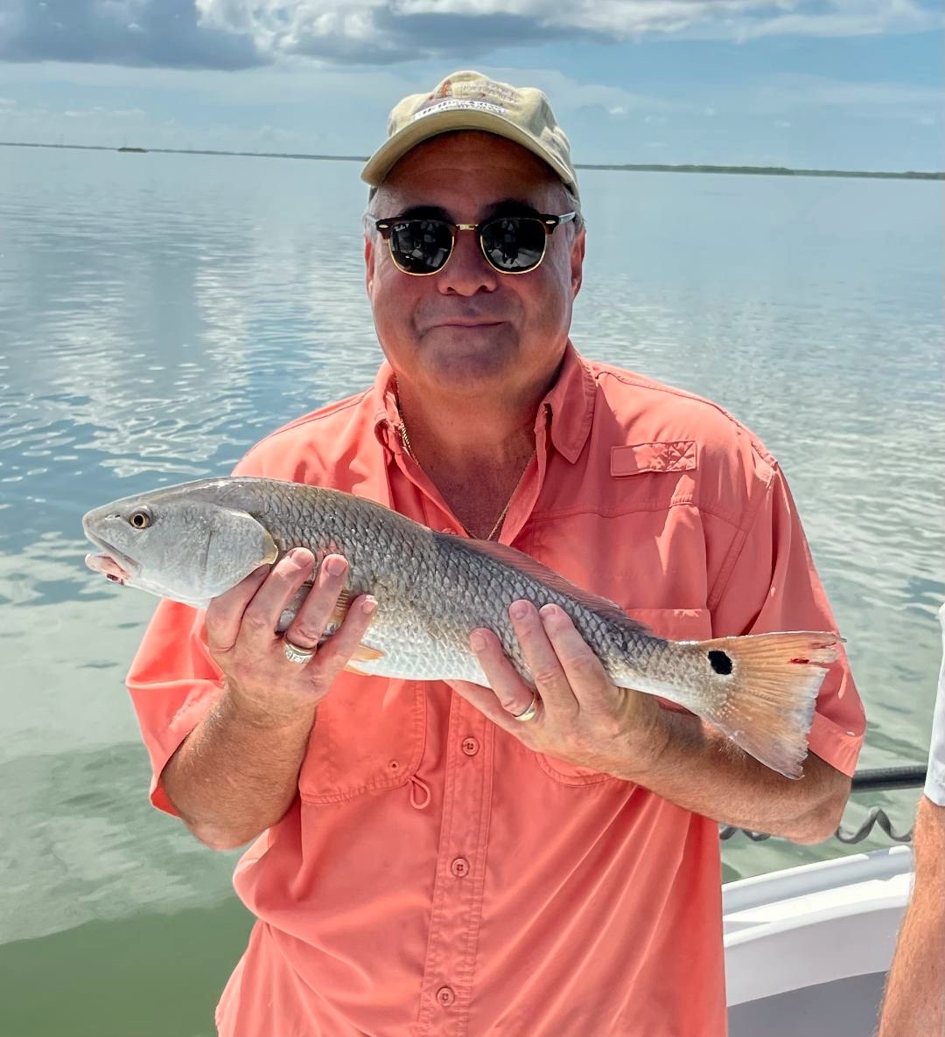

Big Moon Big tides

Pic: Vinnie with a redfish that completed his slam while fishing with Capt Matt Mitchell this week

When I looked at this past week’s tide chart and saw such big highs and major lows that meant we were going to have lots of water movement. The more the water moves the better our fishing is. Even with such a big full moon the action was outstanding all week. Trout and Mangrove snapper were caught out on the flats while the snook fishing was good from the beaches and passes all the way to the backcountry.

My favourite tide to fish all week was the big mid-day high incoming. This tide offered lots of water flow offering lots of options from both oyster bars and mangroves. Oyster bars on the western side of the sound from Captiva to Cayo Costa were loaded up with snook and even an occasional redfish. Every day I fish these bars I’m seeing more and more redfish as our best redfish action of the year is coming up fast. Mangrove fishing for redfish was also a good bet with the NE end of the sound. Start at Panther key and work north, cut bait and cut pinfish did best during the last few hours of the incoming tide.

Though our Fall cool off is a very gradual thing you can certainly notice our days have begun to get shorter. When asked what’s my favourite time of year to fish our waters I cannot think of a better time than late September and October. Spring is good too though the lack of angling pressure in the Fall makes it as good as it gets. Cooling temperatures along with the bait migration mean the variety of target species is limitless. One of my favourite things to do in the Fall is get out along the beaches and fish around the bait schools. These pods of bait can be found from in close to out a few miles. Once you find the birds and bait you never know what it can lead to.

On the back side of the super moon tarpon have slowly started to reappear in the sound. Slick calm mornings made it easy to spot them. One cool thing I saw this week that I have not seen for years was tarpon working bait on a weed line in the sound. Seeing these fish push up and down the edge of the floating grass was amazing even though we never caught one. Live pinfish under a float are hard to beat as we approach Fall tarpon fishing. If you’re willing to put in your time and start early tarpon have been more active than I’ve seen in months, start the hunt in the middle sound.

The FWC has planned to open the redfish harvest for our region Sept 1st after a 5yr closure. With these fish making what seems like a slower comeback than both snook and trout I don’t agree with this move and personally think they should have kept this fishery closed for at least another year. The size regulations on Redfish will remain 18-27 inches though thankfully the one per person per day limit will be reduced to 2 per boat max. After what our beloved fishery went through airing on the side of caution would have been a better call.

