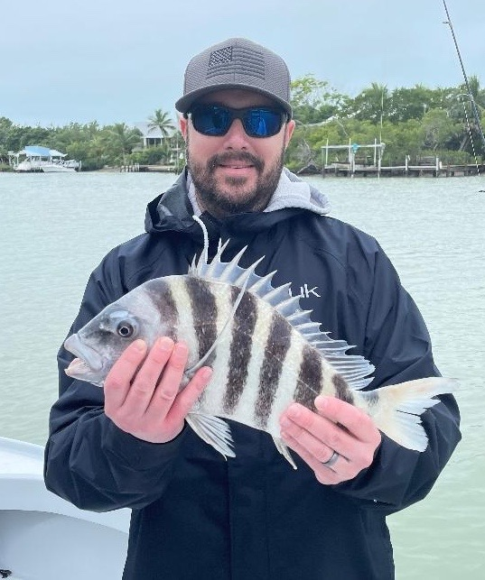

Another winter weather weekend

Pic: Bryan Thomas from NJ got in on the winter action with Capt Matt Mitchell this week

With yet another cold front arriving just in time for the weekend this one not only brought gale warnings but the lowest temperatures we have seen in years. Extreme cold fronts like this one always have anglers worrying about our Snook population as prolonged cold water can bring a Snook kill. Luckily this time it looks like by mid-week temperatures will quickly rebound and we should be out of that danger zone.

Getting out on the water all week until the front blew us out for a few days we spent our time fishing for sheepshead and trout. Seemed no matter what the conditions are you can always find somewhere out of the wind and keep the rods bent while staying close to home. The colder it gets the better this fishing has got.

Sheltered grass flats in the 2-4ft range have been loaded with the most trout since I have seen since before our 2017 red tide. Experiencing this amazing trout bite reminds me of when we always took trout fishing for granted. Catching trout after trout ranging in size from 12-20 inches is a barometer of how healthy is once again. New regulations on trout went into effect after the almost 4ear closer. These new regulations are 3 fish per person limit or 6 per boat max Trout have to measure between 15-19 inches with one over the 19-inch max per vessel.

Trout fishing has been a great way to start off a charter as it’s a very visual bite. Popping corks rigged with a live shrimp on a 1/4oz jig head roughly 30 inches below has been deadly. This rig allows you to make long fan casts and cover lots of water. Gently pop the float roughly every 10-20 seconds to attract the fish. When a trout strikes you will see the float go under. Don’t set the hook hard just reel fast enough to come tight while slowly lifting the rod create. If the trout lets go continue popping the float as they will often stay with it. The key to keeping these extremely soft mouthed fish on is to keep a bend in the rod, any amount of slack line they will come off.

Once a trout is boat side if you don’t plan on harvesting it a hook out tool allows you to release them without ever touching them. These fish are very delicate and have a much better chance of survival the less they are handled. If you are going to measure them, wet your hands before lightly grab them. The less of the protective slime coat you disturb the more healthy they will be when they swim off.

The better sheepshead bite continues to be on structure in and around all our passes. These are the first places these fish are stopping as they come in from the Gulf side to spawn. After each cold front expect a new wave of these fish to flood in. Chunks of shrimp work best with enough weight to hold the bait down in the current. Although the minimum size of Sheepshead is 12 inches unless these fish are 14 inches, they simply don’t yield much meat and should be released.

