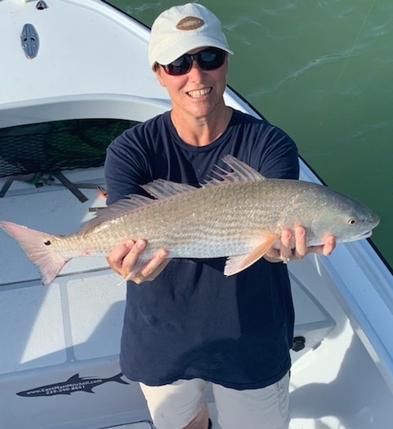

An early April reset

Pic: Pam Murray with a 27 inch redfish caught this week with Capt Matt Mitchell

Starting off April with a nasty cold front is never what anyone wants. This is not that unusual though but this one hurt. It felt like we hit the reset button on our Spring fishing pushing everything backwards. Strong northerly winds and mornings in the low 50’s sent our water temperature plummeting more than ten degrees.

Early season Tarpon fishing will be forgotten for at least the next week until water temperatures hopefully recover to that magical mid 70’s. Pre cold front tarpon where being caught all through the area. I had reports of fish being hooked from marker #4 all the way up to the powerlines along with the waters behind Cayo Costa. These deeper holes and channels are always a good choice for a early season silverking. Conditions were close to perfect for about a week before this weather made these fish retreat back to the deeper, warmer Gulf waters. Nothing puts a holt on early season tarpon fishing like a late cold front.

After the a few weeks of of non stop snook action it may take a few days for this bite to get back on track. Just like after any other cold front it will be about fishing deeper sheltered channels with warmer water. Catching fish will require slowing down the presentation to get that bite. Luckily Redfish and trout will fill the snook void for a couple of days until things get right again. Fishing the passes will produce a variety of species including redfish, trout, mackerel and even a few late season sheepshead.

March and April are traditionally our windiest months of the year. This is certainly proving true yet again. Getting blown out for Easter weekend caused lots of cancellations during what can only be described as a extremely busy time. Mother nature makes the final decision on if we get to go fishing or not. Small craft advisories and high winds meant a few days off the water until conditions improved.

