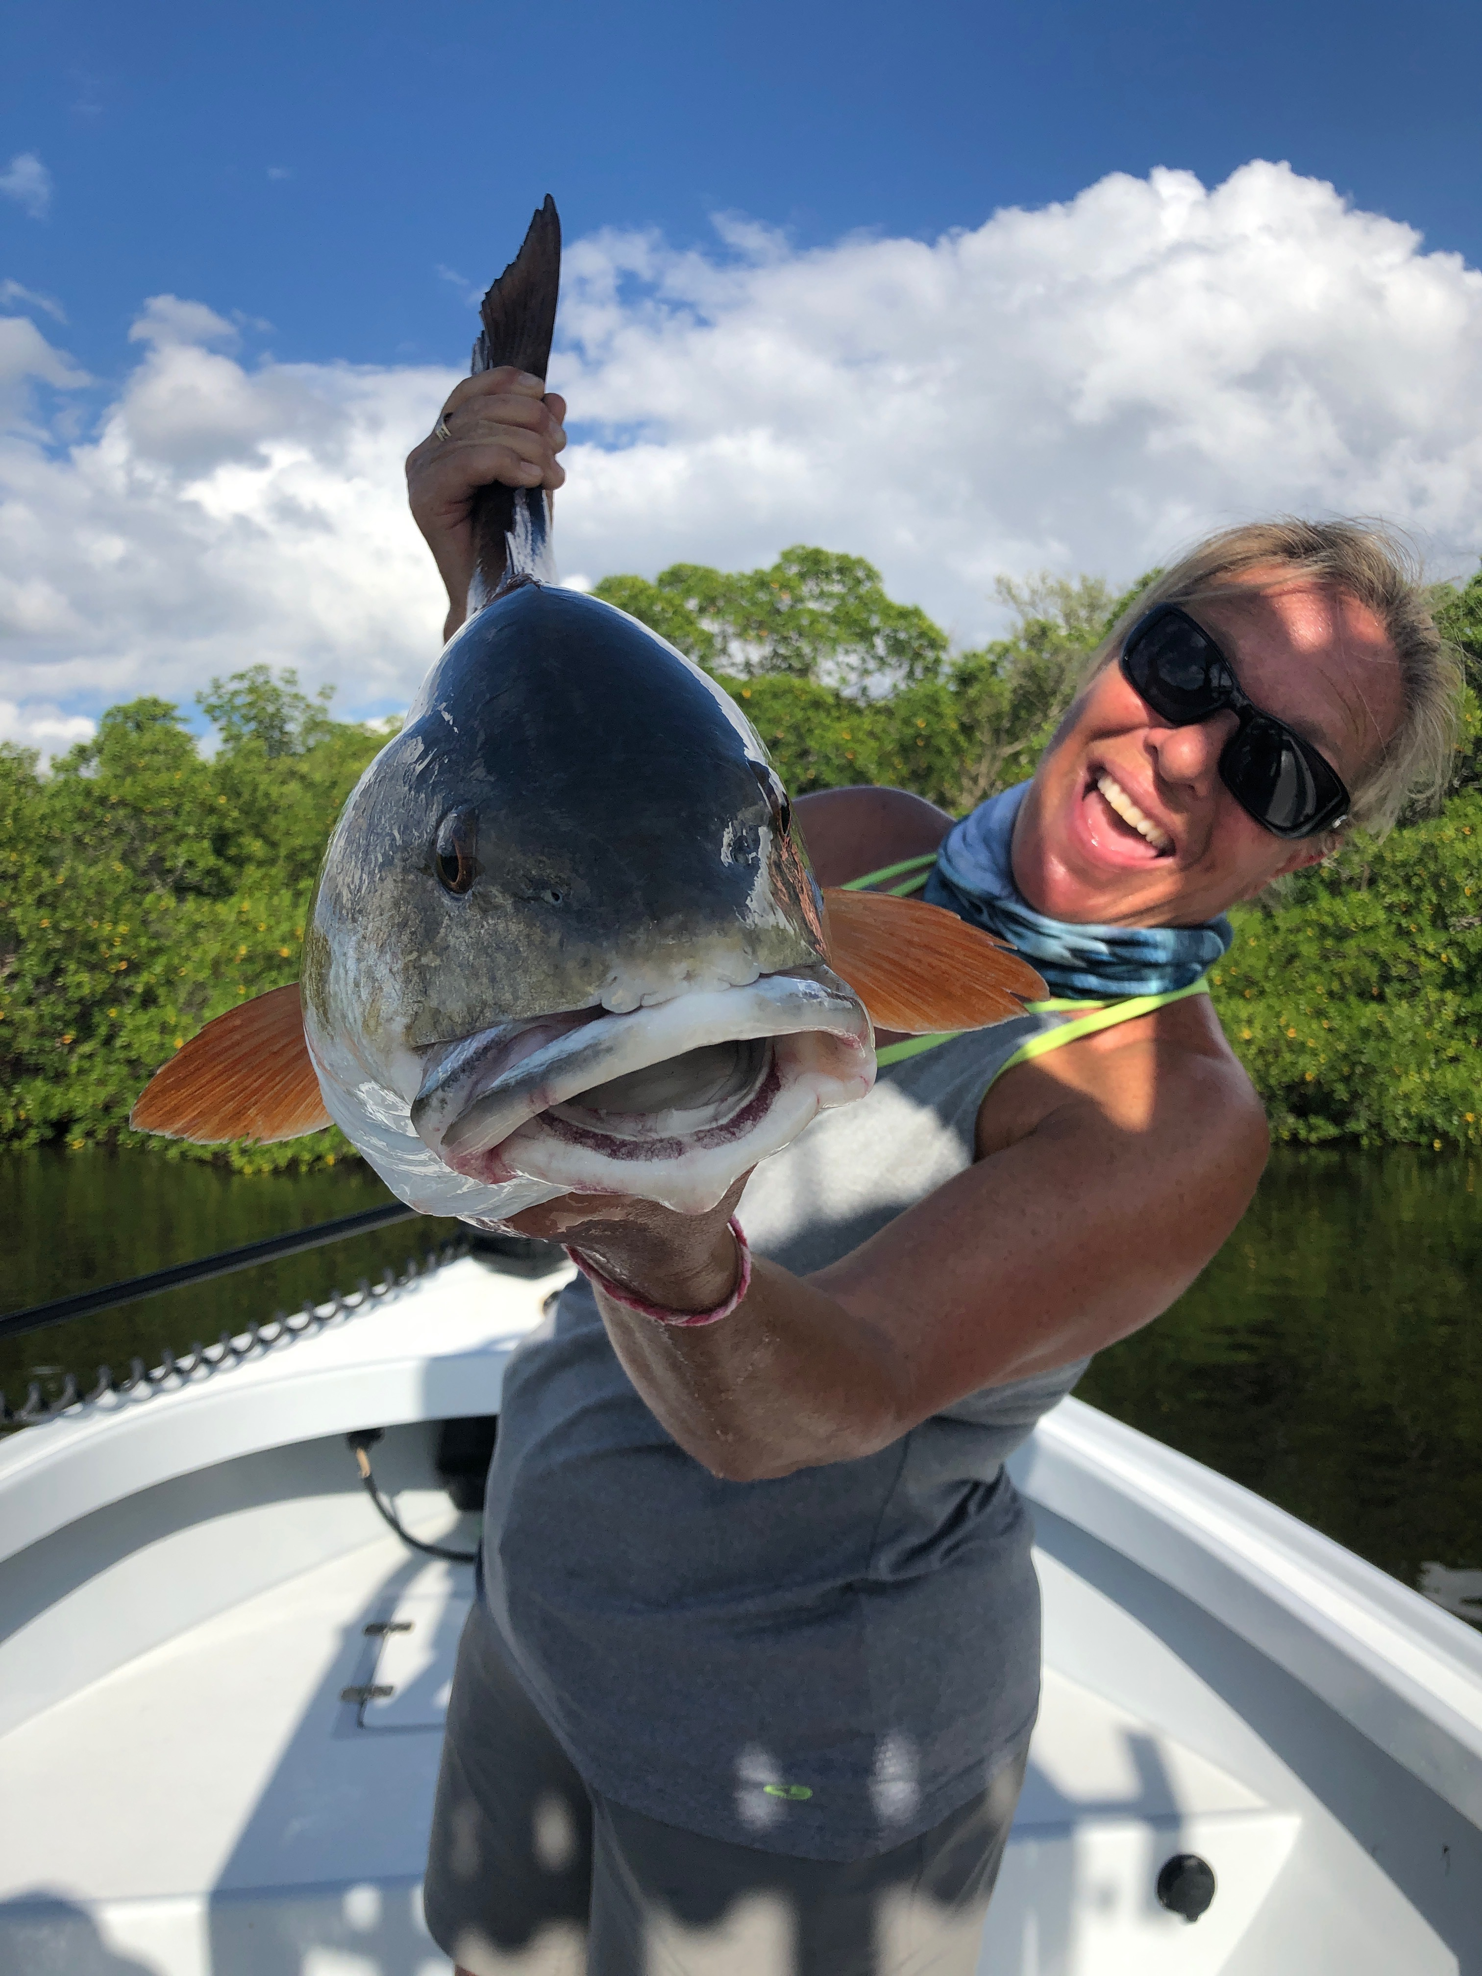

Adaption

Pic: Mary Laser from St James City with a big redfish caught while fishing with Capt Matt Mitchell this week

Changing weather patterns are all part of our fall fishing season. Learning to adapt to the days conditions is just part of every successful fisherman's repertoire. Often we have to switch up the days plan because of weather no matter how good the fishing was the day before. Some days even just a slight wind or tide change can make all the difference in the world.

Locating diving pelicans in the sound has been the easiest way to find shiners as the changing conditions have these bait schools moving on almost a daily basis. Several mornings this week I had to scramble to get my bait as it had disappeared from where I had caught it just the day before. Pushing the morning pick up time back a half hour has taken the stress out of daily bait catching. Until the clocks fall back the first weekend of November it usually pretty dark until almost 7:30am.

Once loaded up on shiners the options have been almost endless with the wind direction and phase of the tide being the deciding factors on what and where to fish. Red light shoal in Pine Island Sound has been one of my favorite places to fish over the past few weeks with fish feeding here on either tide. This has been a great place to start a trip and quickly bend the rods on a variety of species. Setting up the boat in the 4-6ft depth range and pitching a few handfuls of live shiners gets the fish feeding. Though all the bait that was on this shoal for the past few weeks has moved the many species of hungry fish including trout, snapper, jacks, ladyfish and even the occasional gag grouper have remained.

Despite Tropical Storm Nestor washing out the weekend there could be a silver lining. Winds and rain hopefully will help break up some of the patchy red tide that has being killing fish from Ft Myers beach south and blowing a few dead fish into San Carlos bay. Once past the power lines the sound has remained in pristine condition though seeing even just a few dead fish floating quickly brings back thoughts of the nightmare red tide of last year.

